英语试题
Ⅰ. 听力（共三节，20小题；每小题1.5分，满分30分）
第一节 听下面五个句子，从每小题所给的A、B、C三幅图中选出与句子内容相关的选项。（每个句子读两遍）
1. A. 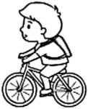 B. 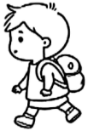 C. 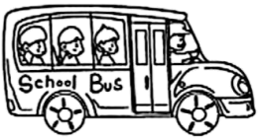
2. A. 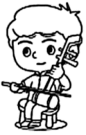 B. 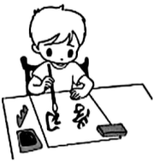 C. 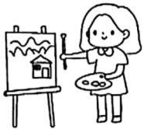
3. A. 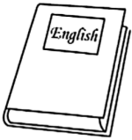 B. 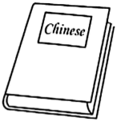 C. 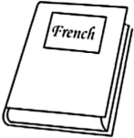
4. A. 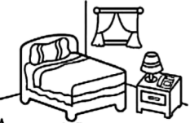 B. 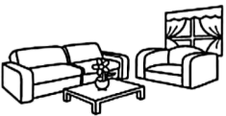 C. 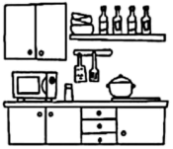
5. A. 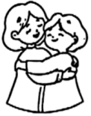 B. 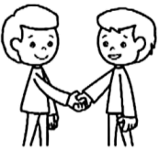 C. 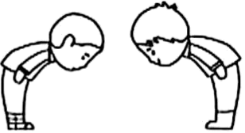
第二节 听下面七段对话，从每小题所给的A、B、C三个选项中选出正确答案。（每段对话读两遍）
听第1段对话，回答第6小题。
6. Whose hat is this?
A. Betty’s. B. Timmy’s. C. Kate’s.
听第2段对话，回答第7小题。
7. How often does Grace make a study tour?
A. Once a year. B. Twice a year. C. Three times a year.
听第3段对话，回答第8小题。
8. What time will the speakers watch the movie?
A. At 2:00. B. At 5:00. C. At 6:00.
听第4段对话，回答第9小题。
9. What does Wang Qing think of his trip?
A. Relaxing. B. Comfortable. C. Meaningful.
听第5段对话，回答第10、11小题。
10. What is on sale in the shop?
A. Trousers and skirts. B. Skirts and shoes. C. Trousers and shoes.
11. How much is the skirt?
A. 45 yuan. B. 55 yuan. C. 65 yuan.
听第6段对话，回答第12、13小题。
12. Where did Bill get the vegetables from?
A. The market. B. The farm. C. The vegetable garden.
13. What are the speakers going to have tonight?
A. Potatoes. B. Carrot juice. C. Tomato and egg soup.
听第7段对话，回答第14、15小题。
14. What are the speakers mainly talking about?
A. A summer camp. B. Paper cutting. C. A birthday gift.
15. What is the relationship between the speakers?
A. Strangers. B. Friends. C. Mother and son.
第三节 听下面短文，根据你所听到的内容，完成以下表格，每空填一词。（短文读三遍）
Book Cover Design Competition
Time | Before next 16 .
Prizes | A set of 17 story books.
Rules | ◇Use colored 18 only.  ◇Choose no more than 19 colors.  ◇ 20 the cover all by yourself.
Ⅱ. 选择填空（共15小题；每小题1分，满分15分）
从每小题所给的A、B、C三个选项中，选出可以填入空白处的最佳答案。
1. —Do you like sports?
—Sure. I am good ________ table tennis.
A. of B. at C. to
2. —I am going to meet Miss Chen in two days.
—Please send my best wishes to ________.
A. her B. she C. herself
3. —I’d like to travel to Shandong.
—Mount Taishan is a place of interest. You can’t ________ it.
A. miss B. reach C. change
4. AI technology in China has developed ________ than anyone expected.
A. fast B. faster C. fastest
5. In the art classroom, Li Li cut out a thin wood board in the ________ of Tian’anmen.
A. place B. size C. shape
6. Since last year, our school ________ free breakfasts to students in need.
A. offered B. has offered C. was offering
7. Harbin held the 9th Asian Winter Games ________ in February 2025.
A. quickly B. suddenly C. successfully
8. My parents love our hometown so much that ________ of them have gone back to help build a new countryside.
A. all B. both C. either
9. Sue looked at her son ________. She couldn’t believe that he won the game.
A. in surprise B. by mistake C. on purpose
10. China’s Beijing Library ________ “Public Library of the Year” in 2024.
A. named B. was named C. will be named
11. —Mom, let’s go to the supermarket.
—Wait a moment. It’s ________ to make a shopping list first.
A. wise B. friendly C. difficult
12. —How did you ________ the difficult math problem?
—With my teacher’s help.
A. work out B. hear about C. give up
13. We will attend the tea festival in our town ________ more about tea culture.
A. learning B. to learn C. learned
14. —Have a safe trip to Hangzhou, my dear!
—OK, Dad. I’ll give you a call ________ I arrive there.
A. until B. so that C. as soon as
15. —Could you tell me ________?
—This Sunday morning.
A. when we will do volunteer work in the community
B. which community we will do volunteer work in
C. who will do volunteer work in the community
Ⅲ. 完形填空（共10小题；每小题1.5分，满分15分）
阅读下面短文，从每小题所给的A、B、C三个选项中，选出可以填入空白处的最佳答案。
Wen Yan is a doctor of China Medical Team to Africa. She often thought of the fight to ___16___ Beauty, a baby who was born with only 800 grams. She had weak lungs (肺) and could hardly breathe. It was believed that she couldn’t live long in a hospital ___17___ necessary equipment (设备). “But even with the smallest chance, my team and I had to try our best,” said Wen.
To keep the baby ___18___, Wen coated Beauty with a soft cloth. The most dangerous moment arrived when Beauty’s heart beat only 30 times a minute. Wen stayed close to Beauty to ___19___ her for almost five hours. ___20___, Beauty was able to breathe by herself.
By the time of her leaving hospital over two months later, Beauty weighed 2,050 grams. The medical team and her family ___21___ the great moment with laughter and tears. Beauty’s mother held Wen’s hands and said, “I want my daughter to be a doctor like you.”
During her stay in Africa, Wen helped thousands of ___22___. Wen traveled to faraway villages under a burning hot sun. ___23___ she often felt tired after long traveling, she had no time to take a rest, because the local people were lining up for help. They endlessly expressed their ___24___ for her efforts.
Besides saving lives, Wen’s team also ___25___ local doctors and nurses every week to better their skills.
16. A. wake B. dress C. save
17. A. short of B. filled with C. famous for
18. A. clever B. warm C. lovely
19 A. look after B. play with C. talk about
20 A. Clearly B. Finally C. Certainly
21. A. celebrated B. forgot C. held
22. A. travelers B. patients C. volunteers
23. A. Unless B. As C. Though
24. A. interests B. ideas C. thanks
25. A. called B. trained C. ordered
Ⅳ. 阅读理解（共两节，25小题；满分45分）
第一节 阅读下列短文，根据短文内容，从题中所给的A、B、C、D四个选项中，选出最佳答案。（共20小题；每小题2分，满分40分）
A
The earth is our home. There are some ways that you and your family can use to help the planet and make a difference.
①Use less water. | Take shorter showers. A 10-minute shower or a full bathtub (浴缸) can waste a lot of water. Also, turn off the tap as you brush your teeth. Use less water in the garden and let the rain clean cars.
②Avoid wasting food. | Don’t take more than you can eat. About one-third of food in some areas is thrown out or wasted.
③Care and repair. | Take good care of things you own and they will get along life. If they break, try to repair them. If you can’t repair them, call a repairman. Producing new good swill add CO₂ to the air.
④Use reusable bags. | Use plastic and paper bags more than once. When you go shopping, use cloth bags instead of plastic bags.
⑤Use fewer paper cups. | Use reusable cups instead of throwaway paper cups if necessary. If you use more paper cups, you will produce more rubbish.

26. What can you do to save water?
A. Take shorter showers. B. Bathe in a full bathtub.
C. Stop using the tap. D. Clean cars every day.
27. What should you do when something breaks?
A. Throw it away. B. Repair it if possible.
C. Produce new goods. D. Take good care of it.
28. What does the writer suggest?
A. Using fewer paper cups. B. Using more plastic bags.
C. Using throwaway paper cups. D. Using paper bags just once.
29. Which of the following is about reusing things?
A. ①④ B. ①⑤ C. ②③ D. ④⑤
30. In which section of a newspaper can you probably read the text?
A. Culture. B. Health. C. Sports. D. Environment.
B
Mary’s uncle Ted was an engineer. He told her great stories about the rockets he helped design, and he often brought Mary science books. He also taught her some knowledge about space. Mary loved technology and science, and she was also adventurous (爱冒险的). For those reasons, Mary’s family kept telling her she should be an astronaut when she grew up, but she just wasn’t sure.
One Saturday, Mary and Uncle Ted went to visit the Science Museum. They watched a show on space travel. Uncle Ted told her something interesting about spaceships and space suits. But she was most interested in two model robot arms and tried operating (操作) them. She stayed there all day and felt very excited.
By the time they got on the bus to return home, Mary was very tired. Closing her eyes, she was thinking about what it would be like to fly into space. As she nearly fell asleep, Mary started to feel the weightlessness that astronauts must feel when they are in zero gravity (重力). The next thing she knew, she was looking out the window not of a bus but of a spaceship. Mary was operating a huge robot arm outside the spaceship. She felt nervous. But she kept at it. Soon she succeeded. She felt proud of herself.
Just then, Mary heard Uncle Ted’s voice. “Wake up, my dear! We’re back home now.” When she opened her eyes, she realized she had been dreaming, but she knew this for sure—she wanted to be an astronaut one day and couldn’t wait for her first trip into space.
31. What did Uncle Ted do?
A. He was a writer. B. He was an engineer.
C. He was an astronaut. D. He was a teacher.
32. What interested Mary most in the museum?
A. Two model robot arms. B. Amazing space suits.
C. A long show on space. D. An interesting spaceship.
33. How did Mary feel in the museum that Saturday?
A. Excited. B. Tired. C. Nervous. D. Proud.
34. What happened to Mary on her way home?
A. She was sent into space. B. She operated a robot arm.
C. She had a wonderful dream. D. She experienced zero gravity.
35. At last Mary decided to be an astronaut because of ________.
A. her science books B. her parents’ wish
C her uncle’s encouragement D. her trip to the museum
C
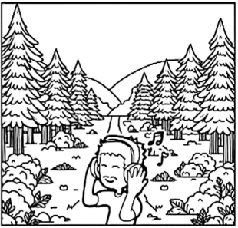
As we often use eyes to touch nature, most of us “lose” the ability to listen to the world.
Peter writes music. He likes sounds and uses natural sounds as part of his music. He often went out to the wild with his microphone and recorded interesting sounds to put in movies or to use in his own songs. Instead of trying to capture just the sound of one animal or bird, he recorded the sound of everything all together—the animals, the trees, the wind and the earth. He called these recordings “soundscapes”—the sound of a certain place. Every soundscape Peter recorded had a lot of information.
Back in his workshop, Peter used a computer to make a picture of all the sounds going on in a place. Each animal, bird and insect had its own place on the picture—its own notes in the music. The busier the picture, the richer the life in that place. “While a picture may be worth 1,000 words, a soundscape is worth 1,000 pictures,” Peter said. “Our ears tell us the sound of every leaf and animal and speak to the natural sources (来源) of our lives, which may hold the secrets of love for all things, especially our own humanity.”
But not everything is satisfying. When Peter began recording over forty years ago, he could record for ten hours and get one hour of usable material good enough for a movie. Now, because of human activities, it can take up to 1,000 hours or more to get the same thing. Some of the places he has recorded over the years have slowly fallen silent. His sound pictures show that although nature might look the same to humans, it has lost part of its orchestra (管弦乐队).
So next time you are in the forests, try another way to look—shut your eyes, and listen.
36. Why did Peter record natural sounds?
A. To write songs for a music group. B. To discover rich lives in the forest.
C. To use some of them in his music. D. To make music about birds singing.
37. What does the underlined word “capture” in paragraph 2 mean?
A. Shut. B. Catch. C. Touch. D. Check.
38. What is a sound picture in the text?
A The sound of every leaf and animal in nature.
B. The sound recorded in the natural environment.
C. A picture of music with sounds of 1,000 animals.
D. A picture of music with natural sounds in a place.
39. What can we learn from paragraph 4?
A. Recording sounds needs less material. B. Sound pictures are the same as before.
C. Some beautiful sounds in nature are lost. D. Human activities improve recording results.
40. What does the writer mainly want to tell us?
A. Nature is the source of our future. B. Nature has wonders to be heard.
C. Making music enriches our lives. D. Making music needs information.
D
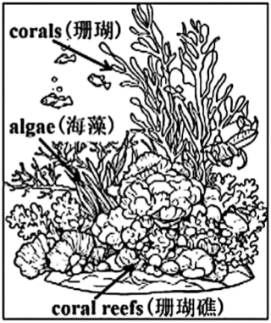
Deep under the Pacific Ocean lie coral reefs colored by some algae that live with corals. Corals usually provide nitrogen (氮) to algae, and in return they get carbon (碳), which gives them energy.
In the early 1980s, a huge heat wave turned more than 90 percent of these corals a pale, lifeless white. And it was believed that about 50 percent of reefs with beautiful corals might disappear by 2030. Heat waves warmed up the same Pacific waters in the late 1990s and again in 2015—2016, but scientists noticed that these heat waves didn’t influence the reefs as badly as the first. Maybe corals have found a way to adapt (适应).
Swimming to cooler waters is not a good choice for corals, for it makes them easily hurt by the changing climate. But corals are able to adapt. Some turn to those algae that can deal well with heat. Others can use rows of tiny hairs on their bodies to “fan” away too much harmful oxygen (O₂) let out by stressed-out algae. Certain baby corals change their own metabolisms (新陈代谢) in order to fight the warming waters. But all these adaptations can protect themselves only to some degree.
After studying and understanding these adaptations, scientists are trying to find ways to help corals fight. If researchers can make corals accept algae that can deal with heat pressure or if they energize genes (基因) that can deal with heat pressure, it will raise the corals’ chance of living through future ocean heat waves.
“When I go down to the sea and see a beautiful healthy reef with these colorful corals, I feel this pleasure of being in this underwater world,” a famous biologist says. “It will be really sad to see it dead. But that does drive you to want to use your skills and your love to help fight.”
41. What can we know from paragraph 1?
A. Corals make algae more colorful. B. Algae provide room for corals to live in.
C. Corals and algae depend on each other. D. Algae produce nitrogen to influence corals.
42. What does the underlined part “the first” in paragraph 2 refer to?
A. The heat wave in the early 1980s. B. The heat wave in the late 1990s.
C. The Pacific waters in 2015—2016. D. The reefs’ disappearance by 2030.
43. What difficulty do corals face?
A. They cannot completely adapt to heat waves.
B. They cannot change their own metabolisms.
C. They have no ability to swim to cooler waters.
D. They have no ability to drive away harmful oxygen.
44. What can we infer from the last paragraph?
A. It’s necessary to live with corals. B. The ocean has become unhealthy.
C. We should try our best to save corals. D. Making a study of the ocean is a must.
45. Which would be the best title for the text?
A. Corals Die Out B. Corals Fight Back
C. Corals Break Down D. Corals Come into Being
第二节（共5小题；每小题1分，满分5分）
E
阅读下面短文，从短文后所给的五个选项中选出能填入短文空白处的最佳选项，使短文通顺、连贯，意思完整。
Hobbies lead to better health, more sleep, lower pressure and greater life satisfaction. Get joy from your hobby, and you’ll be a better person. ___46___ Here are some suggestions from experts.
● ___47___
Hobbies can help you calm down. An expert suggests asking yourself how you want an activity to make you feel. Relaxed or socially connected?
It’s also helpful to consider what your life is missing, like creativity or art skills.
● Start small.
___48___ Wait for a while to find out if it’s right for you. You can always do more later.
It’s also smart not to do something more than you can. If you don’t want to do that, just stop. ___49___
●Take a trip back in time.
Recall activities you loved when you were young, like singing or collecting things. It’s a really helpful place to start, and it allows you to feel comfortable.
Also, consider going back to school. ___50___ Or sign up for a lesson at a local community center and learn more about a potential (潜在的) hobby.
Always keep in mind that if a hobby makes you healthier and happier, everyone around you will benefit.
A. But where do we start?
B. Check out classes at university.
C. Ask yourself: How do I want to feel?
D. You get fun from hobbies, not pressure.
E. Don’t spend a lot of time on a new hobby at once.
Ⅴ. 情景交际（共5小题；每小题2分，满分10分）
根据情景提示，用得体的英语完成下列对话。
51. A: Happy New Year!
B: ________________!
52. A: Which sport do you like better, running or swimming?
B: ________________.
53. A: ________________ is it from your home to school?
B: About five kilometers.
54. A: ________________?
B: Fine, thank you.
55. A: ________________?
B: I come from Fujian.
Ⅵ. 看图写话（共5小题；每小题2分，满分10分）
根据每小题所提供图画情景和提示词，写出一个与图画情景相符的句子。
56. now 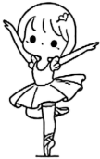
________________________
57. pick, next weekend 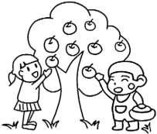
________________________
58. should 
________________________
59. there, next to 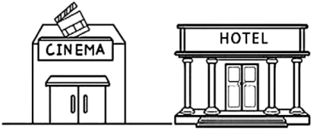
________________________
60. because 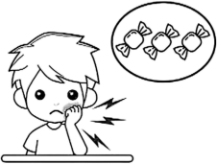
________________________
Ⅶ. 短文填空（共10小题；每小题1分，满分10分）
阅读下面短文，根据语境或所给单词的提示，在每个空格内填入一个恰当的词，要求所填的词意义准确、形式正确，使短文意思完整、行文连贯。
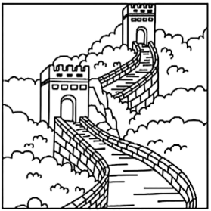
The Great Wall, which is a symbol of our history, snakes across a mountain area of Tianzhu, Gansu province. Thirty-nine protectors work ___61___ (careful) in the area to protect the great wonder.
With ___62___ history of over 2,000 years, the wall in Gansu wasn’t in good condition. Nature did great harm to the wall. Some ___63___ (part) of the wall were washed away by heavy rains and blown away by strong winds. People in some places also harmed it.
But things started to change. In 2006, Great Wall Protection Regulations (条例) ___64___ (come) into effect. After that, more and more people started to take part ___65___ caring for the wall. In recent years, the government of Tianzhu has spent more and more money ___66___ (protect) the wall. Modern technology like self-driven sensing technology ___67___ drones (无人机) have also been used to watch the wall.
With all these efforts, the protectors are still busy with the work. Every week they guard the wall, and any changes are well recorded and ___68___ (report) to the government. They also help people realize it’s important to protect cultural heritage (遗产). Luckily, with ___69___ (they) hard work, much greater changes have taken place.
“As long as we are here, we will protect this wall. It is our job and our ____70____ (proud),” said one of the protectors.
Ⅷ. 书面表达（满分15分）
71. 假定你是某校学生李华，近日你校开展了以“共植诚信之树”为主题的活动。请你结合以下提示，用英语给笔友Henry写一封电子邮件，分享活动内容及感受。词数80左右。
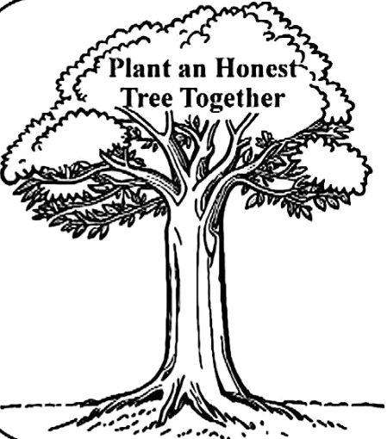 | Time:  Plant an Honest Tree Together  June 10th, 2025  Activities:  ●watch a video  ●listen to a speech  ●have a discussion  ●plant an honest tree  Feeling (s):  ...
注意事项：1. 必须包含所有提示信息，可适当发挥，开头和结尾已给出，不计入总词数；
2. 意思清楚，表达通顺，行文连贯，书写规范；
3. 请勿在文中使用真实的姓名、校名和地名。
Dear Henry,
I’m glad to share with you the event “Plant an Honest Tree Together” in our school. __________________________________________________________________________________________________________________________________________________________________________________________________________________________________________________________________________________________________________________________________________________________________________________________________________________________________________________________________________________________________________________________________________________________________________________________________________________________________________________________________________________________________________________________________________________________________________________________________________________________________________________________________________________________________________________________________
Yours,
Li Hua

