秘密
解密时间：2026年
6月14日下午3:00
南充市二〇二六年初中学业水平考试
英语试题
注意事项：1．考试时间120分钟，试卷满分150分。
2．答题前将姓名、座位号、身份证号、准考证号填在答题卡指定位置。
3．所有解答内容均须涂、写在答题卡上。
4．选择题须用2B铅笔将答题卡相应题号对应选项涂黑，若需改动，须擦净另涂。
5．非选择题在答题卡对应题号位置用0.5毫米黑色字迹笔书写。
第一部分 听力（共两节，满分30分）
第一节（共5小题；每小题1.5分，满分7.5分）
听下面5段短对话。每段对话后有一个小题，从题中所给的A、B、C三个选项中选出最佳选项，并在答题卡上将该项涂黑。听完每段对话后，你都有10秒钟的时间来回答有关小题和阅读下一小题。每段对话读两遍。
1. How does Tom go to school these days?
A.  B. 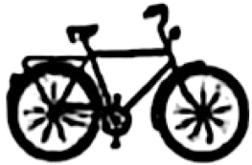 C. 
2. Where is the man going?
A. To the bookstore. B. To the cinema. C. To the shopping mall.
3. What is Jack going to do?
A. Check the weather. B. Play football. C. Stay at home.
4. How does the woman feel?
A. Excited. B. Upset. C. Calm.
5. What are the speakers talking about?
A. Delicious food. B. A holiday plan. C. Family members.
第二节（共15小题；每小题1.5分，满分22.5分）
听下面5段长对话或独白。每段对话或独白后有几个小题，从题中所给的A、B、C三个选项中选出最佳选项，并在答题卡上将该项涂黑。听每段对话或独白前，你将有时间阅读各个小题，每小题5秒钟；听完后，各小题将给出5秒钟的作答时间。每段对话或独白读两遍。
听第6段材料，回答第6至第7两个小题。
6. What does the woman like most about the movie?
A. The story. B. The actors. C. The music.
7. How much will the man pay?
A. 10 yuan. B. 20 yuan. C. 40 yuan.
听第7段材料，回答第8至第10三个小题。
8. What is the relationship between the speakers?
A. Saleswoman and customer. B. Mother and son. C. Teacher and student.
9. What kind of books does the man’s son prefer?
A. Science and technology. B. Chinese classics. C. Short stories.
10. What will the man do next?
A. Become a member. B. Hold a party. C. Share a book.
听第8段材料，回答第11至第13三个小题。
11. Why is Lily looking pale?
A. She has a cough. B. She has a sore back. C. She has a fever.
12. How does the man keep healthy?
A. He runs every day. B. He has a healthy diet. C. He walks to work.
13. What does the man advise Lily to do in the end?
A. Join a club. B. Set a small goal. C. Find an example.
听第9段材料，回答第14至第16三个小题。
14. What did Mark do at the museum?
A. He hosted activities. B. He cleaned the hall. C. He introduced the objects.
15. What did the museum provide for volunteers?
A. Free books. B. Some training. C. Art works.
16. What does Mark want to be?
A. A history teacher. B. A museum volunteer. C. A chemistry expert.
听第10段材料，回答第17至第20四个小题。
17. When will the school bus leave?
A. At 8:30 a.m. B. At 8:45 a.m. C. At 9:00 a.m.
18. What should the listeners bring?
A. A jacket. B. Tents. C. Food.
19. What should the listeners do this Friday?
A. Ask more questions.
B. Discuss in the entrance hall.
C. Pay attention to the noticeboard.
20. What is the speaker most probably?
A. A tour guide. B. A school teacher. C. A bus driver.
第二部分 阅读（共三节，满分50分）
第一节（共15小题；每小题2分，满分30分）
阅读下列短文，从每题所给的A、B、C和D四个选项中，选出最佳选项，并在答题卡上将该项涂黑。
A
Li Hua’s study group made a poster about water. Today, they are sharing it in English class.
Part 1 | How much water do we need to take in every day?  2.7-3.7 litres (L) |  | It takes water to make these things, even though we don’t see water in them.  
Part 2 | Percentage of water on Earth  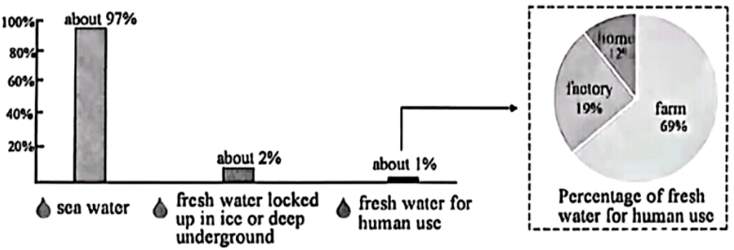
Part 3 | 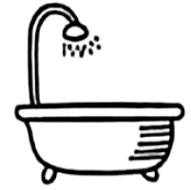 |  | 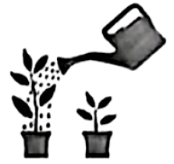 | 
Part 3 | Take shorter showers |  | Water plants with grey water | Use energy-saving washing machines

1. How much water does a person need to take in every day?
A. 0.7-1.6L. B. 1.7-2.6L. C. 2.7-3.7L. D. 3.8-4.7L.
2. Which of the following takes the most water to make?
A. A hamburger. B. A shirt. C. 1 kilo of sugar. D. A pair of shoes.
3. What do we know about fresh water?
A. Factories use more fresh water than farms do.
B. Fresh water from underground is easy to get.
C. Fresh water takes up about 3% of Earth’s water.
D. About 2% of the world’s fresh water was used up.
4. What is Part 3 mainly about?
A. Suggestions for saving water. B. Reasons for reusing water.
C. Ways of getting fresh water. D. Results of wasting water.
5. When is this poster most likely to be used?
A. On World Health Day. B. On World Earth Day.
C. On World Forest Day. D. On World Food Day.
B
Are you wondering how chocolate tasting could be a job?
Though this job sounds like a joke, chocolate producers do need professional tasters to taste their products. In the process of production, tasters are given samples (样本) of chocolates to taste, tell if there is too much of cocoa (可可粉), sugar or any other ingredient, and give opinions on them honestly. In this way, the taste can be improved to be perfect. In a sense, you could call this professional a Quality Control Manager.
To be a professional taster is not easy. The necessary skill that they have is a strong sense of taste and smell. They should have professional knowledge about chocolates. In addition, they might have to work long hours to complete large orders of sample tasting within a certain time. It means that they need to be very patient and have physical strength.
The job brings a lot to professional tasters. Cherrie Lo, a professional chocolate taster, gets valuable insights (洞察力) into food cultures by exploring new market trends (趋势) in chocolate. Another taster, Rebecca Hsu, gets paid $21,000 a year, which improves her life greatly.
The future of the job is promising. With the growth of technology, this job will be still in high need for the coming years. Workers in this field can expect higher pay and more chances for development. If chocolates are your favorite food and you are willing to center your life around it, why not have it a try?
6. What do chocolate tasters do first during the process of production?
A. Prepare samples. B. Taste samples. C. Judge samples. D. Improve samples.
7. Which of the following qualities do chocolate tasters need?
A. A strong sense of touch. B. Great patience and physical strength.
C. Rich practical experience. D. Professional knowledge of management.
8. How does the writer show the advantages of the job?
A. By asking questions. B. By comparing numbers.
C. By giving examples. D. By having discussions.
9. What does the underlined word “promising” in paragraph 5 mean?
A. Challenging. B. Risky. C. Relaxing. D. Hopeful.
10. What is the writing purpose of the text?
A. To introduce a job. B. To sell chocolates.
C. To spread the food culture. D. To explore the chocolate market.
C
Ugochin is a foreign student studying in China. She took part in the show A Foreign Apprentice Comes to the Mountains in Yunhe, Zhejiang Province, to know more about Chinese country life. She fully experienced it in the show.
In front of the camera, she worked together with local villagers to dig potatoes, make tofu, catch fish and cook tasty meals. Away from the camera, she was interested in this peaceful country life. Such a life was shaped more by land, weather and old customs rather than busy work.
“China’s rural revitalization (乡村振兴) is really amazing.” Ugochin said. In Yunhe, she met local young villagers who had made a big difference. Instead of selling farm produce (农产品) in the old way, they packed it differently to make it look cooler. They also used livestreaming to reach customers across the country. By trying these new methods, they brought fresh energy to their hometown.
Apart from new looks in the countryside, Yunhe’s respect for traditions also impressed (留下印象) Ugochin. “This experience tells me that while we push forward rural revitalization, we should also protect old buildings, carry forward history and keep traditional skills alive.” she shared.
When the filming ended, Ugochin was not ready to leave the experience behind. She planned to go back to Yunhe and spend more time enjoying the priceless giving of the countryside. She said from the bottom of her heart, “Clear water and green mountains are as valuable as mountains of gold and silver. ▲ ”
11. What does the underlined word “it” refer to in paragraph 1?
A. The filming activity. B. The country life.
C. The learning method. D. The mountain trip.
12. What did Ugochin do in the show?
A. She planted potatoes. B. She took photos. C. She fed fish. D. She made meals.
13. Which word can best describe local young villagers in Ugochin’s eyes?
A. Creative. B. Polite. C. Outgoing. D. Humorous.
14. What can we infer from Ugochin’s words in paragraph 4?
A. Keeping traditions should be put in the first place.
B. Development and tradition should go hand in hand.
C. Traditional knowledge is more useful than new ideas.
D. Protecting old buildings may slow down development.
15. Which of the following can be put in the ▲ ?
A. The countryside needs more money. B. A good environment means a better future.
C. China’s countryside is truly a treasure. D. Traditional village life has great value today.
第二节（共5小题；每小题2分，满分10分）
阅读短文，从短文后的选项中选出能填入空白处的最佳选项，并在答题卡上将该项涂黑，选项中有一项为多余选项。
We all answer questions every day. But how do you know if your answer is actually reasonable (合理的)? Here are four simple ways to check.
Think about the logic (逻辑)
A reasonable answer must follow basic logic. If your answer disagrees with common knowledge, something is probably wrong. For example, if a math problem asks how many apples are in a basket, and you get “-5”, that isn’t reasonable. ____16____ Always ask yourself, “Does this fit the real world?”
Use real-life examples
Let’s say you are solving a science question, “Why do we feel cold in winter?” A reasonable answer is, “Because the temperature drops.” Now compare that with an unreasonable answer, “Because the sun gets angry.” The first answer uses facts. ____17____ When you give an answer, try to connect it to something you have actually seen or experienced.
____18____
Before you finish, ask yourself, “Is my answer close to what I expected?” Let’s do a quick math check. If you calculate 38×4, and you get 152, that feels right. But if you get 1,520, that is too big. Compare your answer with an estimate (估算). If they are very different, go back and check your work.
Ask yourself questions
This is the easiest method. Just ask yourself, “Is the answer reasonable?” “Can I explain the answer to a friend?” “Would my teacher accept the answer?” If you can’t explain your answer in simple words, you might not fully understand it yourself. ____19____
In short, a reasonable answer is logical, factual (事实的), close to your estimate, and easy to explain. ____20____ You will make fewer mistakes and feel more confident.
A. You cannot have negative apples.
B. Compare it with what you expected.
C. Connect it with what you already know.
D. A good answer should be easy to talk about.
E. The second sounds funny but has no science behind it.
F. Next time you finish a question, spend a few seconds checking.
第三节（共5小题；每小题2分，满分10分）
阅读下面短文，根据短文内容，完成图表中所缺信息，并将答案写在答题卡相应的横线上，每空限填一词。
Spring is a symbol of new beginning, and spring outings are good chances to get close to nature. Do you know what activities ancient people did during spring outings?
As early as the Western Zhou Dynasty, at the beginning of spring, the king led his officials (官员) to a spring-welcoming ceremony, which could be called the earliest national-level “spring launch event”.
In the Tang Dynasty, there was an elegant (优雅的) spring game called doubaicao. People collected unusual flowers and grasses, and competed to get the largest number.
In the Song Dynasty, activities were mostly centered around Qingming Festival. People connected tomb sweeping with spring outings. They also took part in cuju. Cu means kicking and ju is a kind of leather ball. People kicked the ball through an opening into a net.
During the Ming and Qing dynasties, willow-shooting (射柳) was an event of the era. People shot an arrow (箭) through a willow leaf from a hundred steps. Swinging and kite-flying also enjoyed popularity at that time.
As time goes by, spring outings today not only inherit (继承) the spirit of ancient traditions, but also have been developing in forms and content. The only thing that doesn’t change is the love and longing for a better life in the hearts of Chinese people.
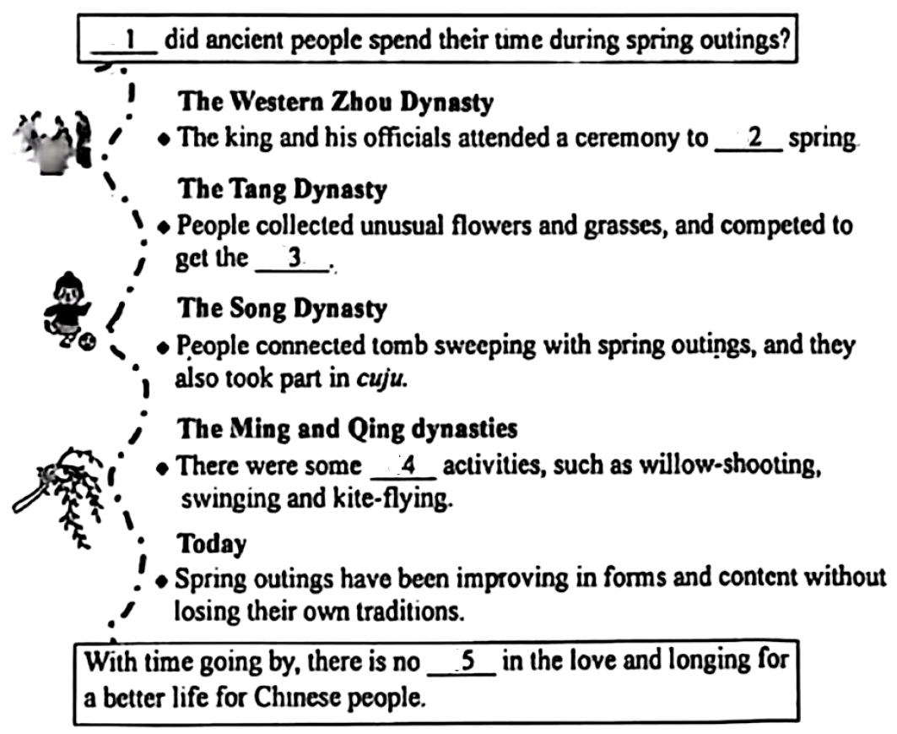
21. ________
22. ________
23. ________
24. ________
25. ________
第三部分 语言运用（共两节，满分45分）
第一节（共15小题；每小题2分，满分30分）
阅读下列短文，从短文后各题所给的A、B、C和D四个选项中，选出可以填入空白处的最佳选项，并在答题卡上将该项涂黑。
A
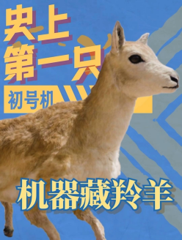
A robotic Tibetan antelope (机器藏羚羊) is now walking around Hoh Xil Nature Reserve (可可西里自然保护区). With 5G networks and AI algorithms (算法), it is used to ____26____ the latest information about Tibetan antelope populations without bringing trouble to their life.
This is the first time that such a robotic antelope has been ____27____ in the heart of Hoh Xil, which sits more than 4,600 meters above sea level. Its ____28____ closely matches a real Tibetan antelope, with similar fur color and body shape. So it has mixed with the Tibetan antelopes ____29____. The information it sends back is clearer and more dependable than that from traditional ways.
For wildlife research and protection, the project is ____30____, especially in the most challenging environment on Earth. It’s a key step in exploring nature for human beings.
26. A. hide B. protect C. collect D. copy
27. A. laid B. thrown C. fed D. forgotten
28. A. appearance B. movement C. ability D. personality
29. A. comfortably B. successfully C. luckily D. bravely
30. A. funny B. easy C. meaningful D. changeable
B
It was the final 800-meter race of the season. I had trained hard all summer, but now, facing my powerful ____31____, Sarah Chen, I doubted myself.
The starting gun fired. The first lap (圈) felt unexpectedly ____32____. But as we turned into the second lap, Sarah was ahead of me a little bit. ____33____ coach’s words “Run your own race”, I told myself to follow her all the time.
____34____, with 200 meters to go, the gap (距离) between Sarah and me became wider. A negative ____35____ hit me, “You can’t catch her. Second place is okay.” I was about to slow down when my coach shouted at me, “Mia, run. Believe yourself.”
Suddenly, something came into my mind—it wasn’t just about winning against Sarah anymore; it was about honoring all those hours of ____36____, and about pushing myself forward. I tried my best to run faster and only ____37____ the finish line.
I crossed the line, ____38____ and tired. Then I heard the announcement, “First place... Mia Johnson!” I was filled with ____39____. Sarah finished a second later, and offered a warm smile and a handshake to me.
What I learned from the race was more than just how to run faster. I also ____40____ that my biggest competitor is often myself. So I’ll keep running and never give up.
31. A. host B. coach C. judge D. competitor
32. A. serious B. smooth C. slow D. strange
33. A. Reading B. Recording C. Remembering D. Reporting
34. A. However B. Besides C. Therefore D. Instead
35. A. memory B. idea C. notice D. reply
36. A. interview B. imagination C. practice D. prediction
37. A. made up B. looked around C. focused on D. left out
38. A. careful B. breathless C. scared D. crazy
39. A. kindness B. stress C. regret D. joy
40. A. realized B. warned C. decided D. expected
第二节（共10小题；每小题1.5分，满分15分）
阅读下面短文，在空白处填入1个适当的单词或括号内单词的正确形式，并将答案写在答题卡相应的横线上。
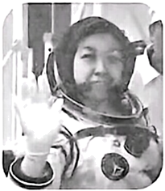
In May, 2026, Lai Ka-ying, with her two teammates, took the Shenzhou ⅩⅩⅢ spacecraft to China’s Tiangong space station. She is the ____41____ (four) Chinese female (女性的) astronaut, and also the first one from Hong Kong to fly into space.
Lai was born in November, 1982 and ____42____ (grow) up in Hong Kong. Before she became ____43____ astronaut, she worked for the Hong Kong Police Force. In August, 2024, she began ____44____ (she) 1,700-hour training at the Astronaut Center of China in Beijing. The process was difficult, ____45____ she kept in good condition and worked closely with her teammates. She worked hard to learn how to operate manned spacecraft ____46____ (correct). Finally, she completed more than 200 subjects with ____47____ (surprise) performance.
In space, Lai will be responsible for different scientific tests and other ____48____ (duty). Thanks to long-term training and careful preparation, she is full ____49____ confidence to finish her tasks.
Lai Ka-ying’s journey has encouraged many students in Hong Kong ____50____ (have) a big dream—whether they want to become scientists, engineers, or even astronauts. Her story shows that with hard work and love for the country, big dreams are within reach.
第四部分 写作（满分25分）
51. 暑假是自我提升的好时机。你校英文网站正在开展主题为“Improve Myself, Grow Better”的征文活动，征文通知页面附带一份自我评价量表，供同学们对照自查。请你从中选择自己最需要提升的一个方面，写一篇短文投稿。
 Articles Wanted: Improve Myself, Grow Better
We’re waiting for your articles! Read the self-check table first and start your writing.
Self-check for Personal Improvement
How well do you do in these areas? | Very well | OK | Need improvement
Doing sports | □ | □ | □
Eating habits | □ | □ | □
Daily reading | □ | □ | □
Volunteer work | □ | □ | □
Housework | □ | □ | □
Art learning | □ | □ | □
Getting on with others | □ | □ | □

Writing points:   | 1. What do you want to improve most?  2. Why do you want to improve it?  3. How do you plan to improve it?
 Summer vacation is a good chance to improve myself. ____________________________________________________________________________________________________________________________________________________________________________________________________________________________________________________________________________________________________________________________________________________________________________________________
要求：
1．词数100左右（短文开头已给出，不计入总词数）：
2．要点齐全，可适当增加细节，以使行文连贯；
3．文中不得出现真实人名、校名或地名。

