达州市2026年初中学业水平暨高中阶段学校招生统一考试
英语
本考试为闭卷考试，考试时间120分钟，满分150分。本试卷分为A卷和B卷两部分，共10页。
温馨提示：
1．答题前，考生需用0.5毫米黑色签字笔将自己的姓名、准考证号、座位号正确填写在答题卡对应位置。待监考老师粘贴好条形码后，再认真核对条形码上的信息与自己准考证上的信息是否一致。
2．选择题必须使用2B铅笔在答题卡相应位置规范填涂，如需改动，用橡皮擦擦干净后，再选涂其他答案标号；非选择题用0.5毫米黑色签字笔作答，答案必须写在答题卡对应的框内，超出答题区答案无效。在草稿纸、试题卷上作答无效。
3．不要折叠、弄皱、弄破答题卡，不得使用涂改液、修正带、刮纸刀等影响答题卡整洁。
4．考试结束后，将试卷及答题卡一并交回。
A卷（共100分）
第一部分 听力（共三节；满分30分）
做题时，先将答案标在试卷上。录音内容结束后，你将有两分钟的时间将试卷上的答案转涂到答题卡上。
第一节（共5小题；每小题1.5分，满分7.5分）
你将听到五个句子，请在下列五幅图中，选出与所听句子内容相符的图片。听完每个句子，你都有5秒钟的时间来回答有关小题和阅读下一小题。每个句子读两遍。
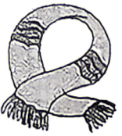 | 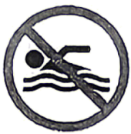 | 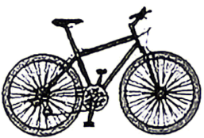 | 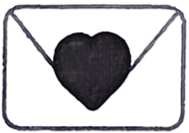 | 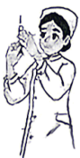
A | B | C | D | E
1. ________ 2. ________ 3. ________ 4. ________ 5. ________
第二节（共5小题；每小题1.5分，满分7.5分）
你将听到五段短对话，请根据所听内容，从题中所给的A、B、C三个选项中选出最佳选项。听完每段对话，你都有5秒钟的时间来回答有关小题和阅读下一小题。每段对话读两遍。
6. What’s Peter’s favorite sport?
A. 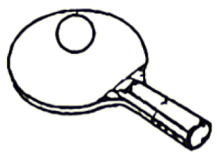 B.  C. 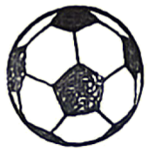
7. When does Sally help cook dinner at home?
A. 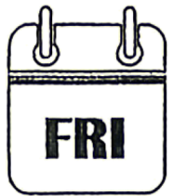 B. 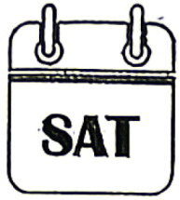 C. 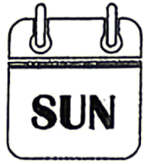
8. Where was the cap?
A. On the sofa. B. Under the table. C. In the bookcase.
9. How’s the weather now?
A. Cloudy. B. Sunny. C. Rainy.
10. What did Frank do on vacation?
A. Climbed the mountain. B. Visited a museum. C. Went to the beach.
第三节（共10小题；每小题1.5分，满分15分）
你将听到两段长对话和一段独白。每段对话或独白后有几个小题，从题中所给的A、B、C三个选项中选出最佳选项。听完每段对话或独白，你都有5秒钟的时间来回答有关小题和阅读下一小题。每段对话读两遍，独白读三遍。
请听第一段长对话，回答第11至13小题。
11. Which floor does the man prefer?
A. The second floor. B. The third floor. C. The fourth floor.
12. How much should the man pay for two nights?
A.80 dollars. B.100 dollars. C.160 dollars.
13. When does the breakfast begin?
A. At 7:00. B. At 8:00. C. At 9:00.
请听第二段长对话，回答第14至16小题。
14. How many pieces of advice does Amy give Victor?
A. One. B. Two. C. Three.
15. What should Victor listen to?
A. English shows. B. English songs. C. English speeches.
16. What is Amy’s second piece of advice?
A. To speak English more.
B. To read English aloud.
C. To listen to English often.
请听下面一段独白，回答第17至20小题。
17. When did Eric move to Sunshine Town?
A. In August. B. In September. C. In October.
18. How often does Eric go to the sports club?
A. Once a week. B. Twice a week. C. Every day.
19. What did Eric do yesterday evening?
A. He went shopping.
B. He watched a movie.
C. He cleaned the house.
20. Where is Eric’s new house?
A. On Park Street. B. On North Street. C. On Green Street.
第二部分 基础知识运用（共两节；满分30分）
第一节 完形填空（共10小题；每小题2分，满分20分）
阅读下面短文，从短文后各题所给的A、B、C、D四个选项中，选出可以填入空白处的最佳选项。
One day, a boy asked his teacher Miss Smith, “What is greed (贪婪)?” The teacher didn’t answer his ____1____ at once. She asked the boy to walk through the chocolate factory next to their school and ____2____ the biggest chocolate bar (巧克力块) he could find. But there was a ____3____: As he passed through the factory, he could not turn back.
The boy went to the chocolate factory. As he walked, he saw a large chocolate bar. He liked it, but thought he might be able to find a ____4____ one if he kept going. He kept walking and saw another chocolate bar. This one was a little bigger. But ____5____, he thought he could find an even bigger one. As he neared the end of the factory, he saw fewer chocolate bars, and ____6____ of them were as large as the earlier ones. He started to regret his ____7____ to keep going.
Finally, he gave up. He went back to his teacher with ____8____ hands and explained what had happened.
The teacher told him, “You liked the first chocolate bar, but you kept ____9____ a bigger one. And later, you found that you had given up the best chocolate bar as you thought you could do better. That is called greed. Sometimes, we miss the best things in our lives _____10_____ we think we can find something even better.”
1. A. call B. question C. door D. need
2. A. pick out B. eat up C. throw away D. sell out
3. A. change B. habit C. rule D. chance
4. A. longer B. stronger C. higher D. bigger
5. A. once B. indeed C. again D. seldom
6. A. none B. some C. any D. many
7. A. advice B. decision C. promise D. dream
8. A. busy B. soft C. dirty D. empty
9. A. looking after B. looking for C. looking up D. looking over
10. A. though B. whether C. because D. unless
第二节 补全对话（共5小题；每小题2分，满分10分）
根据对话内容，从对话后的选项中选出能填入空白处的最佳选项，其中有两项为多余选项。
A: Hi, Mike. ____11____
B: Wonderful! Where did you get it?
A: ____12____ I made it by myself.
B: Cool! What do you usually do in your DIY class?
A: Well, we make different kinds of things. It’s interesting.
B: ____13____
A: Mr. White. He’s very patient.
B: I want to join you. ____14____
A: Sure! The class is on Friday every week. You can come with me next time.
B: ____15____ Thank you.
A. I’d love to.
B. In my DIY class.
C. Can you help me?
D. Who’s the teacher?
E. What’s your hobby?
F. I have learned a lot from them.
G. What do you think of my T-shirt?
第三部分 阅读理解（共20小题；每小题2分，满分40分）
阅读下列短文，从每题所给的A、B、C、D四个选项中，选出最佳选项。
A
  Su Yin | Title: The Adventures of Tom Sawyer  Writer: Mark Twain  Main characters:  Tom Sawyer, a naughty boy  Aunt Polly, Tom’s loving aunt  Huckleberry Finn, Tom’s best friend  Becky Thatcher, Tom’s friend | 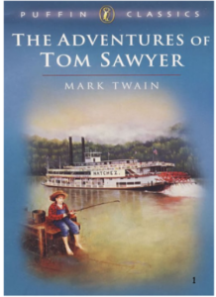
Summary:
It describes the exciting adventures of Tom Sawyer and his friends. Tom and his friends do chores and find treasure together. They also play on an island and run away from bad people. My opinion:
I really enjoy this book because it is both exciting and funny. I love the character Tom best. He is fun-loving and brave, though he often gets into trouble. The story tells us we should fight for what is right even in difficult situations.
Star rating: ★★★★


16. Who is the writer of the book?
A. J. K. Rowling. B. O. Henry.
C. Mark Twain. D. William Shakespeare.
17. What is the relationship between Becky Thatcher and Tom Sawyer?
A. Cousins. B. Friends.
C. Sister and brother. D. Mother and son.
18. What kind of adventure does Tom experience?
A. Exciting. B. Terrible. C. Painful. D. Peaceful.
19. What does the story tell us in Su Yin’s opinion?
A. To find treasure. B. To make brave friends.
C. To enjoy the adventure. D. To fight for what is right.
20. Where is the text most probably taken from?
A. A tour guide. B. A reading website.
C. A science book. D. A nature magazine.
B
Every time I think of kindness, the word reminds me of a very small but warm moment in my life.
It was about 6 o’clock on a Friday afternoon. I walked back home after a tiring but exciting basketball game. I passed by my neighbor Mr. Li’s house and wanted to greet him as usual. He usually did some gardening at that time. But this time, he wasn’t in his yard, and the light in his house wasn’t on. Mr. Li was a sixty-year-old man with heart disease. He lived alone and hardly ever went out. I wondered: Where could he be? Although I was tired and wanted to go home as soon as possible, I decided to check on him.
I knocked on his door, but there was no answer. The big window was open and I peeked (窥视) in. I saw him lying on the ground. His face was pale and there was sweat (汗水) on his forehead. I was shocked, but I didn’t know how to deal with such an emergency. I told myself to calm down and called 120 at once. Later, he was taken to the hospital.
A week later, Mr. Li came back home and told everything to my parents. He was so thankful for my care and help. This experience influences me deeply: Even a small act of kindness can sometimes make a big difference.
21. What did Mr. Li usually do at about 6 p.m.?
A. Walked back home. B. Did some gardening.
C. Cleaned his window. D. Watched a basketball game.
22. How did the writer help Mr. Li?
A. By calling 120. B. By asking neighbors for help.
C. By helping him calm down. D. By knocking on a doctor’s door.
23. Which of the following best describes the writer?
A. Honest. B. Creative.
C. Talented. D. Warm-hearted.
24. What is the correct order of the story?
① I saw Mr. Li lying on the ground. ② I passed by Mr. Li’s house.
③ Mr. Li was thankful for my help. ④ Mr. Li was taken to the hospital.
A. ①→②→④→③ B. ①→④→②→③
C. ②→①→④→③ D. ②→④→①→③
25. What did the writer learn from this experience?
A. Old habits die hard.
B. Every coin has two sides.
C. Failure is the key to success.
D. A small act of kindness makes a difference.
C
China is well known as the Kingdom of Bamboo. More than 800 kinds of bamboo, 51% of all known kinds in the world, grow in China. China has the largest bamboo planted area. Most of China’s bamboo forests grow in the areas south of the Yangtze River.
Bamboo is one of the fastest-growing plants. It can reach a height of 20 meters in just about 60 days. It is widely used in the daily lives of Chinese people. Before paper was invented, people wrote on bamboo slips (竹简). Then bamboo was used for papermaking because it produced high-quality paper and was inexpensive. Today, it is still an important material for papermaking. Bamboo has also been used to create hats, shoes, chairs, houses, bridges and so on.
Bamboo is not just a useful plant. It is called the “gentleman” among plants because it has many good qualities. Its deep roots (根) teach us to have a strong will, and its empty inside reminds us not to be proud. It grows tall and straight, like a person who stands up for what is right. It can bend (弯腰) in the wind but not break. This is like a person who is strong in his or her beliefs but can also change to fit the situation. Bamboo can also grow again after being cut, showing the spirit of never giving up.
For a long time, bamboo has given artists many ideas. Writers have written poems and stories about bamboo to praise its beauty and strong character. Bamboo has also been a favorite topic for famous Chinese painters.
26. How many kinds of bamboo grow in China?
A. Over 800. B. 20. C. About 60. D. 51.
27. What is the second paragraph mainly about?
A. The shape of bamboo. B. The use of bamboo.
C. The history of bamboo. D. The kinds of bamboo.
28. Why is bamboo called the “gentleman” among plants?
A. It can bend in the wind. B. It grows tall and straight.
C. It has many good qualities. D. It can grow again after being cut.
29. What does the bamboo’s empty inside remind us of?
A. Don’t be proud. B. Stand straight.
C. Make a change. D. Never give up.
30. What can be the best title for the text?
A. Famous Poems in China B. The Kingdom of Plants
C. Bamboo in Chinese Culture D. The Material for Papermaking
D
These days, many artists are starting to use AI tools to help them create art. AI can improve the speed of drawing greatly. It often keeps the work in good quality, too. For example, an artist can finish creating a complete painting in just one hour with AI’s help.
However, some painters feel worried about using it. A big worry is that their own drawing could be stolen online. Also, pictures made by AI sometimes look a little unreal. The colors or shapes may not match perfectly.
Another question people often ask is: If a painting is made with AI’s help, can we still call it the painter’s own work? Some believe that since the painter chooses the idea, style and final look, it should still be seen as their creation. Others think that if AI does most of the drawing, the painter is more like a director than a real artist.
Still, AI drawing is becoming more and more popular among young creators. It allows them to try different styles easily and improve their skills faster. Some even join online communities to share their AI-assisted (AI辅助的) works.
So should painters use AI? Those who support it say it is a useful tool that helps them express ideas more freely. Others believe real art comes only from the human mind and hands. What do you think?
31. What do many artists use AI tools to do according to paragraph 1?
A. Match shapes. B. Create art.
C. Choose colors. D. Share works.
32. What is a big worry about painting with AI’s help?
A. AI drawing will be more popular.
B. Painters may lose their own styles.
C. Strangers will get your drawing skills.
D. Painters’ own pictures could be stolen online.
33. What does the underlined word “them” in paragraph 4 refer to?
A. AI tools. B. Online communities.
C. Young creators. D. Pictures made by AI.
34. Why is AI a useful tool for supporters according to the passage?
A. It makes drawing more interesting.
B. It provides more chances for painters.
C. It makes the painter more like a director.
D. It helps painters express ideas more freely.
35. How does the writer end the text?
A. By telling a story. B. By listing numbers.
C. By raising a question. D. By giving an example.
B卷（共50分）
第四部分 阅读提升（共两节；满分25分）
第一节 短文填空（共10小题；每小题1.5分，满分15分）
阅读下面短文，在空白处填入一个适当的单词或括号内单词的正确形式。
Shenzhen Bay Park is located on a major path (路线) migrating birds (候鸟) use to travel, called the East Asian-Australasian flyway. Every winter, ____36____ (thousand) of birds stop here to rest during their long journey. Bright city lights can harm the local environment and the birds, affecting their rest and travel plans. ____37____ (avoid) the effect, the park has started to reduce lighting in the evening.
The park doesn’t turn off all the lights. Instead, they turn off the lights only in certain areas. Some areas like main entrances, bus stops and key paths keep ____38____ (they) basic lights on. This makes sure that people can still visit the park ____39____ (safe) in the evening. Some areas are very important for the birds, so the park keeps them dark or uses only soft light. It is a smart measure (措施) based on science.
After the government ____40____ (decide) to reduce lighting, many local people online supported the move. Some thought it was a thoughtful ____41____ kind action. “Giving living space back to wild ____42____ (animal) is something we should strongly support,” one person said.
In fact, Shenzhen is not ____43____ only city doing this. Lanshan County in Hunan Province is also on this flyway. The county turns off public lights at a set time each evening from September ____44____ November. According to a report, even people dancing in the square turn off their lights, which is ____45____ (help) for birds to find their way.
第二节 完成图表（共5小题；每小题2分，满分10分）
阅读下面短文，根据短文内容，补全图表中所缺的信息。每空不超过3个单词。
Would you ride in a car that drives by itself? Driverless cars use cameras, sensors (传感器) and computers to see the road, stop at red lights and avoid other cars. They use AI to work out the quickest and safest route. Although driverless cars have these high-tech tools, not everyone wants to try them. Are driverless cars a good idea?
Some people think driverless cars are the future of travel. Driving long distances is hard on human drivers. But that’s not a problem for driverless cars. It can carry on without needing a break for the whole journey. If passengers want to sing or play games, they wouldn’t have to worry about distracting (使分心) the driver. What’s more, driverless cars will help build a whole new industry and create a large number of jobs for people over the next 10 years.
However, some have different opinions. Instead of trying out driverless cars, we should explore more planet-friendly ways to travel. Anyway, some passengers like talking to their taxi drivers, especially if they’re in a new city and want to ask questions about it. Though computer-operated cars might be efficient (效率高的) ways to get around, we should think about humans too. If driverless cars take over, what will taxi drivers do for a living instead? Besides, computers can get things wrong. In some areas, driverless cars have led to serious accidents.
Are 1. ________ cars a good idea?
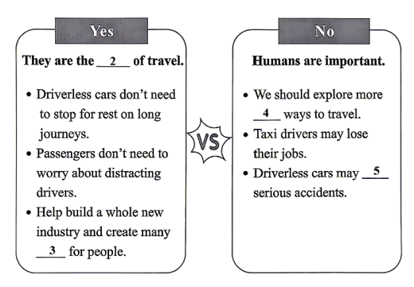
46. ________
47. ________
48. ________
49. ________
50. ________
第五部分 书面表达（满分25分）
51. 对于正处于成长关键期的中学生，身心健康才能绽放生命的美好。请你以Stay Healthy, Stay Happy为题写一篇英文发言稿，在英语口语课上分享，向同学们介绍保持健康的方法，并谈谈你的做法。
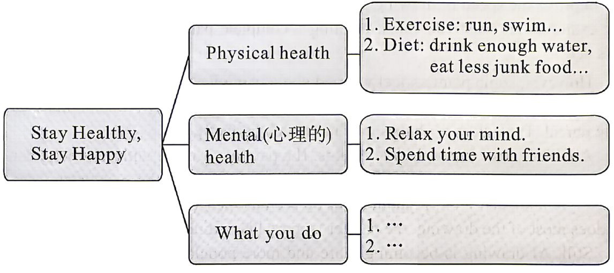
要求：1．参考以上思维导图，可适当发挥；
2．词数100左右（开头已给出，不计入总词数）；
3．文中不得出现真实人名、校名、地名。
Stay Healthy, Stay Happy
Hello, everyone! Today I want to share some ways to stay healthy with you. ___________________________________________________________________________________________________________________________________________________________________________________________________________________________________________________________________________________________________________________________________________________________________________________________________________________________________________________________________________________________________________________________________________________________________________________________________________________________________________________________________________________________________________________________________________________________________________________________
Thank you!

