
自贡市2026年初中学业水平考试暨高中阶段学校招生考试
英 语
注意事项：
1．本试卷分第 Ⅰ 卷(选择题)和第 Ⅱ 卷(非选择题)两部分，共12页，试卷满分150分，考试时间为120分钟。
2．答卷前，考生务必将自己的姓名、座位号、准考证号填写在答题卡上。答卷时，选择题部分必须使用2B铅笔将答案标号填涂在答题卡上对应题目标号的位置上。如需改动，用橡皮擦干净后，再选涂其他答案标号。非选择题部分，须用0.5毫米黑色签字笔书写。在本试题卷、草稿纸上答题无效。
3．考试结束后，将试题卷和答题卡一并交回。
第 Ⅰ 卷(选择题 共100分)
一、听力理解(共两节，满分30分)
第一节(共5小题;每小题1.5分，满分7.5分)
听下面5段对话。每段对话后有一个小题，从每题所给的A、B、C三个选项中选出最佳选项，并标在试卷的相应位置。听完每段对话后，你都有5秒钟的时间来回答有关小题和阅读下一小题。每段对话读两遍。
1. Which season does the man like best?
A.  B. 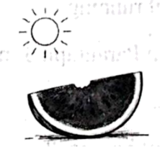 C. 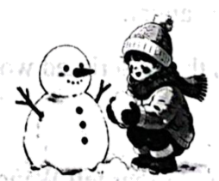
2. What is on the teacher’s desk?
A. 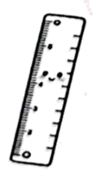 B. 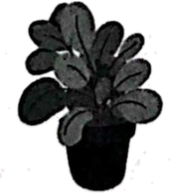 C. 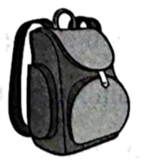
3. Where did the man leave his wallet?
A. 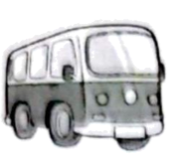 B.  C. 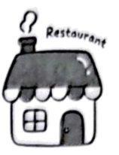
4. What does the girl want to drink?
A. 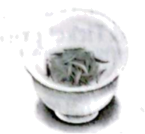 B. 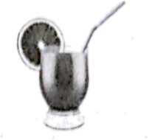 C. 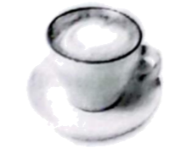
5. Which sign does the man mention?
A.  B.  C. 
第二节(共15小题;每小题1.5分，满分22.5分)
听下面几段对话或独白。每段对话或独白后有一个或几个小题，从题中所给的A、B、C三个选项中选出最佳选项，并标在试卷的相应位置。听每段对话或独白前，你将有时间阅读各个小题，每小题5秒钟。听完后，各小题将给出5秒钟的作答时间。每段对话或独白读两遍。
听下面一段材料，回答第6小题。
6. What size does the man need?
A. S. B. M. C. L.
听下面一段材料，回答第7小题。
7. How will the weather probably be in the afternoon?
A. Rainy. B. Sunny. C. Windy.
听下面一段材料，回答第8小题。
8. What will the woman probably do this weekend?
A. Go to a party.
B. Go to the movies.
C. Study for a test.
听下面一段材料，回答第9小题。
9. What’s the possible relationship between the speakers?
A. Friends. B. Strangers. C. Teacher and student.
听下面一段材料，回答第10小题。
10. How many people will go camping at most?
A. Two. B. Three. C. Four.
听下面一段材料，回答第11至12题。
11. Who does Peter usually play ping-pong with?
A. His friend. B. His cousin. C. His brother.
12. How often does Peter play ping-pong?
A. Twice a week.
B. Three times a week.
C. Four times a week.
听下面一段材料，回答第13至15题。
13. When did Sally take part in the singing competition?
A. In Grade 7. B. In Grade 8. C. In Grade 9.
14. Why could Sally win first prize?
A. She was lucky.
B. She practiced a lot.
C. She got much help.
15. What’s Sally like?
A. Shy. B. Humorous. C. Hard-working.
听下面一段独白，回答第16至20题。
16. Where did the students go yesterday morning?
A. The club. B. The school. C. The community.
17. How did the students get the idea?
A. By watching a video.
B. By reading a newspaper.
C. By listening to the radio.
18. What did the students do yesterday?
A. They cleaned the park.
B. They swept the classroom.
C. They picked up the rubbish.
19. What are the students talking about now?
A. A video.
B. Their study.
C. Their next Clean-up Day.
20. What does the news want to tell us?
A. It’s tiring to do the cleaning.
B. The students are good at cleaning.
C. Everyone should care for the environment.
二、完形填空(共15小题;A篇每小题2分，B篇每小题1分，满分20分)
阅读下面A、B两篇短文，掌握其大意，然后从题中所给的A、B、C三个选项中，选出可以填入相应空白处的最佳选项。
A
Mobile phones are useful, but you should use them wisely. To protect your eyes, every 20 minutes, you should rest your ____1____ and look at something far away. What’s more, you could make your screen brighter or ____2____ to match your environment. Of course, you shouldn’t look at your phone just before you go to bed, ____3____ you certainly shouldn’t look at it when you cross the ____4____ for traffic safety! In fact, you should avoid using your phone too often. You could listen to music instead of watching videos. You could also ____5____ your friends face to face instead of sending them messages.
1. A. eyes B. ears C. hands
2. A. wider B. darker C. bigger
3. A. so B. and C. but
4. A. room B. street C. river
5. A. talk to B. call up C. write to
B
My deskmate Jake was noisy, messy and often borrowed my pens without asking. I thought he was ____6____. So I hated him and never spoke to him.
One morning, I found a ____7____ on my desk. It said, “Sorry, I’m so bad. I don’t have many friends. I just want to talk to you but I’m afraid you will laugh at me.” My ____8____ for him went away. I had been so busy judging him that I never ____9____ him why he acted that way.
After school, I waited for Jake. When he came, I said so ____10____ that others couldn’t hear us. “I read your note. I’m sorry, too. I was cold to you.” Jake looked ____11____ but still told me that his family often ____12____. Every time he made friends, he left. He did some silly things to make people ____13____ him. He was also afraid of talking — afraid he would say something wrong. We talked for hours. Jake was good at drawing and I did well in writing. I started helping him with writing, and he ____14____ pictures for my stories. At the end of the term, we were best friends.
I learned that most problems come from silence. When you stop guessing and start talking, you can turn enemies into ____15____ and true friendship grows.
6. A. unhappy B. unlucky C. impolite
7. A. pen B. note C. book
8. A. fear B. worry C. dislike
9. A. told B. asked C. advised
10. A. quietly B. quickly C. angrily
11. A. bored B. awful C. surprised
12. A. moved B. broke C. argued
13. A. trust B. admire C. notice
14. A. drew B. carried C. bought
15. A. friends B. families C. classmates
三、阅读理解(共 20 小题;每小题 2 分，满分 40 分)
阅读下列短文，从每小题所给的 A、B、C 三个选项中选出最佳选项。
A
Have Fun in Zigong
Zigong lies in southern Sichuan and is known as the Capital of Salt, the City of Lanterns and the Hometown of Dinosaurs. It’s easy to get there by high-speed train. You can have fun in the following places.
Places | What you can do | Opening hours & Ticket prices
Zigong Dinosaur Museum  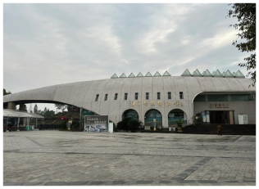 | ◆See dinosaur fossils (化石).  ◆Learn about the knowledge of dinosaurs.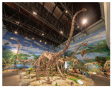  ◆Buy dinosaur toys. | Opening hours: 8:30—17:30  Ticket price: ¥ 40 for an adult Free for children
Zigong Salt History Museum  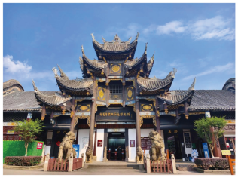 | ◆Study the well salt history.  ◆See different tools for making salt.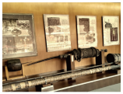  ◆Listen to the stories of the salt businessmen. | Opening hours: 8:30—17:30  Ticket price: ¥ 35 for an adult Free for children
Zigong International Dinosaur Lantern Show   | ◆Enjoy colorful lanterns.  ◆Watch amazing shows.  ◆Taste delicious local food. | Opening hours: 17:00—22:30  Ticket prices: ¥ 98—¥ 168 for an adult Free for children less than 130 cm in height

16. How many famous places in Zigong are mentioned in the passage?
A. One. B. Two. C. Three.
17. What can you do at Zigong Dinosaur Museum according to the passage?
A. See dinosaur fossils.
B. Enjoy colorful lanterns.
C. Study the well salt history.
18. How much will it cost if a couple and a six-year-old boy go to Zigong Salt History Museum?
A. 35 yuan. B. 70 yuan. C. 105 yuan.
19. What time does the lantern show open?
A. At 8:30. B. At 17:00. C. At 17:30.
20. Where is the passage most probably taken from?
A. A novel. B. A travel guidebook. C. A fashion magazine.
B
In a small village lived Wang Ming, a 16-year-old boy from a poor family. He had a dream to become a great runner.
Wang Ming wasn’t the fastest, nor the smartest in the school. But he had one silent power. For two years, he kept training every morning. And he took part in every local race but always came second or third. His friends laughed at him and said he was wasting his time. Yet, he kept running day after day.
One rainy day, Wang Ming fell over and hurt his foot. Tired and depressed, he sat under a tree, crying sadly. An old farmer asked why. After hearing his story, the farmer pointed to a bamboo forest. “Do you know how long it takes bamboo to grow? For five years, nothing shows above the ground. But during that time, the roots (根) are growing strong. Then, it shoots up nearly 80 feet tall before you know it. That’s the power of never giving up, son. You should be like bamboo.”
One year later came a big race. Wang Ming crossed the finishing line first and won the following races. He finally achieved his dream to be a top runner.
Years later, Wang Ming met the farmer again. “Your words saved me from giving up.” he said. The farmer replied, “I only reminded you. You always have the power.”
21. What did Wang Ming want to be?
A. A runner. B. A farmer. C. A worker.
22. What happened to Wang Ming after his friends laughed at him?
A. He was angry.
B. He kept running.
C. He gave up running.
23. What does the underlined word “depressed” in Paragraph 3 mean?
A. Upset. B. Scared. C. Nervous.
24. Why did the farmer tell Wang Ming the story of bamboo?
A. To explain how fast bamboo grows.
B. To remind him to learn from bamboo.
C. To show how strong bamboo roots are.
25. What’s the main idea of the passage?
A. Never give up.
B. Never laugh at others.
C. Never too late to learn.
C
On a spring morning, a student named Le Zongyan from Shenzhen Bao’an Middle School, was studying for exams while a bird kept calling loudly outside the window. He was troubled by the noise, so he wrote a letter to the headmaster, suggesting taking away the bird’s nest (巢).
The headmaster Yuan Weixing was touched by the letter. He realized the students’ need for a quiet study environment, and then he wrote a thoughtful reply.
Yuan expressed his understanding of the pressure students faced. He explained birds sing loudly for dating and communication instead of making noise. “The world does not only belong to humans.” Yuan wrote, “Learning to live peacefully with all living things is a necessary part of growing up. The real goal of education is not to ask the world to change for us, but to help us learn how to get along with the world.”
“Simply driving the birds away wouldn’t be suitable, but doing nothing wasn’t good, either,” Yuan said. The school then invited environmental experts and students to discuss practical solutions—to provide earplugs (耳塞) to the students in the dorms (寝室) near the wooded areas. At the same time, man-made nests were set up to guide the birds away from the classrooms and dorm buildings.
This simple problem became a life lesson about living in peace with nature.
26. How does the writer start the text?
A. By listing numbers.
B. By describing a scene.
C. By asking a question.
27. Why do birds sing loudly?
A. To express joy.
B. To trouble students.
C. To date and communicate.
28. What’s the right order of the following events?
① The student wrote a letter to the headmaster.
② Headmaster Yuan wrote a thoughtful reply to the student.
③ The school provided earplugs and set up man-made nests.
④ The school invited environmental experts to discuss solutions.
A. ①②④③ B. ①④②③ C. ③①④②
29. Which of the following best describes the character of Headmaster Yuan?
A. Warm. B. Crazy. C. Strict.
30. What can the students learn from this experience?
A. Schools should meet the students’ needs.
B. Humans should live with nature peacefully.
C. Birds are more important than students’ exams.
D
A Chinese-made shield tunneling machine (盾构隧道机) named “Linghang” is making history. It’s digging a 14.25-kilometer tunnel to allow high-speed trains to travel under the Yangtze River. It had completed 11.18 kilometers by March 29 this year.
“Linghang” is 148 meters long and weighs about 4,000 tons, making it the world’s largest high-speed rail shield tunneling machine. It also has many high technologies, such as a smart digging system and another system to keep water out under high water pressure. Besides, it can give early warnings in real time. These advantages help “Linghang” deal with challenges like huge water pressure, complex geology (复杂的地质) and non-stopping digging. Once finished, the tunnel will allow high-speed trains to cross the river at 350 km/h without slowing down.
This project shows China’s growing power in infrastructure (基础建设). Twenty years ago, China had no shield tunneling machines. ▲ But today, Chinese-made shield tunneling machines are sold to over 40 countries, holding 70% of the market of the world. As one engineer said, “This is not just a technical achievement. It shows China’s leading role in building high-speed underwater tunnels.” Under the great river, China is building a road to the future.
31. How long is the tunnel under the Yangtze River?
A. 148 meters. B. 11.18 kilometers. C. 14.25 kilometers.
32. What does the underlined word “it” in Paragraph 2 refer to?
A. The tunnel.
B. The high-speed rail.
C. The “Linghang” machine.
33. What do we know about “Linghang”?
A. It has a long history.
B. It has high technologies.
C. It has huge water pressure.
34. Which sentence can be put in the ▲ in Paragraph 3?
A. We had a digging system.
B. We had to buy them from abroad.
C. We couldn’t cross the Yangtze River.
35. What is the writer’s purpose in writing the text?
A. To explain how “Linghang” works.
B. To introduce what “Linghang” looks like.
C. To show China’s power in infrastructure.
四、口语交际(共5小题;每小题2分，满分10分)
阅读下面对话，从6个选项中选择5个恰当的句子完成此对话。
(Anna meets Paul on the playground. )
Paul: Hey, Anna. Where are you going?
Anna: Hi, Paul. ____36____
Paul: What kind of books do you prefer?
Anna: ____37____
Paul: Me too, but I’m a slow reader. Can you give me some advice?
Anna: ____38____ Try reading in word groups.
Paul: That sounds helpful. I’ll have a try.
Anna: We often share English books with each other in the English reading club. ____39____
Paul: I’d love to. When do you usually meet?
Anna: Every Monday and Thursday after school.
Paul: That’s great!
Anna: ____40____
A. See you then.
B. English novels.
C. Would you like to join us?
D. Sure! Don’t read word by word.
E. Why do you like reading novels?
F. I’m going to the library for some books.
第 Ⅱ 卷(非选择题 共50分)
注意事项：必须使用0.5毫米黑色签字笔在答题卡上题目所指示区域内作答，答在试题卷上无效。
一、补全单词(共5小题;每小题1分;满分5分)
根据句意及首字母提示写出完整的单词。
41. It’s a good way to ride a b________ for exercise.
42. We all like h________ people who never tell a lie.
43. If you want to p________ the exam, you must study hard.
44. There are many whales and sharks living in the blue s________.
45. Please t________ the story of Jiang Zhujun into different languages to let more foreigners know her.
二、短文填空(共10小题;每小题1.5分，满分15分)
阅读下面短文，在空白处填入1个适当的单词或括号内单词的正确形式。
In 2016, Derek Poskin followed a poem by Li Bai to arrive in China and developed a growing love for Chinese tea culture. These years, he ____46____ (become) a tea businessman already, finding good tea leaves across China and selling them to customers ____47____ (wide) in the world.
He thinks coffee is for work, but tea is for life. He started a business to connect Western drinkers ____48____ Chinese tea traditions in 2018. Instead of buying tea from other businessmen ____49____ sell tea directly, he travels to Yunnan’s ancient forests and Fujian’s oolong gardens to buy it himself.
He thinks it’s ____50____ (wonder) to be part of the living tea culture. Once in Guafengzhai, ____51____ small village in Yunnan, he picked, sun-dried, and roasted (烘) tea leaves with the local ____52____ (villager). In Chaozhou, Guangdong Province, he spent a year ____53____ (learn) to make clay teapots used for gongfu cha.
He thinks Chinese tea culture is changeable—every place has ____54____ (it) own style, and any way is right. For him, tea leaves are only the surface. The true depth lies not only in the land, in the people, ____55____ also in Chinese traditions.
三、阅读表达(共5小题，每小题2分，满分10分)
根据短文内容，完成图表中所缺信息，每空一词。
Do you save old movie tickets or candy wrappers in your bag?
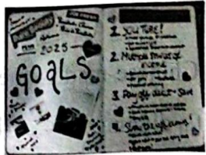
Instead of throwing them away, many young people are now turning this “junk” into art. This is called junk journaling (垃圾手账). It is a popular art of making your journals with old things like train tickets or photos. These things show where you’ve been and what you’ve done. They can help to keep your memories alive in a new way.
Why is junk journaling popular? First, there are no rules. You don’t need to be a great artist or spend much money. Just glue things together and have fun. What’s more, it is also about making friends. Everyone can go to the clubs to show their works and tell stories through their pages.
Making a junk journal is easy and fun. First, just find an old book cover. Fold it in half to make the cover of your junk journal. Then, get your pages ready with different kinds of paper. Next, put the pages into the cover and tie them together. Finally, make it beautiful! Add small bags or stickers (贴纸). Glue your movie tickets or photos in them. Remember: there are no rules. Just have fun and use your hands to tell your own stories!
Junk Journaling
Meanings of a junk journal | ◆ It shows where you’ve been and what you’ve done.  ◆ It keeps your memories ____56____ in a new way.
Reasons for the ____57____ of junk journaling | ◆ There are no rules and you can have fun.  ◆ It helps build friendships.
Steps to make a junk journal | ◆ Find an old book cover and ____58____ it in half to make a cover.
Steps to make a junk journal | ◆ ____59____ your pages with different kinds of paper.
Steps to make a junk journal | ◆ Put the pages into the cover.
Steps to make a junk journal | ◆ Make the journal beautiful by ____60____ stickers or small bags.

61. 新年伊始，青少年健康再次成为教育关注的热点话题。假如你是李华，学校英语期刊发起了以“Health First”为主题的征文活动，请根据以下图示写一篇英语短文投稿。
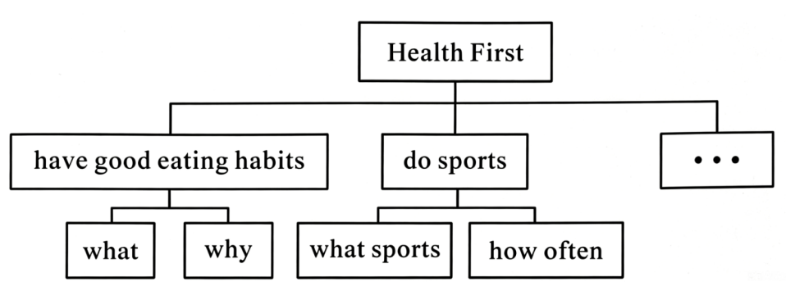
注意：
1．短文需包含以上提示信息，可适当发挥；
2．词数80左右(标题、开头已写好，不计入总词数)；
3．文中不得出现真实人名和校名。
Health First
The “Health First” topic is hot again this year. As we know, health is very important for us teenagers.________________________________________________________________________________________________________________________________________________________________________________________________________________________________________________________________________________________________________________________________________________________________________________________________________________________

