
英 语
听力部分（共20分）
一、情景反应（每小题1分，共5分）
本题共有五个小题，每小题你将听到一组对话。请从每小题所给的A、B、C三幅图片中，选出与你所听到的信息相关联的一项，并在答题卡上将该项涂黑。
1. A. 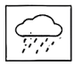 B. 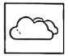 C. 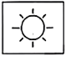
2. A. 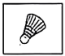 B. 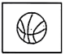 C. 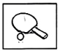
3. A. 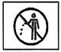 B. 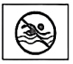 C. 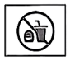
4. A. 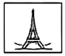 B. 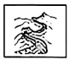 C. 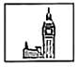
5. A. 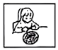 B. 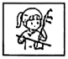 C. 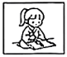
二、对话理解（每小题1分，共5分）
本题共有五个小题，每小题你将听到一组对话和一个问题。请从每小题所给的A、B、C三个选项中，选出一个最佳选项，并在答题卡上将该项涂黑。
6. A. John. B. Tina. C. David.
7. A. By car. B. By bike. C. By bus.
8. A. 6 yuan. B. 10 yuan. C. 16 yuan.
9. A. A teacher. B. A doctor. C. A reporter.
10. A. He is afraid of running.
B. He will keep on practicing.
C. He likes travelling to far places.
三、语篇理解（每小题1分，共5分）
本题你将听到一个语篇，请根据语篇内容和所提出的五个问题，从每小题所给的A、B、C三个选项中，选出一个最佳选项，并在答题卡上将该项涂黑。
11. Where did Li Hua’s family go last weekend?
A. To a park. B. To a farm. C. To a zoo.
12. What did Li Hua do after arriving?
A. He collected leaves.
B. He took a lot of photos.
C. He walked along the river.
13. Who told Li Hua stories about the old trees?
A. His father. B. His mother. C. His brother.
14. Why did Li Hua feel excited?
A. Because he had a picnic.
B. Because he found the way back.
C. Because he met his geography teacher.
15. What can we learn from the story?
A. Interest is the best teacher.
B. Love makes the world a better place.
C. Knowledge from textbooks helps in real life.
四、听力填空（每小题1分，共5分）
本题你将听到一个语篇，请根据所听内容，完成下面的句子，并将答案写在答题卡相应的位置上。每空一词。
Start a New Journey
Be ________.
Try to do ________ small things every week.
Read more.
·Reading is a ________ to the world.
·Reading lets you ________ in the sea of imagination.
Work with others.
Group work can influence your lives ________.
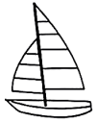
笔试部分（共100分）
五、补全对话（每小题2分，共10分）
请根据下面的对话内容，在空白处填上一个适当的句子，使对话的意思连贯、完整，并将答案写在答题卡相应的位置上。
(Two students are talking on the street.)
Teng Fei: Hi, I’m Teng Fei. It’s my first time to come here.
Liu Qiang: Hi, Teng Fei. I’m Liu Qiang. ____________________________1____________________________
Teng Fei: Glad to meet you, too! Is there a science and technology museum nearby?
Liu Qiang: ____________________________2____________________________
Teng Fei: I heard we can see the scenes of the first men landing on the Moon there.
Liu Qiang: Exactly. You can also know about China’s space exploration (探索).
Teng Fei: Cool! ____________________________3____________________________
Liu Qiang: Sure. Just go along this street, turn left at the first crossing, and you can find it.
Teng Fei: I see. ____________________________4____________________________
Liu Qiang: The museum usually closes at 5:00 p.m.
Teng Fei: OK. Thank you very much.
Liu Qiang: ____________________________5____________________________ Have a good time!
六、完形填空（每小题1分，共8分）
请阅读下面语篇，根据其内容，从每小题所给的A、B、C三个选项中，选出一个能填入空白处的最佳选项，并在答题卡上将该项涂黑。
Peter’s father was a man of few words. He ____6____ had a heart-to-heart talk with Peter. He was busy with his work and usually got home very late. How Peter ____7____ his father could play basketball or go fishing with him!
One evening, while working on a math problem, Peter found it so difficult that he wanted to ____8____. He was about to close the book when a small yellow note fell out ____9____. On it was a short message with a lovely hand-drawn heart. It said, “You can do it! — Dad”. Peter felt ____10____. Soon he found another note in his English dictionary, and one more in his favorite magazine. ____11____ he saw those notes written in his father’s beautiful handwriting, he was lost in thought.
Peter looked towards the door. He pictured his tired father coming home late and opening his schoolbag to leave these simple words of ____12____. His father never said “I love you”, but his love was hidden in every ____13____. His love might be silent, but it was always there, like a mountain.
Feeling a sudden rush of warmth, Peter picked up his pen again.
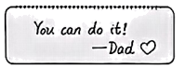
6. A. always B. sometimes C. hardly
7. A. wished B. doubted C. believed
8. A. wake up B. give up C. stay up
9. A. suddenly B. safely C. heavily
10. A. bored B. surprised C. nervous
11. A. Unless B. Though C. When
12. A. agreement B. punishment C. encouragement
13. A. page B. talk C. mountain
七、阅读理解（本题共有五个语篇，每篇后有五个小题，34-57每小题2分，58小题4分，共52分）
(A)
请阅读下面语篇，从每小题所给的A、B、C三个选项中，选出一个最佳选项，并在答题卡上将该项涂黑。
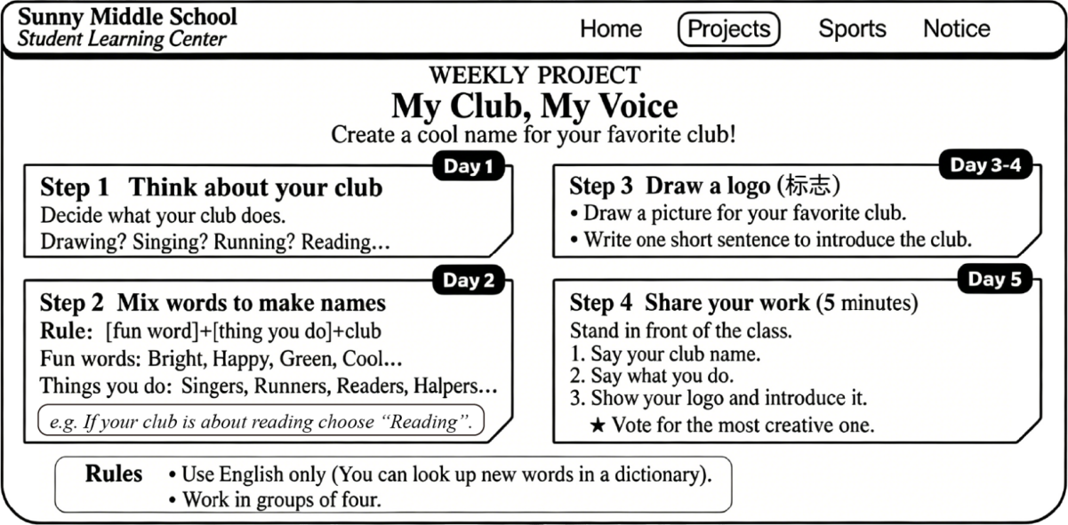
14. What is the project for?
A. Practicing your sports.
B. Creating a cool club name.
C. Talking about the dream job.
15. How long does the project last?
A. For four days. B. For five days. C. For six days.
16. Which name follows the rule of Step 2?
A. Club Runners Green.
B. Runners Green Club.
C. Green Runners Club.
17. Which of the following activities is part of Step 4?
A. Drawing a picture. B. Making a team. C. Sharing a logo.
18. Where can you read the text?
A. On a website. B. In a diary. C. In a storybook.
(B)
请阅读下面语篇，从每小题所给的A、B、C三个选项中，选出一个最佳选项，并在答题卡上将该项涂黑。
Every time Steve woke up, he felt his right hand was on fire. He could not lift a cup or touch cold water. The medicine he took didn’t work well. But one day, he put on a VR (虚拟现实) headset and things began to change.
VR treatment is being used in medical fields, especially for helping people with chronic (慢性的) pain. In fact, VR can give people experiences that are similar to the real world. In a VR program, Steve was trying out a VR headset. Surprisingly, it took him to a different situation where he was able to move his right hand slowly. Jenny also received the VR treatment in this program. Her back pain bothered her for years. Wearing a VR headset, she was surprised to find she got a little better.
So how does VR help? Scientists say that the pain is not only about the body. It also has something to do with the brain. When you fully focus on something exciting, your brain pays less attention to the pain. VR uses this idea to help people feel better.
Of course, VR treatment may not suit everyone suffering from pain. It is still being studied, but for those living with pain every day, VR technology brings something important: hope.
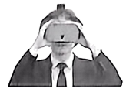
19. How does the writer start the text?
A. By listing a number.
B. By asking a question.
C. By giving an example.
20. What did Steve do after putting on a VR headset?
A. He lifted his cup quickly.
B. He touched his back easily.
C. He moved his hand slowly.
21. What does the underlined word “bothered” probably mean in Paragraph 2?
A. Protected. B. Troubled. C. Covered.
22. How does VR make people feel less painful according to the text?
A. By making the brain focus less on pain.
B. By making the body stronger to fight pain.
C. By giving people medicine through the headset.
23. Which of the following ideas does the writer probably agree with?
A. VR treatment is suitable for everyone.
B. People pay little attention to VR treatment.
C. VR treatment can help people in some ways.
(C)
请阅读下面语篇，从每小题所给的A、B、C三个选项中，选出一个最佳选项，并在答题卡上将该项涂黑。
Ieoh Ming Pei was known as the master of modern architecture (建筑). He designed (设计) many famous buildings and landmarks around the world.
Pei was born in Guangzhou in 1917. He grew up in a family that valued education and traditional art. Suzhou was his ancestral hometown. Pei spent most of his childhood holidays there. During those holidays, he would visit the gardens whenever he had time. Seeing those rocks, stone bridges and waterfalls, he began to show interest in them. At the age of ten, Pei moved with his family to Shanghai. The city’s international architectural style had a strong influence on him. He decided to become an architect. In 1935, Pei went abroad to study. When he was 38, he started his company in New York. In 1983, he won the Pritzker Prize, the highest honor in architecture.
One of Pei’s most famous works is the glass pyramid in front of the Louvre Museum (卢浮宫) in Paris, which was designed in 1989. It showed his idea—let light design the buildings. Many people disliked it because it was so different from the traditional architecture at that time. But today, it is one of the most popular places in France. Suzhou Museum is another work of his. It opened in 2006 and became a must-go place later. Pei explained, “It should belong to Suzhou, but also to the world. It should be traditional, yet modern.” He left over 50 designs during his life.
Pei passed away in 2019 at the age of 102. His designs are regarded as the gifts to the world.
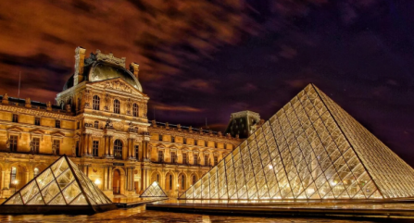
24. Where did Pei begin to show interest in gardens?
A. In Suzhou. B. In Guangzhou. C. In Shanghai.
25. What is the right order of the following facts according to Paragraph 2?
① He moved to Shanghai. ② He won the Pritzker Prize. ③ He began to study abroad.
A. ①②③ B. ①③② C. ③①②
26. What is the glass pyramid in front of the Louvre Museum like today?
A. It is very popular. B. It is easily broken. C. It is quite traditional.
27. What does Paragraph 3 mainly talk about?
A. Pei’s experiences. B. Pei’s achievements. C. Pei’s background.
28. What can be the best title for the text?
A. Science Opens up Mind
B. Prize Builds up Courage
C. Architecture Lights up Life
(D)
请阅读下面语篇，根据其内容，从所给的选项中选出能填入空白处的最佳选项，使其意思通顺，并在答题卡上将该项涂黑。选项中有一项为多余选项。
Imagine you have just cleaned your classroom. Then a strict teacher in school walks in, looks around, and gives you a big smile. ____29____ But this time the testers are birds.
In recent years, groups of rare (稀有的) birds like black storks and egrets have been seen along the Fenhe River. ____30____ These birds are very picky: they only live near clean water. Their arrival makes the river full of life.
Things were quite different in the past. There were few rare birds. ____31____ Because the river was polluted seriously. Then the government started a plan to bring the river back to life. Workers spared no effort to turn dirty water into clean water. ____32____ These wetlands helped clean the water. The water quality has improved a lot.
____33____ There are more plants growing in the wetlands. More and more birds choose the Fenhe River as their winter home.
When people take care of nature, nature gives back. The balance between humans and nature has become a reality in Shanxi.
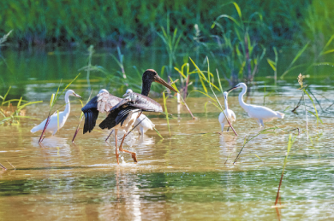
A. Why was that?
B. They rest along the river banks playing happily.
C. The results of people’s hard work are easy to see.
D. The Fenhe River is the mother river of Shanxi Province.
E. That is exactly what is happening along the Fenhe River.
F. What’s more, they cleaned and added wetlands along the river.
(E)
请阅读下面语篇，根据其内容回答问题，并将答案写在答题卡相应的位置上。
Money is part of our life. So we are faced with the same question: what to do with our money?
Smart spending (理性消费) means using money in a way that fits real needs, real value and real plans.
In daily life, teenagers usually spend most of their money buying something necessary—food, clothes or school things. But sometimes, they buy things they don’t really need. Following the crowd may lead teenagers to buy something unnecessary. For example, when some classmates have the same kind of pencil case, a teenager may feel unhappy about having a different one. So he will buy a new one like theirs.
Teenagers can start learning how to manage money wisely at an early age. On Tom’s 6th birthday, his grandmother gave him several jars (罐子) to help him make good use of money. One was for spending, one for saving and another for giving. It was at that time that Tom started his own money journal (记账本) to record where the money had gone. He has had this habit since then.
 | Date | Spending | Things | Remaining
 | May 2nd | ¥18 | A film ticket | ¥82
 | May 9th | ¥25 | A scarf for Mum | ¥57
 | May 15th | ¥35 | A dictionary | ¥22
 | May 28th | ¥12 | Snacks and drinks | ¥10
Tom’s birthday present is more than several jars. His grandmother has given a kid the chance to learn lifelong values. The wider goal of the jars is to encourage teenagers to think more wisely about the money and the things they can do.
News
Xingfu Community Plants 8 Trees with Saved Money
This spring, Xingfu Community started a “Tree Bank” activity. Many teenagers took part in it. With their saved money, they bought 8 young trees. On Tree Planting Day, they planted the trees on a hill outside the city. “One coin can bring social meaning,” said a teenager.

34. What does smart spending mean?
______________________________________________________
35. What may lead teenagers to buy something unnecessary?
______________________________________________________
36. Why did Tom’s grandmother give him several jars?
_____________________________________________________
37. What were the top two things Tom spent money on in May?
______________________________________________________
38. Will you give away money like the teenagers in Xingfu Community? Why or why not?
__________________________________________________________________________________________________________________________________
八、词语运用（本题共有两个语篇，A篇有五个小题，B篇有十个小题，每小题1分，共15分）
(A)
请阅读下面语篇，根据其内容，将适当的单词填入空白处，并将答案写在答题卡相应的位置上。每空一词。
 How to Improve Memory 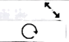
You may find it hard to remember what you have learned in class. In fact, it’s quite common to _____39_____ things. Here is some advice.
You can use songs to help you. Pick a song _____40_____ interests you. Change what you need to remember into its lyrics. Then you can memorize them as you sing. It is relaxing and easy.
A mind map helps you organize information in a visual (视觉的) way. We need several steps to create a mind map. First, write the main idea in the center. For example, write “_____41_____” in the center. Then, write other key ideas around the main idea like “the Mid-Autumn Festival”, “the Spring Festival”, “the Dragon Boat Festival” and so on. Next, write more words about the key ideas like “date”, “food”, “activities” and so on. Now, look _____42_____ the mind map. It’s very helpful, right?
No one can remember everything, _____43_____ everybody can learn how to improve their memory. Follow the tips, and you will make progress.
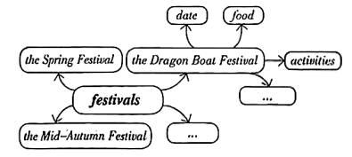

(B)
请阅读下面语篇，根据其内容，从方框内选出适当的单词，将其正确形式填入空白处，并将答案写在答题卡相应的位置上。方框中有两个词为多余选项。
I run luck tell share clear see old idea move visit decide
I am a British student studying history at Shanxi University. Last Sunday, I ____44____ Jinci Museum. It was a trip that I had planned for a long time.
After stepping inside, I saw a wooden building standing in front of me. I ____45____ by a local guide that it was the Shuijing Stage, an old theater dating back to the Ming and Qing Dynasties. When an opera singer sang on the stage, everyone in the yard could hear the voice ____46____. I looked closely at its wooden structure. There were no modern machines, just hands and clever ____47____ from ancient builders. The wisdom and creativity of Chinese people surprised ____48____ a lot.
What also caught my attention was the ancient trees. The guide told me that one of them, the Zhou Cypress (柏树), was planted during the Western Zhou Dynasty. It was much ____49____ than I had ever imagined. Watching its dark green leaves dancing in the wind, I found myself lost in its beauty. I felt ____50____ to have the chance to go there. It was an unforgettable experience, which made me fall in love with Chinese culture. I made a ____51____ to go to more places of interest in Shanxi.
Now I understand why people say, “If you want ____52____ thousands of years of Chinese civilization (文明), you should come to Shanxi.” I ____53____ the experience with my friends when I return to my hometown next month. The history of Shanxi is more than just stories of the past. It is also a cultural treasure.
九、书面表达（共15分）
54. 在成长的过程中，每一次突破往往始于“一小步”；是不会骑车的你开始学骑自行车；是擅长跑步的你再次刷新自己的最好记录；是内向的你主动参加志愿服务……迈出这“一小步”，你就突破了自我。你校英语社团将举办以“A small step, a big breakthrough (突破)”为主题的演讲活动，请结合自己的亲身经历，用英语写一篇演讲稿。
内容包括：
• what small steps are in your eyes
• one of your experiences of taking a small step
• the influence that the experience has on you
要求：
1．词数不少于80词，开头和结尾已给出，不计入总词数；
2．文中不得出现真实的人名、校名。
Hello, everyone! ___________________________________________________________________________________________________________________________________________________________________________________________________________________________________________________________________________________________________________________________________________________________________________________________________________________________________________________________________________________
That’s all. Thank you!

