
机密★启用前
2026年广东省初中学业水平考试
英语
本试卷共12页，81小题，满分120分。考试用时90分钟。
注意事项：1．答题前，考生务必用黑色字迹的签字笔或钢笔将自己的准考证号、姓名、考场号和座位号填写在答题卡上。用2B铅笔在“考场号”和“座位号”栏相应位置填涂自己的考场号和座位号。将条形码粘贴在答题卡“条形码粘贴处”。
2．作答选择题时，选出每小题答案后，用2B铅笔把答题卡上对应题目选项的答案信息点涂黑；如需改动，用塑料橡皮擦干净后，再选涂其他答案，答案不能写在试卷上。
3．非选择题必须用黑色字迹的签字笔或钢笔作答，答案必须写在答题卡各题目指定区域内相应位置上；如需改动，先划掉原来的答案，然后再写上新的答案；不准使用铅笔和涂改液。不按以上要求作答的答案无效。
4．考生必须保持答题卡的整洁。考试结束后，将试卷和答题卡一并交回。
一、听说应用（本大题共30小题，每小题1分，共30分；A、B、C、D部分为听力理解，E部分为情景对话）
A．听句子（本题共5小题，每小题1分，共5分）
请根据所听内容，选择符合题意的图画回答问题，并在答题卡上将对应选项涂黑。每个句子听两遍。
1．What was the weather like last Saturday?
A.  B.  C. 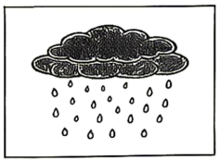
2. Where did Li Hua and his parents go?
A. 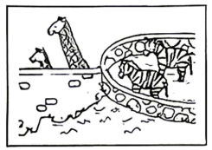 B. 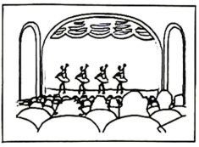 C. 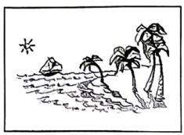
3. What did Li Hua buy?
A. 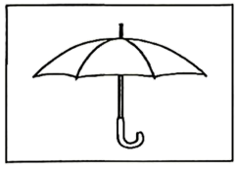 B.  C. 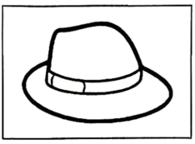
4. What did they have for lunch?
A. 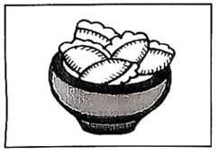 B. 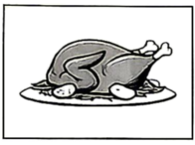 C. 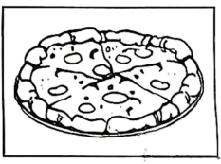
5. How did they go home?
A. 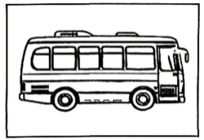 B. 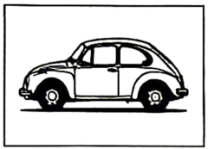 C. 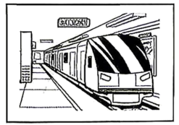
B．听对话（本题共10小题，每小题1分，共10分）
请根据每段对话的内容回答问题，从每小题所给的三个选项中选出一个最佳答案，并在答题卡上将对应选项涂黑。每段对话听两遍。
听第一段对话，回答第6小题。
6. What will Mary talk about in her speech?
A. Future jobs. B. Moon travels. C. Smart cities.
听第二段对话，回答第7小题。
7. Which floor should the woman go to?
A. The second floor. B. The third floor. C. The fourth floor.
听第三段对话，回答第8小题。
8. How was Frank’s weekend?
A. Busy. B. Boring. C. Relaxing.
听第四段对话，回答第9小题。
9. How does Adam keep fit?
A. By swimming. B. By jogging. C. By skating.
听第五段对话，回答第10小题。
10. Who are they talking about?
A. A scientist. B. A writer. C. A painter.
听对话，回答小题。
11. What is the matter with Tom?
A. He has a fever. B. He has a headache. C. He has a stomachache.
12. What will the woman do next?
A. Heat some milk. B. Call the doctor. C. Have breakfast.
听对话，回答小题。
13. Which club is Lucy in?
A. The cooking club. B. The writing club. C. The drama club.
14. Why does Lucy join the club?
A. To make friends. B. To build confidence. C. To practice English.
15. How often do the club members meet?
A. Once a week. B. Once a month. C. Twice a month.
C．听短文（本题共5小题，每小题1分，共5分）
请根据所听内容，从每小题所给的三个选项中选出一个最佳答案，并在答题卡上将对应选项涂黑。短文听两遍。
16. When was the school singing competition?
A. In June. B. In September. C. In December.
17. Where did the class practice singing?
A. In the classroom. B. In the music hall. C. In the playground.
18. Who took pictures of the class in the competition?
A. Schoolmates. B. Teachers. C. Parents.
19. How did the class feel when they gave the performance?
A. Excited. B. Nervous. C. Tired.
20. What did the class get from the competition?
A. Happy moments. B. Some snacks. C. First prize.
D．听填信息（本题共5小题，每小题1分，共5分）
你将听到一则学校活动的通知。请根据所听内容填写下面的信息卡，并将答案写在答题卡对应题目的答题位置上。短文听两遍。
A Special Trade Activity
Time: on ________, from 8 a.m. to 5 p.m.  Place: at the service desk near the ________ gate of the gym  Gifts: ♦ a lovely bookmark for ________ bottles  ♦ a beautiful ________ for five bottles  Requirements: ♦ to check the bottles and make sure they are ________  ♦ not to cut in line while waiting | 
E．情景对话（本题共5小题，每小题1分，共5分）
请通读下面的对话，根据对话内容，从选项中选出能填入空白处的最佳选项，并在答题卡上将对应选项涂黑。选项中有一项为多余选项。
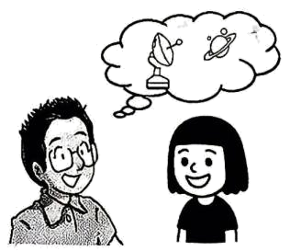
Caroline: Dr. Chen, what is the best part of your job as a space scientist?
Dr. Chen: ____1____ There is so much to research.
Caroline: What made you study space in the first place?
Dr. Chen: I loved watching the sky when I was little. ____2____
Caroline: Did you learn a lot of physics?
Dr. Chen: Sure. I’m still learning.
Caroline: ____3____
Dr. Chen: It depends. For me, it is easy and fun.
Caroline: I am also interested in space science. Can you give me some advice?
Dr. Chen: Read more. ____4____ And let your curiosity guide you.
Caroline: I’ve learned a lot from you today, Dr. Chen. ____5____
Dr. Chen: You’re welcome.
A. Thank you very much.
B. Keep asking questions.
C. Is physics difficult to learn?
D. Studying the soil from the moon.
E. How long have you worked here?
F. I wanted to know what was out there.
二、语法选择（本大题共10小题，每小题1分，共10分）
请通读下面的短文，掌握其大意，根据语法和上下文连贯的要求，从每小题所给的三个选项中选出一个最佳答案，并在答题卡上将对应选项涂黑。
Emma’s school has a tower with a big bell in it. Every morning, the bell rings and a new school day starts. One winter morning, however, the bell remains ____6____. The familiar sound disappears. This worries Emma and many other ____7____.
Emma and her friends try ____8____ what has happened. Their first stop is the headmaster’s office. There they hear the headmaster talking with the repairman on the phone. He is asking the repairman to come and check what is wrong ____9____ the bell.
The curious kids cannot wait and decide to explore the bell tower ____10____. They walk up to ____11____ top of the tower. Surprisingly, a lovely small cat ____12____ on the button (按钮) of the bell.
The kids realize ____13____ is the trouble maker. At that moment, the cat wakes up and looks at them with a shy “meow.” Clearly, it has chosen the bell tower as its home. The kids think they should find it a new home ____14____ the bell can ring again.
The kids go back to the headmaster and tell him that the bell problem is solved. They ask him if he would like to take care of the cat. To their joy, the cat ____15____ by the headmaster. Now it has a perfect, warm home. Finally, the familiar sound of the bell comes back.
6. A. silent B. silence C. silently
7. A. student B. student’s C. students
8. A. find out B. found out C. to find out
9. A. for B. with C. over
10. A. them B. theirs C. themselves
11. A. the B. an C. a
12. A. sleep B. is sleeping C. will sleep
13. A. why B. who C. whether
14. A. so that B. ever since C. because of
15. A. welcomes B. is welcomed C. are welcomed
三、完形填空（本大题共10小题，每小题1分，共10分）
请通读下面的短文，掌握其大意，从每小题所给的四个选项中选出一个最佳答案，并在答题卡上将对应选项涂黑。
A team of high school students in a coastal city have developed a storm-shelter app. It helps people find shelters (庇护所) quickly during bad weather.
The team started by ____16____ information of the local shelters from the government website. Then they used AI tools to turn the information into an app. This app ____17____ all the local shelters on the map. When a storm comes, the app can guide a user ____18____ to the nearest shelter. It also gives safety instructions to help its users make best ____19____. The local emergency management organization noticed the app and put it on its official website.
Mr. Green, their science teacher, thought these students did a good job and he felt very ____20____. “The students put what they have learned into practice. They are using ____21____ to solve real problems. And they try their best to give back to the community. I am sure they will be ____22____ adults when they grow up,” he said.
So far, the app has got thousands of downloads. The young developers never expected that their app would be so ____23____. They were truly excited to be able to create something helpful for a large community. “Every year, many storms hit our city. Local people suffer a lot. We are glad that people can ____24____ our app,” Eric, a team member, said. The team are now working to ____25____ the app. They will add information of more shelters so that the app can be used across the country.
16. A. clearing B. hiding C. collecting D. protecting
17. A. shows B. opens C. visits D. sweeps
18. A. directly B. bravely C. carelessly D. personally
19. A. guesses B. preparations C. suggestions D. inventions
20. A. proud B. angry C. sorry D. curious
21. A. biology B. charity C. chemistry D. technology
22. A. honest B. polite C. responsible D. interesting
23. A. cheap B. popular C. normal D. similar
24. A. turn off B. take over C. give away D. benefit from
25. A. copy B. create C. improve D. download
四、阅读理解（本大题共15小题，每小题2分，共30分）
请阅读A、B两篇短文，从每小题所给的四个选项中选出能回答所提问题或完成所给句子的最佳答案，并在答题卡上将对应选项涂黑。
A
 | Want your children to manage money wisely?  Bring them to our free workshops!
Our money workshops are for 7 to 12-year-old children. These workshops will be held in the city library on weekends. Each workshop can take up to 20 children.
Workshop 1: Wise Spender (9 a.m.—10 a.m. Sat.)  Aims:  ▶ to understand “needs” and “wants” in spending  ▶ to learn how to make a budget plan | 
Example Activity
Children are given some spending choices like buying a book or seeing a film. They work together and discuss what to spend on within a budget.
Workshop 2: Smart Saver (4 p.m.—5 p.m. Sun.)  Aims:  ▶ to understand the benefits of saving  ▶ to learn how to open a bank account | 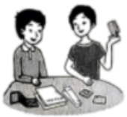
Example Activity
Children are divided into two groups. One group acts as bank managers and the other acts as customers who want to open an account.
Why Choose Us?
We use real-world examples to help children learn to make smarter decisions on money.
How To Book?
You need to complete a booking form and send it to us at booking@citylibrary.org. For more information, please visit www.citylibrary.org.

26. When are the money workshops held?
A. On Thursdays and Saturdays. B. On Tuesdays and Sundays.
C. On Mondays and Wednesdays. D. On Saturdays and Sundays.
27. What can children learn from Workshop 1?
A. How to create a budget plan. B. How to make a saving plan.
C. How to make a lot of money. D. How to open a bank account.
28. The example activity in Workshop 2 is ________.
A. a card game B. a role-play game C. a word game D. a treasure-hunt game
29. What makes the workshops a good choice?
A. Interesting books. B. Free lunch. C. Real-life examples. D. Smart robots.
30. How can people get more information about the workshops?
A. By visiting the website. B. By sending an email.
C. By making a phone call. D. By filling in the form.
B
Many schools have started projects to make changes to their school grounds in order to make better use of them. The projects have achieved good results. Some schools have reduced heat, some have got more play space, and others have helped create different learning experiences.
The most common practice of the schools is planting more trees around the playground. Trees provide cooler spaces in summer. They also bring birds and insects. Students, therefore, would like to go to the playground more often. And they become more connected to nature. Some schools even set up reading areas under these trees. Students can listen to birds singing while reading there.
▲ For example, they turn some of the school grounds into vegetable fields or fruit gardens. The students work in teams and learn how to grow vegetables or fruits. In this way, they get hands-on learning experience. At harvest (收获) time, they share what they get from the fields and gardens, and they also harvest the joy of labor and cooperation.
These reshaping projects make school grounds more popular with students. The reason behind the success is that students are included. After all, they are the users of the grounds. In many cases, designers first survey the students for their ideas. Then they draw up several designs for the students to vote on. When the project is completed, the students are invited to feed back on it so that it can be further improved in the future.
31. What is Paragraph 1 mainly about?
A. The results of the projects. B. The importance of learning.
C. The benefits of play space. D. The history of some schools.
32. What happens with more trees around the playground according to Paragraph 2?
A. Students grow more fruits. B. The school turns cleaner.
C. Students get closer to nature. D. The school raises more money.
33. Which of the following can be put in “ ▲ ” in Paragraph 3?
A. Some schools refuse to change. B. The changes make schools bigger.
C. The changes make teachers happier. D. Some schools explore other possibilities.
34. Why are the projects successful?
A. Schools have strict rules. B. Students’ opinions are valued.
C. Parents’ support is provided. D. Teachers give clear instructions.
35. What do the underlined words “feed back on” mean in Paragraph 4?
A. Say goodbye to. B. Give advice on. C. Look down upon. D. Keep away from.
C
配对阅读。左栏是对五种植物的介绍，右栏是花店的七张广告卡片，请为每种植物匹配合适的广告卡片，并在答题卡上将对应选项涂黑。选项中有两项为多余选项。
____36____ The Venus Flytrap is amazing. When an insect like a fly falls into it, it closes its leaves within half a second. Then it turns the insect into its food.  ____37____ The Sensitive Plant is known for its interesting leaves. When you touch it, its leaves close up. In Chinese, it is called “Shy Grass.”  ____38____ The Air Plant is famous for its ability to grow without soil. It lives well in indoor environments.  ____39____ Aloe Vera has thick leaves. The juice from its leaves can be used to treat burns that are not serious.  ____40____ Sunflowers have big flowers. They like sunlight and require watering every day. Their bright yellow color makes them a good choice for gardens. | A. You will not see flies in your house again if you take it home.
 | B. The best place for it is the kitchen. You can use it for first aid if you get your hands burnt while cooking.
 | C. Would you like an unusual plant? Take this plant. It doesn’t need soil or bright sunlight.
 | D. Love big flowers? This plant is the right choice for you. It will make your garden lively and pretty.
 | E. This is Lucky Bamboo. It provides a sense of positive energy. Get it and you’ll be lucky.
 | F. Want a plant that can “communicate” with you? Try touching this plant and see how “shy” it will become.
 | G. This plant can flower all year round. Its small purple flowers will surely bring life to your room.

五、短文填空（本大题共10小题，每小题1.5分，共15分）
请从方框内选择适当的词并用其正确形式填空，使文章完整连贯。注意每空一词，每词仅用一次，有两词为多余选项。请将答案写在答题卡对应题目的答题位置上。
alone and can culture have his idea of or return upon well
Yang Ming is a 26-year-old designer. He once studied and worked in Shanghai. There he developed his designing skills. Two years ago, he ____41____ to his hometown. With the help of the government, Yang started ____42____ own business.
Yang’s hometown is known for its fishing ____43____. This gives him lots of creative business ____44____. He mixes local cultural characteristics into his products. So far, he has developed more than 30 products. Among them, the most successful one is a refrigerator magnet (冰箱贴). It sells much ____45____ than the others in gift shops. The magnet has the shape of a traditional fishing boat. It reminds the tourists ____46____ their travel experience in Yang’s hometown.
“Cultural products are not about simply printing traditional symbols on products,” Yang said. “The key is to find a natural connection between tradition ____47____ modern life.”
Yang is not ____48____. Across China, a growing number of young designers are turning to traditional local culture for inspirations (灵感). As their products become popular abroad, more foreigners will ____49____ a better understanding of Chinese culture. “Chinese traditional culture ____50____ be seen by the world as long as we find the right way to present it,” Yang said.

六、读写综合（本大题分为A、B两部分，共25分）
A．回答问题
请阅读下面的短文，根据所提供的信息，回答五个问题，并将答案写在答题卡对应题目的答题位置上。要求所写答案语法正确、信息完整切题。

To celebrate Labor Day, a photo show was held in a community this month. It started from May 1st and lasted for 10 days.
All the photos on show were about ordinary (普通的) workers in the community. Behind each photo there was a happy worker doing his or her daily job. A pancake maker was laughing, with flour (面粉) all over his hands. A driver was helping an elderly lady get off the bus — warm smiles were on their faces.
The photos were taken by Chen Hang, a young man who lived in the community for five years. He spent nearly a month walking around the neighborhood with a camera. His idea was simple — to record the smiles of ordinary workers. He “collected” 100 smiling faces. The photos greatly touched him and he decided to share the touching moments in the photos with more people. So he went to the community center for help. The volunteers there organized his photos and turned them into a show for the Labor Day celebrations.
The show drew people in the community, including the “models,” to stop and watch. They were excited to recognize the familiar faces in the photos. They felt happy with the photo show and thankful to Chen Hang. “Without these photos, we may not know how beautiful we are at work,” one of the “models” said.


51. How long did the photo show last?
____________________________________________________________________________________________
52. Who was helping the elderly lady get off the bus in one photo?
____________________________________________________________________________________________
53. What did Chen Hang want to record?
____________________________________________________________________________________________
54. Where did Chen Hang go for help?
____________________________________________________________________________________________
55. Were the people satisfied or disappointed with the photo show?
____________________________________________________________________________________________
B．书面表达
请根据要求完成短文写作，并将短文写在答题卡对应题目的答题位置上。
56. 假设你是李明。受到上文照片展的启发，你计划举办“班级照片展”。请你写一封电子邮件邀请交换生Peter提交一张照片参展，要点如下：
（1）分享上文读后感受和你的计划，并发出邀请；
（2）告知照片展主题和对照片的两点要求；
（3）说明照片提交时间和方式。
注意：（1）不能照抄原文；不得在作文中出现真实校名和考生的真实姓名。
（2）语句连贯，词数80左右。作文开头和结尾已经给出，不计入总词数，也不必抄写在答题卡上。
Dear Peter,
The other day I read about a photo show of smiling workers.
_________________________________________________________________________________________________________________________________________________________________________________________________________________________________________________________________________________________________________________________________________________________________________________________________________________________________________________________________________________________________________________________________________________________________________________________________________________________________________________________________________________________________________________
Looking forward to your wonderful photo.
Best,
Li Ming

