天水市2026年初中学业水平考试
英语试卷
考生注意：本试卷含听力，满分为150分，考试时间为120分钟。所有试题均在答题卡上作答，否则无效。
Ⅰ．听力理解（分4小节，共20小题；每小题1分，满分20分）
第一节：听句子，选择与所听内容相符的图片。每个句子读两遍。
 |  | 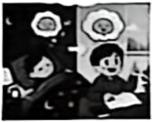 |  | 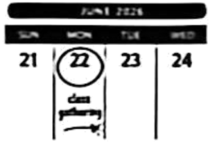
A | B | C | D | E
1. ________ 2. ________ 3. ________ 4. ________ 5. ________
第二节：听句子，选择恰当的应答语。每个句子读两遍。
6. A. It’s his. B. It’s 50 yuan. C. It’s white.
7. A. Fine, thank you. B. See you. C. Nice to meet you, too.
8. A. Tea, please. B. No, I don’t. C. I’m full.
9. A. For two hours. B. Once a week. C. In a month.
10. A. Yes, I did. B. Me too. C. Thanks for your advice.
第三节：听对话及问题，选择能回答所提问题的最佳答案。每段对话读两遍。
11. What will the weather be like this weekend?
A. Warm. B. Hot. C. Cold.
12. What kind of music does the boy like?
A. Rock music. B. Classical music. C. Light music.
13. What does the boy plan to do in the summer holiday?
A. Join a soccer club. B. Visit his grandparents. C. Go to Mount Tai.
14. Why was the girl late for school?
A. The traffic was bad. B. She got up late. C. She had a cold.
15. What will the girl probably do this weekend?
A. Go hiking. B. See a film. C. Help her brother with study.
第四节：听短文，根据其内容选择能回答下列问题的最佳答案。短文读两遍。
16. Why did the speaker feel sad at first?
A. She was poor in English.
B. She had no time for English.
C. She wasn’t interested in English.
17. What does the speaker do every day to improve listening?
A. Watch English films.
B. Listen to English songs and news.
C. Do listening exercises.
18. Which of the following mainly helps the speaker with her speaking?
A. Reading texts every day. B. Talking with foreigners. C. Speaking bravely in class.
19. How many ways does the speaker mention about learning English?
A. 3. B. 4. C.5.
20. Which sentence can show the speaker’s idea about English learning?
A. Never give up and keep practising.
B. It is quite easy to learn English well.
C. Reading is the most difficult part.
Ⅱ．语法与情景对话（共20小题；每小题1分，满分20分）
阅读下列各题，从A、B、C、D四个选项中选择一个最佳答案。
1. For learning English, first you need to become ________ active learner.
A. a B. an C. the D. /
2. Life will be easier if you ________ stronger.
A. get B. got C. will get D. were getting
3. We celebrate International Workers’ Day in the ________ month of a year.
A. sixth B. fifth C. third D. ninth
4. ________ painting takes time, it teaches us to notice the beauty around us.
A. Because B. Although C. Unless D. If
5. Every time I was upset, there ________ always my parents comforting me.
A. is B. are C. was D. were
6. China’s Shenzhou-23 manned spaceship was successfully launched ________ May 24, 2026.
A. in B. on C. at D. during
7. One of ________ solar energy power stations in the world, “Super Mirror Solar Power Station”, lies in Gansu.
A. large B. larger C. largest D. the largest
8. It’s a good ________ to write down your mistakes and look them over.
A. habit B. rule C. team D. place
9. My father ________ to work by car, but now he ________ riding a bike.
A. is used; is used B. was used; is used to
C. used to go; is used to D. used to going; used to
10. The scenery of Gansu in autumn is ________ amazing and beautiful.
A. hardly B. only C. simply D. nearly
11. In 2026 Spring Festival Gala, the performers ________ a wonderful show that perfectly mixed AI technology with traditional Chinese culture.
A. put off B. put out C. put away D. put on
12. —________ do you usually review your lessons?
— By making mind maps and discussing difficult points with my classmates.
A. Why B. How C. When D. Where
13. —I don’t know what the future will be like.
—________. Just take every step as it comes.
A. You’re welcome B. No way C. It’s a pity D. Take it easy
14. —Why is Gansu called “The Hometown of Han Slips (汉简)”?
—Because nearly 70,000 Han Slips, ________ of all the Han Slips found in China, have been found in Gansu.
A. little B. most C. some D. few
15. —Look at the lead singer on the stage! Is that our music teacher, Mr. White?
—It ________ be him. Mr. White is sitting right next to us in the front row.
A. must B. might C. can’t D. mustn’t
16. —The Yellow River is the second longest river in China. Do you know ________?
—Yes, it’s 5,464 kilometers long.
A. how long it is B. how far it is C. how big it is D. how wide it is
17. —The concert begins at 3:35 p.m. and lasts for 90 minutes.
—Got it. So it will end exactly at ________.
A. 4:40 B. 4:55 C. 5:00 D. 5:05
18. What does the notice on the right tell us?
You Are Wanted
Do you like sports? Do you want to play badminton? Everyone is welcome at our club, especially beginners.

A. Anyone can take part in the club.
B. Only beginners can join the club.
C. The club opens to baseball lovers.
D. You need to pay for the club.
19. —I have practised this English speech for three days, but I still make mistakes.
—Don’t give up! ________. Practice makes perfect!
A. An apple a day keeps the doctor away B. Two heads are better than one
C. Rome wasn’t built in a day D. Actions speak louder than words
20. What does the sign on the right mean? 
A. People can smoke freely here. B. Only a little smoking is allowed here.
C. Smoking is not allowed in this area. D. You can smoke only in this area.
Ⅲ．完形填空（共10小题；每小题1.5分，满分15分）
阅读下面短文，从短文后各题所给的四个选项中选出能填入空白处的最佳答案。
It was an afternoon of December. Four junior students from the city of Linxia were taking a bus to school. Suddenly, something ___21___ happened. When the bus was near the Longwangmiao Station, it began to shake. The driver breathed painfully with his eyes almost closed. The bus was ___22___ and run towards the opposite direction.
Sitting behind the driver, one of the students was the first to act. He rushed to move the driver’s ___23___ away, and pressed hard on the brake (刹车) with both hands. At the same time, his two classmates turned the steering wheel (方向盘) to get the bus back to its way. Another student held the driver’s shoulder and tried to ___24___ him up. Nervous but calm, they worked together and finally stopped the bus safely by the roadside. ___25___, all the 18 passengers in the bus were safe. And ___26___ of them were even hurt.
After that, they carefully helped the driver get off the bus. They used first-aid knowledge learned at school to ___27___ the driver and called 120. They didn’t hurry to school ___28___ the driver was sent to the hospital. The news spread widely and everyone took pride in them.
Their act of ___29___ is like a shining light that makes something amazing happen. People think highly of them for their courage in the face of ____30____. The four students put what they had learned into practice, and show a sense of responsibility of Chinese teenagers!
21. A. interesting B. unexpected C. pleasant D. surprising
22. A. out of control B. out of power C. out of order D. out of work
23. A. arm B. hand C. leg D. foot
24. A. get B. wake C. pull D. cheer
25. A. Unluckily B. Sadly C. Luckily D. Disappointedly
26. A. none B. all C. many D. half
27. A. ask for B. look for C. care for D. wait for
28. A. until B. before C. after D. when
29. A. humor B. friendliness C. politeness D. bravery
30. A. chance B. danger C. failure D. progress
Ⅳ．阅读理解（共15小题；每小题2分，满分30分）
A

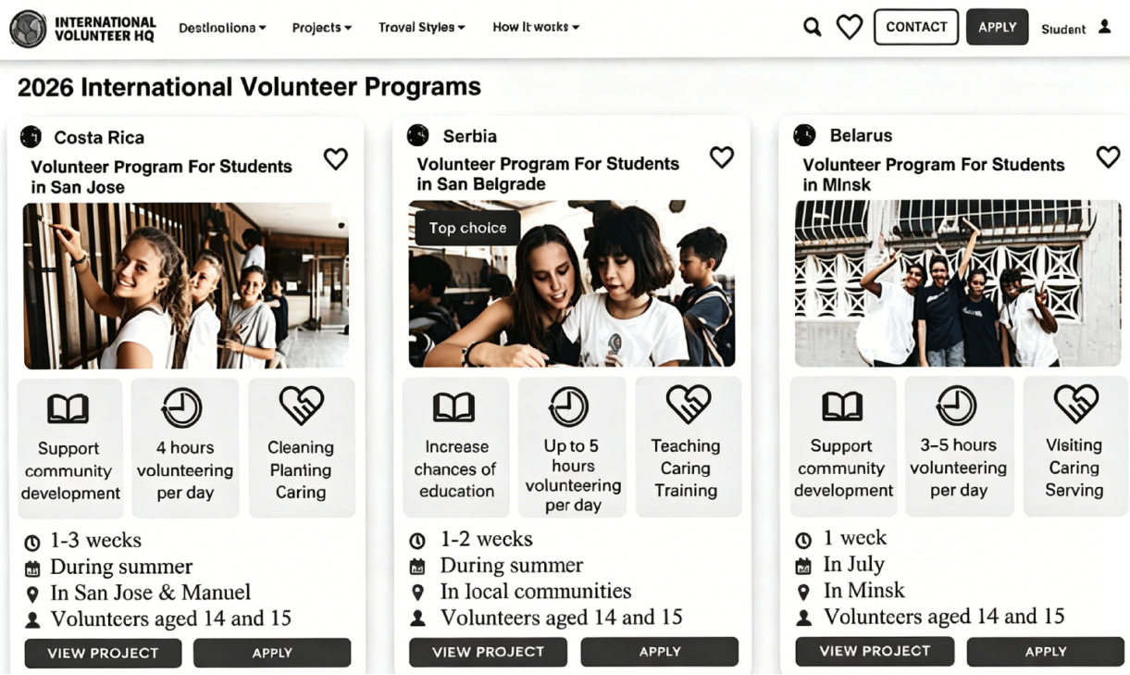
阅读以上网站信息，判断下列句子正误。正确填(涂)A，错误填(涂)B。
31. The volunteer program in Costa Rica runs for at most 3 weeks.
32. The program in Serbia focuses on supporting community development.
33. You can take part in the program in Belarus at any time during this summer.
34. All the three programs require volunteers to be between 14 and 15 years old.
35. The program in Serbia is the most popular one.
B

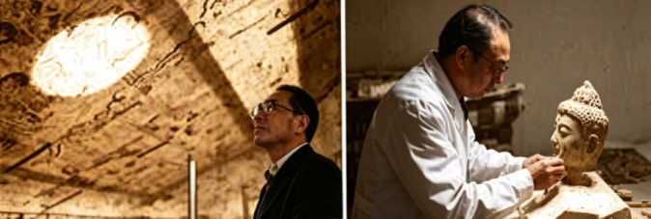
Deep in the desert, a man has spent more than forty years solving the “illness” of ancient paintings.
His name is Fan Zaixuan. He is an expert at protecting and repairing wall paintings in the Dunhuang Academy (敦煌研究院). In fact, the “patients” are the ancient wall paintings. The wall paintings in Dunhuang Mogao Caves are beautiful. However, after thousands of years, their surfaces slowly come off and fall down, which makes people feel sad.
Fan Zaixuan works hard to repair these art works. For the peeling parts, he first adds special glue and smooths them slowly and carefully. It is more difficult to repair the broken areas. Workers must take away harmful salt that breaks the paintings. To solve this problem, Fan Zaixuan and his team have been working for eight years and finally found a practical way. They turned the harmful salt into water and developed new materials to take in the liquid (液体). So far, the research team led by Fan Zaixuan has repaired more than 500m² of broken wall paintings in Mogao Caves. These ancient treasures shine again and keep their beauty after thousands of years.
Fan Zaixuan says his daily work is to protect ancient wall paintings and keep their natural looks. To his relief, over the past forty years, he has trained hundreds of young workers for cultural protection organizations across the country. Now, a new team of repairers has joined in the repair work of these valuable paintings.
Fan Zaixuan has spent all his time and energy on his work. He protects the ancient art silently and has become a part of these wonderful paintings through time.
阅读以上材料，回答下列各小题。
36. How long did Fan Zaixuan’s team spend finding the method to repair broken wall areas?
A. 40 years. B. 8 years. C. 5 years. D. 10 years.
37. What problem did the wall paintings face?
A. The color of the paintings changed a lot. B. The surface of the paintings turned dark.
C. The surface of the paintings come off. D. People did harm to the wall paintings.
38. What does the underlined word “relief” probably mean?
A. Joy. B. Shock. C. Disappointment. D. Sadness.
39. What can we learn from the passage?
A. Fan’s team repaired less than 500m² of the wall paintings.
B. Fan repairs the wall paintings only by taking harmful salt away.
C. Young workers refuse to take part in wall painting repair work.
D. Harmful salt is one of the reasons for the broken wall paintings.
40. What is the best title for the passage?
A. Beautiful Wall Paintings in Dunhuang
B. Practical Ways to Protect Old Cultural Relics
C. Fan Zaixuan: A Protector of Ancient Paintings
D. The Long History of Dunhuang Ancient Art
C
Teen Inventors Build A Robot To Replant Burned Forests
Like many countries, Portugal has been experiencing increasingly hotter, drier weather. This has caused many big wildfires. Since 2000, the country has lost about half of its forest because of these big fires. More than 60% of these areas are dangerous, making replanting difficult. Two university students have come up with a creative solution—a tree-planting robot called Trovador.
Marta Bernardino and Sebastião Mendonça, grew up near Portugal’s capital, Lisbon. They spent much of their childhood exploring the nearby woods. Sad to see them burned by fire again and again, they decided to act.
In 2023, they began building Trovador, a tree-planting robot. The first robot, made from recycled parts and costing $17, could plant young trees 28% faster than humans, and 90% of the young trees survived.
Their work quickly got international praise. In 2024, they received $10,000 to improve Trovador.
Trovador now is a four-legged, AI-powered robot. It uses cameras to find its way across difficult ground. It can work up to 3 hours on one full power and plant up to 200 young trees per hour. It is expected to be ready for work by the end of 2026.
Once ready, Trovador will provide more services to help plant more trees. Workers will use an app to choose planting areas, and the robot will do the rest. Marta and Sebastiāo hope it will help bring Portugal’s forests back.
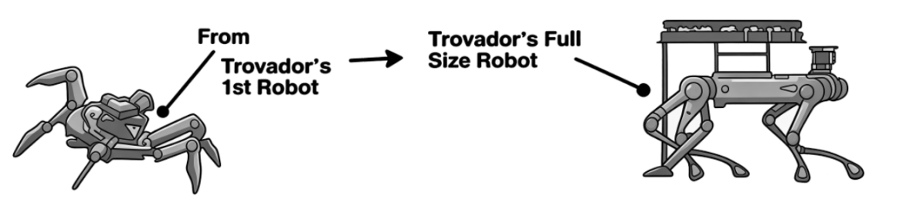
阅读以上材料，回答下列各小题。
41. Why is it difficult to replant trees in Portugal?
A. Because the weather is getting hotter and wetter.
B. Because much of the burned land is dangerous.
C. Because the country has lost about half of its forest cover.
D. Because there are too many big wildfires happening since 2000.
42. What are Marta Bernardino and Sebastião Mendonça?
A. Scientists. B. Students. C. Firefighters. D. Explorers.
43. What do we know about the first Trovador robot?
A. It was made of new expensive materials.
B. It cost as much as 10,000 dollars.
C. It worked faster than human planters.
D. Half of the young trees that it planted lived.
44. Which of the following is TRUE about Trovador?
A. It’s now a snake-shaped machine.
B. It can work 4 hours after being powered.
C. It has already been widely used across Portugal.
D. It will do the planting work in the chosen areas.
45. What is the main purpose of the passage?
A. To warn people of serious wildfires in Portugal.
B. To introduce a tree-planting robot built by teens.
C. To explain how wildfires do harm to local forests.
D. To encourage students to take part in creative work.
V．任务型完形填空（共10空；每空1分，满分10分）
用方框中所给单词的适当形式填空，使短文通顺、正确、连贯。(每个单词限用一次)
finally from wear hold and we be information fantastic first


NOTICE
Boys and girls,
How time flies! Three years have passed, and we are going to graduate ___46___ junior high school soon. To celebrate this important moment, our school ___47___ a grand graduation ceremony.
Please pay attention to the following ___48___:
Date: June 26, 2026
Time: 9:00-12:00
Place: The School Hall
Please arrive at the hall by 8:45 a.m. ___49___ sit in your own seats. During the three-hour ceremony, the headmaster will make a speech to give us his best wishes ___50___. After that, students from different classes will give ___51___ performances, such as singing, dancing, and poetry reading. Then, students will give flowers to ___52___ hard-working teachers. ___53___, we will take group photos to keep the sweet memories.
After the ceremony, there will ___54___ a farewell party in our own classrooms. Please don’t forget ____55____ your suit that day. We look forward to sharing this unforgettable day with you!
Students’ Union
June 18

Ⅵ．任务型阅读理解（共5小题；满分10分）
阅读下面材料，并按要求完成1至5小题。
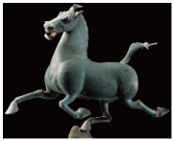 Welcome to Gansu 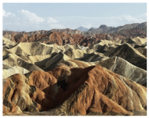
Dear exchange students, welcome to our school! During your 3-month stay, you will have many free weekends. Gansu is a beautiful place with a long history. We hope you enjoy your time here. Here are the top places to go on weekends.
 Top Places to Go in Gansu 
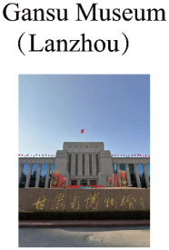  You can learn about the history of the Silk Road and see the famous Bronze Galloping Horse (铜奔马).  Ticket: Free  (But you need to book online first.)  Phone:  0931-2339131  Website:  www.gansumuseum.com | 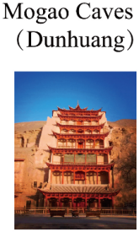  It is very famous in the world. You can see beautiful old paintings and statues in the caves.  Ticket:  ¥ 238 (Adults) / ¥ 148 (Students)  Prices may change in different seasons.  Phone:  4008-333-715  Website:  www.mgk.org.cn |   The mountains here have many beautiful colors. They look like a rainbow on the earth. It is great to take photos here!  Ticket:  ¥ 108 (Ticket+ Bus)  Phone:  0936-5623666  Website:  www.zydanxia.com | 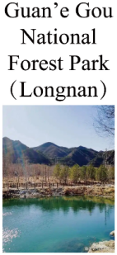  It is a great place for a cool summer. You can see clear lakes, tall waterfalls, and green mountains.  Ticket:  ¥ 80 (Adults) / Free (Seniors 70+)  Phone:  0936-6229138  Please search “官鹅沟” (Guan’e Gou) on WeChat. |   __________________  __________________  __________________  本题请在答题卡对应区域内作答。  __________________  __________________
▲
  Please wear hats and sunglasses. |   Please bring some water with you. |   Please bring your student ID card for cheaper tickets. |   Remember to bring a warm jacket. |   Remember to bring comfortable sports shoes. |   Remember to bring some medicine.
任务一：回答问题
56. How long will the exchange students stay at the school?
____________________________________________________
57. What do visitors need to do first if they want to visit Gansu Museum?
____________________________________________________
任务二：情景应用
58. Lucy, one of the exchange students, feels very hot these days. She wants to go to a cool place in nature to relax. According to the reading material, which place do you recommend her to go? Why?
____________________________________________________
任务三：读写链接
59. 补全材料画线处 ▲ 内容，使文意通顺、连贯、正确、符合逻辑。（作答不超过5词）
____________________________________________________
60. 请你为交换生团队推荐一处甘肃其他值得去的地方，并说明原因。（作答不少于20词）
____________________________________________________
Ⅶ．口语交际（共5小题；每小题2分，满分10分）
阅读下面的对话，根据上下文，从方框内选择恰当的选项补全对话，使句意完整、符合逻辑。（其中有两项为多余选项）
Liu Li, a Chinese student from No. 1 Junior High School, and her friend, Huang Lei, meet in the Olympic Park. A is for Liu Li; B is for Huang Lei.
A: Hey, Huang Lei! You look really energetic after running in the park.
B: Thanks, Liu Li! I believe “Health First”. ___61___
A: That’s great! Our school always encourages us to stay active.
B: Really? ___62___
A: I exercise on the smart sports field in the school and it gives me points for running and rope jumping.
B: ___63___
A: So it is! Now, we have one P. E. class every day.
B: We do the same! We are encouraged to exercise for at least two hours every day at school.
A: ___64___ We also have strict rules for our school restaurant to serve meals with less sugar and salt.
B: A good diet and regular exercise are surely the best ways to stay healthy.
A: ___65___
B: Let’s get some water and keep it up!
A. What do you usually do for your health?
B. So do we!
C. I exercise every day.
D. How often do you usually exercise?
E. Do you have a balanced diet?
F. That sounds amazing and fun!
G. I totally agree with you.
Ⅶ．词汇考查（共10小题；每小题1分，满分10分）
你校将举行“一起读书吧”活动，请用括号内所给单词的适当形式填空，补全下面宣传语。
66. Welcome to join the reading theatre, which will be held ________ (two) a day in the school hall.
67. Books allow ________ (we) to experience different lives.
68. Books are always ________ (fill) with fun and interesting facts.
69. Reading provides us much knowledge that can be ________ (help) in daily life.
70. Reading is a good way that ________ (open) our eyes to the world.
71. Do you know that many popular ________ (movie) are based on books?
72. If we want to learn more about the world, we should read ________ (often).
73. Let’s understand and learn different ________ (write) styles by reading!
74. Why not use a reading list to introduce what you’ve ________ (read) recently?
75. Pick up a book and ________ (start) reading today!
Ⅸ．根据所给汉语提示完成下列句子（共5小题；每空1分，满分10分）（每空限填一词）
76. 世上没有比健康更好的财富，没有比内心快乐更大的快乐。
Nothing is ________ than health; nothing is ________ than inner peace.
77. 他为自己没有放弃而感到自豪。
He was ________ ________ himself for not giving up.
78. 不要怀疑自己的价值，也不要怀疑努力的意义。
Never doubt your ________ or the ________ of hard work.
79. 你的学习成就取决于良好的学习方法和态度。
Your learning achievements ________ ________ good learning methods and attitudes.
80. 造纸术不仅推动了中国文化的发展，还改变了世界文明的进程。
The papermaking technique ________ ________ speeded up the development of Chinese culture, but also changed civilizations around the world.
Ⅹ．书面表达（满分15分）
81. 假设你是李华，在六月五日世界环境日这天，你收到了英国好友Jack给你写的一封邮件。请你认真阅读后，回复一封邮件。
要求：1．词数约80词；2．开头与结尾已给出，不计入总词数；3．内容条理清晰，行文连贯，可适当发挥；4．文中不得出现真实的人名、学校等信息。
 | 
Dear Li Hua,  How is everything going?  June 5 is World Environment Day. I’ve heard that the topic of China for this year is “Green Changes for a Beautiful China”. Have you noticed any warm green changes around you? Does your lifestyle change a little?  Please share them with me!  I’m looking forward to your reply!  All the best!  Jack | Dear Jack,  I hope this email finds you well.  ________________________________________________________________________________________________________________________________________________________________________________________________________________________________________________________________________________________________________________________________________________________________________________________________  Yours,  Li Hua

