[机密]2026年
6月14日11:00前
重庆市2026年初中学业水平考试
英语试题
（全卷共九个大题 满分：150分 考试时间：120分钟）
注意事项：
1．试题的答案书写在答题卡上，不得在试题卷上直接作答。
2．作答前认真阅读答题卡上的注意事项。
3．考试结束，由监考人员将试题卷和答题卡一并收回。
第Ⅰ卷（共100分）
Ⅰ．听力测试。（共35分）
第一节（每小题1分，共6分）
听两遍。根据你所听到的句子，从A、B、C三个选项中选出最恰当的答语，并把答题卡上对应题目的答案标号涂黑。
1. A. I’m fine, thanks. B. Nice to see you, too. C. Good morning.
2. A. Don’t mention it. B. That’s right. C. Hold on, please.
3. A. Here you are. B. Sorry, I won’t. C. You’re welcome.
4. A. Have a good time. B. The same to you. C. Take it easy.
5. A. It doesn’t matter. B. I can play it. C. Wonderful.
6. A. Best wishes. B. Good idea. C. This way, please.
第二节（每小题1.5分，共9分）
听两遍。根据你所听到的对话和问题，从A、B、C三个选项中选出正确答案，并把答题卡上对应题目的答案标号涂黑。
7. A. /ə'meɪzɪŋ/. B. /ək'sept/. C. /ə'vɔɪd/.
8. A. Once a week. B. Twice a week. C. Three times a week.
9. A. It’s snowy. B. It’s sunny. C. It’s cloudy.
10. A. By bike. B. By bus. C. On foot.
11. A. White. B. Black. C. Red.
12. A.  B.  C. 
第三节（每小题1.5分，共6分）
听两遍。根据你所听到的长对话，从A、B、C三个选项中选出正确答案，并把答题卡上对应题目的答案标号涂黑。
听第一段材料，回答第13和14小题。
13. What kind of music does the girl like best?
A. Pop music. B. Classical music. C. Folk music.
14. Where are the two speakers probably talking?
A. In the zoo. B. In the school. C. In the cinema.
听第二段材料，回答第15和16小题。
15. What was Sarah doing yesterday morning?
A. She was singing. B. She was reading. C. She was shopping.
16. What do some factories use to make clothes?
A. Recycled paper. B. Recycled glass. C. Recycled plastic.
第四节（每小题1.5分，共6分）
听两遍。根据你所听到的短文内容，从A、B、C三个选项中选出正确答案，并把答题卡上对应题目的答案标号涂黑。
17. What grade is Zhang Wei from?
A. Grade Seven. B. Grade Eight. C. Grade Nine.
18. What prize did Wang Lin win?
A. Top Speaker. B. Best Story-teller. C. Future Star.
19. How was Li Hua’s speech?
A. It was interesting. B. It was clear. C. It was moving.
20. Why did the school hold this competition?
A. To develop students’ good learning habits.
B. To help students show their creative abilities.
C. To encourage students to share ideas in English.
第五节（每小题2分，共8分）
听两遍。根据你所听到的演讲内容，补全笔记。每空1词，并把答案填写在答题卡上对应的位置。
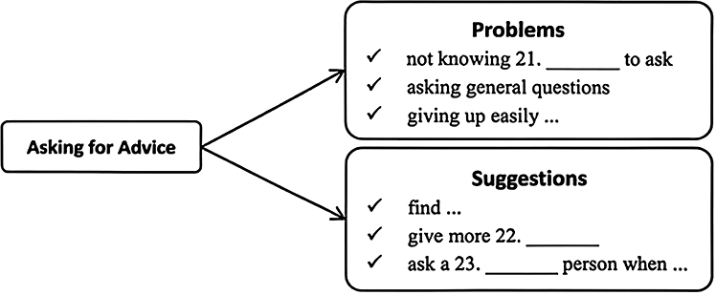
The key is not to 24. ______ ______ to ask for advice.
Ⅱ．语法选择。（每小题1分，共10分）
根据短文内容，从A、B、C三个选项中选出一个语法正确的答案，并把答题卡上对应题目的答案标号涂黑。
Dear Alex,  How is everything going? Two months has passed since I started working here in Tanzania. I miss ____1____ all so much. I’d like to tell you something special here.  Yesterday I ____2____ hiking in the wild. The views were beautiful with different kinds of plants and lots of ____3____. I hiked a little ____4____ than usual. Suddenly, I realized I got lost and my phone ____5____ in my office. I felt hungry, so I tried ____6____ some fruit from a tree. But the tree was too tall for me. Just then, I found ____7____ young monkey watching me curiously. It seemed that he was interested in ____8____ I was doing. He then climbed up the tree, picked some fruit, ____9____ gave it to me. I smiled to the little helper and enjoyed the tasty fruit.  Tanzania is full ____10____ surprises, and I’m so lucky to have this experience!  Take care!  Love,  Daddy |   _______________________________________________________________________________________________________________________________________________________________________________________________________________________________________

1. A. you B. your C. yourself
2. A. go B. goes C. went
3. A. bird B. birds C. birds’
4. A. far B. farther C. farthest
5. A. left B. is left C. was left
6. A. to get B. get C. got
7. A. a B. an C. the
8. A. when B. what C. which
9. A. or B. and C. so
10. A. with B. in C. of
Ⅲ．完形填空。（每小题1.5分，共15分）
根据短文内容，从A、B、C、D四个选项中选出一个能填入相应空格内的最佳答案，并把答题卡上对应题目的答案标号涂黑。
Paul has always loved bowling. As a child, he often said, “When I ____11____, I will own a bowling alley (保龄球馆).” For him, it was the perfect job.
When Paul got older, however, he had bills to pay. He started a family, and he needed ____12____. He took a job he didn’t really care for just to make a living. Owning a bowling alley seemed like a distant (遥不可及的) dream… ____13____ Lucky Lanes went up for sale.
Lucky Lanes was a bowling alley in Paul’s neighborhood. It was old and ugly, and ____14____ was surprised when the owner put it up for sale.
Paul had a crazy thought. Why didn’t he buy it? He knew it wasn’t ____15____. He had to borrow money to pay for the building and pay workers to ____16____ the broken floors and paint the old walls. But he just couldn’t resist (抵制) his dream.
He bought Lucky Lanes and promised to work hard to make it a success.
Before Lucky Lanes reopened, Paul completely ____17____ it. New lights shone on bright tables and clean floors. A food stand was set up to sell pizzas and other snacks. Every night, Paul was there, talking to customers and keeping a close eye on the busy food stand.
It turned out that Paul had a ____18____ for business. The next year, Lucky Lanes saw more customers than anyone had ever expected. It became one of the ____19____ places to hang out in the neighborhood.
Paul’s hard work paid off. Though he wasn’t sure of the ____20____ at the beginning, he wanted to try, and that made all of the difference.
11. A. come up B. get up C. grow up D. give up
12. A. money B. love C. friendship D. happiness
13. A. if B. until C. because D. although
14. A. somebody B. anybody C. everybody D. nobody
15. A. easy B. difficult C. serious D. important
16. A. burn B. hit C. repair D. touch
17. A. started B. changed C. bought D. sold
18. A. talent B. risk C. choice D. course
19. A. cleanest B. coolest C. worst D. cheapest
20. A. loss B. reason C. secret D. success
Ⅳ．阅读理解。（每小题2分，共30分）
阅读下列材料，从A、B、C、D四个选项中选出最佳答案，并把答题卡上对应题目的答案标号涂黑。
A

D6 January 24, 2026
page editor: Jason@163.com
Tip 1  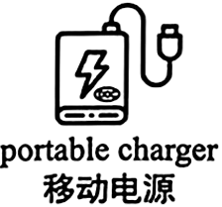  Carry a portable charger that works anytime and anywhere. It can prevent your phone from dying. | Tip 2  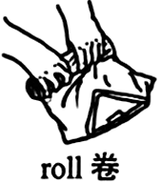  Rather than folding your clothes, try rolling them up to save more space in your suitcase.
Tip 3    Email yourself a scanned copy of your passport. If your passport is lost, it can keep you calm and help you just in time! | Tip 4  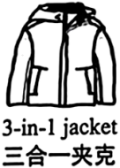  A single 3-in-1 jacket keeps you ready for any weather condition. It can make your trip lighter.

21. Which picture best matches Tip 2?
A. 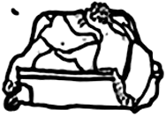 B.  C. 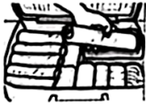 D. 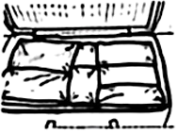
22. Why do you need a scanned copy of the passport?
A. To prevent your phone from dying. B. To help you in time if your passport is lost.
C. To save more space in your suitcase. D. To keep you ready for any weather condition.
23. In which part of the newspaper can you read these tips?
A. Sports. B. Science. C. Art. D. Travel.
B
“I could only see large letters within 20 cm. After the doctor’s treatment, I could see them from 270 cm away.” said an elderly man who suffered from eye problems.
The magic, from the deep rainforest of Yunnan, is called Dai Medicine. It is the survival wisdom of the Dai people which has a history of around 2,500 years. It has its own understanding of how the body works.
Dai Medicine includes many special treatments. The heated herbal bed therapy (睡药疗法) is a famous one. In this treatment, the doctor spreads warm herbs over a bed and makes the patient lie on it. Then he places more herbs over the patient. Finally, he covers the patient with a quilt (被子) to keep the temperature. In 2011, the therapy was included in China’s Intangible Cultural Heritage. Another well-known treatment is the herbal pouch therapy (敷药疗法). The doctor heats a cloth bag filled with herbs, puts it on the affected area (患处) and then moves it backwards and forwards.
At present, about 11 therapies are widely used in practice. Dao Huixian, a Dai doctor, said, “In our general hospital, for critical illnesses, we mainly depend on modern medicine. But for chronic (慢性的) diseases, the strengths of Dai Medicine offer greater advantages.”
Since Yunnan is close to Southeast Asia, Dai Medicine is not only a way of treating diseases, but also an important bridge for medical and cultural communication with neighboring countries. In the future, this ancient wisdom may help more people around the world!
24. How long is the history of Dai Medicine?
A. Around 2,000 years. B. Around 2,100 years.
C. Around 2,500 years. D. Around 3,000 years.
25. What is the right order of the heated herbal bed therapy?
a. cover the patient with a quilt
b. spread warm herbs over a bed
c. ask the patient to lie on the bed
d. place more herbs over the patient
A. b-c-d-a B. c-a-b-d C. c-a-d-b D. b-a-d-c
26. Which sentence uses “critical” with the same meaning as the underlined word?
critical /ˈkrɪtɪkl/ adj. ① 危急的 ② 挑剔的 ③ 有判断力的 ④ 至关重要的

A. Emily, don’t be so critical of others’ mistakes.
B. Students are encouraged to develop critical thinking.
C. Your decisions and choices are critical to your future.
D. The man is in a critical condition because of the cancer.
27. What is the best title for the passage?
A. A Visit to Dai Villages B. The Future of Dai Culture
C. A Look into Dai Medicine D. The History of Dai Medicine
C
Once, long ago in a land far away, there lived four little characters. Two were mice named “Sniff” and “Scurry” and the other two were little people named “Hem” and “Haw”. Every day the four spent time in the maze (迷宫) looking for Cheese. It wasn’t long before they found Cheese Station C with plenty of Cheese.
Scene One
(At Cheese Station C. Some friends are invited to enjoy the Cheese.)
Haw: Pretty nice Cheese, huh?
Friends: Sure! How delicious!
Hem: This Cheese is ours. We deserve (应该得到) this Cheese. We have worked long and hard enough to find it.
Scene Two
(At Cheese Station C. Sniff and Scurry look around and find no Cheese. They quickly run off in search of New Cheese. Hem and Haw can’t believe that the Cheese is gone.)
Hem: What! No Cheese? No Cheese? Who moved my Cheese?
Haw: Oh, no! I can’t believe it!
Scene Three
(Sniff and Scurry go up and down in the maze. Finally they arrive at Cheese Station N. There they find a mountain of New Cheese. Hem and Haw are still at Cheese Station C.)
Hem: Who moved my Cheese? Why didn’t they tell me earlier? It’s unfair!
Haw: Maybe our Cheese will never come back. We’ll have no food. We’ll die! Maybe Sniff and Scurry have found New Cheese now. Let’s go and find ours!
Hem: Oh, no! I like it here. It’s comfortable. It’s what I know. It’s dangerous out there. I’ll never go out!
Scene Four
(At Cheese Station N. After enduring (忍受) doubts and hardships, Haw finally reaches Cheese Station N, weak, tired and hungry. His old friends Sniff and Scurry are enjoying the Cheese there. Haw quickly says his hellos and jumps into the New Cheese.)
Haw: What delicious Cheese! Hooray for Change!
28. What were the names of the two little people?
A. Hem and Haw. B. Sniff and Scurry. C. Hem and Sniff. D. Haw and Scurry.
29. According to Scene Two and Scene Three, which sentence best describes Sniff and Scurry?
A. They were lazy and foolish. B. They were quick in action.
C. They were clever but careless. D. They were good at planning.
30. How did Haw’s feelings change according to the story?
A. Worried → shocked → sad → excited.
B. Proud → surprised → worried → excited.
C. Worried → sad → happy → disappointed.
D. Proud → angry → unhappy → disappointed.
31. What can we learn from the story?
A. East or west, home is the best. B. Friendship should not be all on one side.
C. Two heads are better than one. D. Where there is a change, there is a chance.
D
By 2030, the world’s data (数据) centers are expected to use more than double the electricity they use today. AI is the main driver. It forces countries to look for new ways to solve the big problem. China is leading the way by putting data centers under the sea as a greener solution.
In December 2022, Hainan became home to China’s first underwater data center. This was followed by a more advanced (先进的) project in Shanghai in 2025.
AI servers give off heat while working, making the temperature rise. If the heat isn’t taken away in time, the servers won’t run well or even break down. On-land data centers have to use up to 40% of their electricity just for cooling AI servers.
Underwater data centers, like the one in Shanghai, use pipes to pump (输送) seawater. Seawater goes through the radiators on the back of the servers. It takes in heat and carries it away. The sea temperature is about 15℃, perfect for natural cooling. In this way, the electricity is saved. An assessment (评估) from the China Academy of Information and Communications Technology shows the underwater data center uses at least 30% less electricity than on-land data centers thanks to natural cooling.
Underwater data centers can also reduce land usage by 80%. And the one in Shanghai offers another benefit: it will get more than 95% of its electricity from a kind of renewable energy—wind energy. And the use of tidal (潮汐) and wave energy is also taken into consideration.
China’s efforts in developing underwater data centers show its promise to create low-carbon digital infrastructure (低碳数字基础设施). The act not only helps reduce the environmental influence of AI, but also could set a new standard for sustainable computing (可持续算力) worldwide.
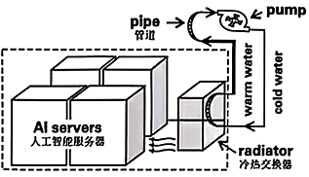
32. What is the main reason for China to develop underwater data centers?
A. To provide more electricity for AI servers directly.
B. To reduce the cost of building on-land data centers.
C. To solve the problem of high energy use caused by AI.
D. To increase the speed of internet connections worldwide.
33. How does an underwater data center cool AI servers?
A. It uses seawater to cool AI servers naturally.
B. It uses air conditioners for cooling AI servers.
C. It depends on wind energy to power its cooling.
D. It is connected with tidal and wave energy for cooling.
34. Which of the following is TRUE according to paragraph 4 and paragraph 5?
A. 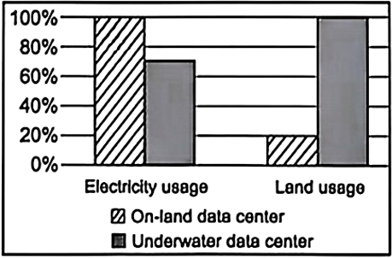 B. 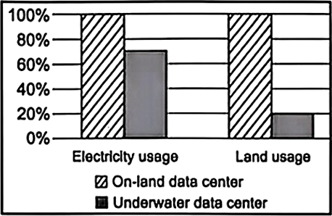
C. 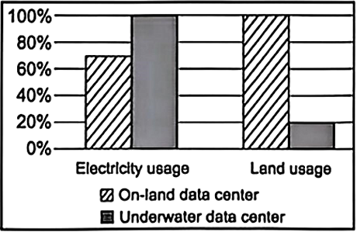 D. 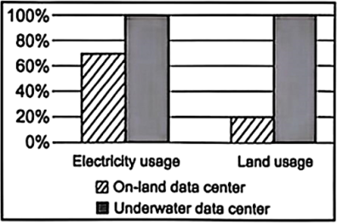
35. What would you do next if you were the developer of China’s underwater data centers according to the passage?
A. Close all the on-land data centers to save electricity in the near future.
B. Focus on developing on-land data centers instead of underwater data centers.
C. Cut down the cost of research and development since the projects are successful.
D. Explore the use of tidal and wave energy to further improve sustainable computing.
Ⅴ．口语应用。（每小题2分，共10分）
阅读下面对话，从7个选项中选择5个恰当的句子完成此对话，并把答题卡上对应题目的答案标号涂黑。
A: Hello! Danny! How are you these days?
B: ____36____ We had a Sports Day last week.
A: Really? ____37____
B: Yes. I took part in a running race.
A: Oh, that’s cool! Did you win?
B: Hmm... ____38____
A: It’s OK. I believe you tried your best.
B: Surely I did. I was a little sad when I learned about the result.
A: ____39____ After all, you had an unforgettable experience.
B: You’re right. I feel much better now.
A: Wish you good luck next time.
B: ____40____
A. Not bad.
B. Cheer up!
C. Thank you.
D. When was it?
E. Welcome to join us.
F. I only got fourth place.
G. Did you take part in any events?
第Ⅱ卷（共50分）
Ⅵ．任务型阅读。（65-66小题，每小题2分；67-68小题，每小题3分；共10分）
阅读下文并回答问题。
In a small village called Kangtou in Shandong, a special library named “Siyuan Library” has recently caught people’s eyes. It was set up by Zhou Qinggui, who was awarded in the National Conference on Reading (全民阅读大会) in 2026. Here are some notes from a reporter who interviewed Zhou Qinggui, Zhou’s father and a volunteer.
Born in a poor family, I was able to continue my education with the help of my family and villagers. In 2019, when I returned to my hometown, I found there was no place for children to read, and many of them spent too much time on entertainment (娱乐). Without college student models to follow, they never dreamed big. I felt heartbroken. My hometown shaped me, and I wanted to do something in return. Building a library to improve the cultural climate could be a right step forward.
—Zhou Qinggui
I fully supported his idea of building the library. Though some neighbors didn’t understand in the beginning, we never gave up. Now, as a librarian, seeing children reading here, I feel proud.  —Zhou Chenglin, Zhou’s father | In 2021, Zhou and his six childhood friends raised over 80,000 yuan to turn his old house into a library. I saw its growth supported by many people. In the last five years, it has collected more than 20,000 books from volunteers, and Zhou’s university alumni (校友) have also been invited to give talks here.  —Hu Feipeng, a volunteer
Siyuan Library has changed the village a lot. As village children pick up good study habits and confidence, their parents also join them in reading in the library. In 2024, 14 local students entered college; in 2025, this number rose to 34. Zhao Xiaoya is one of them, who once often read and studied in Siyuan Library and finally went to university. When asked about the library, Zhao Xiaoya said, “ ”
41. Was Zhou Qinggui born in a poor family?
__________________________________________________________________________________________
42. How many books has the library collected in the last five years?
__________________________________________________________________________________________
43. What made Siyuan Library a success?
__________________________________________________________________________________________
44. What would Zhao Xiaoya say? Finish the ending. (about 30 words)
__________________________________________________________________________________________
Ⅶ．完成句子。（69-72小题，每空1分；73小题2分；共10分）
阅读短文，根据方框中的内容和各小题的提示，完成句子。1-4小题，每空一词，含缩略词。
1. It has a long history.
2. Common people could afford them at that time.
3. Chinese painting is famous for flower-and-bird painting.
4. 它如此美丽以至于很多人都喜欢。
5. more popular, it, in the future, will become
Chinese painting is also called danqing. 1.____45____ it ____46____ a long history? (一般疑问句) Yes. The artists painted it on silk or cloth in the past. These materials were expensive. Common people 2. ____47____ ____48____ them at that time. (否定句) 3. ____49____ ____50____ Chinese painting famous for? (对划线部分提问) Flower-and-bird painting. It is 4. ____51____ beautiful ____52____ many people like it. (完成译句) Now, many young children are learning Chinese painting. 5. _______________53_______________. (连词成句)
Ⅷ．概要补全。（74和75小题，每小题2分；76和77小题，每小题3分；共10分）
阅读文章，用恰当的短语或句子补全概要。补全部分总词数不超过30词，不能照抄原文连续超过3个词。
When you’re happy, things might feel simpler. But when you’re worried or upset, even easy tasks can seem difficult.
This isn’t just something you imagine. In one study, researchers asked people to watch either a happy video or a sad video before they took a creativity test. People who watched the happy video had more creative ideas than those who watched the sad one. In another study, students who were given a small gift before an exam scored higher than those who were not.
Psychologist Barbara Fredrickson calls it positivity—the power of positive emotions (情绪). It suggests that feeling good helps you see “the big picture”. That is to say, you can have a wider view of the situation. And “the big picture” thinking is what you’ll need to come up with more creative solutions to problems.
Negative emotions, on the other hand, narrow your focus. This can be helpful in certain situations, like when you need to concentrate on (专注于) a dangerous task. However, in most cases, positive emotions can help you more.
Some schools are already applying (应用) positivity. They have introduced “happiness breaks” during which students spend a few minutes sharing funny jokes or stories before lessons. Teachers say this helps students think of more possible ways to work out the problems.
As students, how can you put it into practice? Try doing something fun before studying, like playing games with your classmates or watching a funny video. Take a few minutes to relax before a test, maybe by taking deep breaths or listening to a favorite song. This can help you do better in your work.
Emotions influence the way people think. Studies show happy people are more creative and get ____54____. This results from positivity. Compared to negative emotions, positive emotions are ____55____ in most cases. Some schools use positivity to benefit students. Students can ____56____ before work to improve their performance. In a word, positivity can help people solve problems better because ____57____.

Ⅸ．书面表达。（满分20分）
58. 某校英语社团正在开展主题为“A Dream Weekend”的征文活动。请根据该校学生周末活动的平均时间调查结果 (如图所示)，谈谈你发现的问题 (1—2个)，并结合自我成长、休闲娱乐和家人陪伴等方面规划一个理想的周末安排，简述理由，参与投稿。
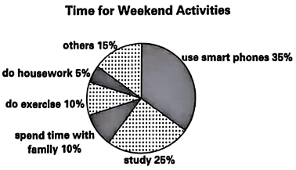
要求：
1．80—120词，开头已给出，不计入总词数；
2．文中不能出现自己的姓名和所在学校的名称。
参考信息：
▶ Self-improvement: study, read books, learn to sing…
▶ Relaxation: do exercise, watch movies, hang out with friends…
▶ Family time: do housework, talk with…, go camping…
▶ …
According to the survey,
______________________________________________________________________________________________________________________________________________________________________________________________________________________________________________________________________________________________________________________________________________________

