
二〇二六年齐齐哈尔市初中学业水平考试
英语试卷
第一部分 听力理解（20小题，每小题1分，共20分）
第一节 听下面五段对话。每段对话后有一个小题，从题中所给的A、B、C三个选项中选出最佳答案，每段对话读两遍。
1. How much is the ticket?
A. 1 dollar. B. 5 dollars. C. 10 dollars.
2. How did Miss Green come here?
A. By bike. B. By car. C. By train.
3. Why does Coco have breakfast at home?
A. It’s healthy. B. It’s tasty. C. It’s clean.
4. What will Peter do tonight?
A. Goto see a film. B. Watch TV at home. C. Prepare for the English test.
5. Where are the speakers going to have dinner?
A. The Moon Restaurant. B. The Sun Restaurant. C. The Ocean Restaurant.
第二节 听下面几段对话。每段对话后有几个小题，从题中所给的A、B、C三个选项中选出最佳答案。每段对话读两遍。
听对话，回答以下小题。
6. What does Mary think of Miss Wang?
A. Careful. B. Patient. C. Kind.
7. What will the students do for the teacher?
A. Say thank you. B. Make a card. C. Buy some flowers.
听对话，回答以下小题。
8. What’s Cindy’s favourite animal?
A. The giraffe. B. The panda. C. The elephant.
9. When will Linda meet her cousins?
A. One o’clock. B. Two o’clock. C. Three o’clock.
10. What will Cindy bring to the zoo?
A. A camera. B. Some drinks. C. An umbrella.
听对话，回答以下小题。
11. How old is the girl from Shenzhen?
A. 8. B. 13. C. 16.
12. What’s the name of the AI?
A. AI Helper. B. AI Learner. C. AI Inventor
13. What does the AI help the girl with at first?
A. Her report. B. Her interest. C. Her study.
14. What can the AI do for the students?
A. Talk with them. B. Find key points. C. Invent tools.
15. What is the AI like?
A. A friend. B. A partner. C. A teacher.
第三节
听下面一篇短文，请根据短文内容，写出下面表格中所缺信息，每空仅填一词，短文读两遍。
Weather Report
In the north | There’s a heavy ________. It will last for about one hour. The wind is blowing hard. The temperature is around 25℃.
In the west | It’s ________ and the temperature is about 22℃. It’s just right to ________ outside.
In the south and east | The sun is shining and it’s very hot. It’s around ________℃. You’d better wear a hat and sunglasses.
In the center | It’s cool and dry, and the temperature is about 28℃. It’s a good day to have a ________.
第二部分 阅读理解（25小题，每小题2分，共50分）
(A)
Project: Electricity Around Us  Do some research on electricity and design a poster. Use the questions and the information to help you.  ◆ What’s electricity?  ◆ How much do you learn about electricity?  ◆ How can we use electricity safely and wisely? | Use of electricity  ◆ Electricity is very useful for us. It can bring us light, heat, moving energy and so on.  Facts about electricity  ◆ It travels at the speed of about 300 million meters per second.  ◆ We can use water, wind and sunlight to produce electricity.  Electrical safety  ◆ Don’t stick your finger into the socket (插座).  ◆ Read the instructions carefully before using new electrical appliances (电器).  Ways to save electricity  ◆ Turn off the lights when leaving.  ◆ Don’t leave the fridge door open when cooking.
Come and join our Energy Club! Let’s complete the project together.  Time: Friday afternoon 4:30-6:00, June 12th  Place: Classroom 303, Building One  Welcome all the students from Grade 9!  Interesting activities are ready; Gifts are ready; Are you ready? |  | 
根据语篇内容选择最佳答案。
1. How many ways of getting electricity are there in the article?
A. Two. B. Three. C. Four.
2. Which of the following is mentioned in the article?
A. 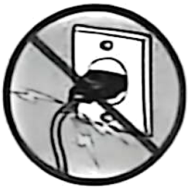 B. 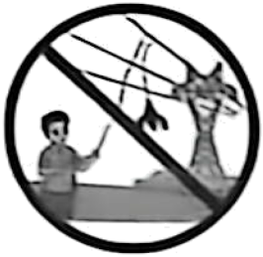 C. 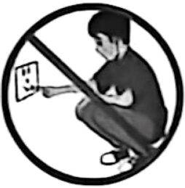
3. What’s the purpose of making the project?
A. To explore electricity around us.
B. To tell the history of electricity.
C. To teach the ways to save electricity.
4. Who may join the Energy Club?
A. Tom who is from a primary school.
B. Amy who is interested in physics.
C. Bob who is absent from school on Friday.
5. From what kind of books will you get more information for the project?
A. Sport. B. Health. C. Science.
(B)
Have you ever traveled abroad? Two Frenchmen, Voisot and Humblot, recently did. They traveled from their hometown in southeastern France to Shanghai. While this may sound like a usual trip, they were widely reported because they completed it almost on foot.
Yes, on foot! Voisot, 26, and Humblot, 27, set off in September, 2024. They walked around 45 kilometers a day and rested every five or seven days. After crossing 16 countries, they finally reached Shanghai in February, 2026. Tired but overjoyed, they hugged each other by the Huangpu River. “It’s hard to believe!” said Voisot, “We weren’t sure we would make it, but we told ourselves we’d try it out.”
Voisot and Humblot have known each other since 2008. They went to primary school and university together. One night after work, they talked about making a trip. They wanted to avoid flying and then they had this crazy idea of walking all the way.
Of course, Voisot and Humblot faced many challenges. There were very hard winters, and they made their way to cross a desert in Uzbekistan. Still, their strong will kept them going.
Since they have reached Shanghai successfully, will Voisot and Humblot simply pack up and head home? No! The two have come up with an even crazier idea. “Now that we have hit the ocean, why don’t we take a boat and head east to the United States?” said Humblot. “Then we could walk across North America, cross the Atlantic and walk back home, making a full circle!”
根据语篇内容做出判断，正确选A、错误选B、未提及选C。（未提及表示在语篇中没有提到句中信息）
6. Arriving in Shanghai means the two Frenchmen finished the usual journey.
7. China is the seventeenth country in the two Frenchmen’s trip.
8. Voisot and Humblot raised enough money before setting out.
9. The underlined word in the last paragraph “hit” means “reached”.
10. The two Frenchmen will fly back to their hometown for a good rest.
(C)
Do you know the book The Storied Life of A. J. Fikry? The wonderful book, written by Gabrielle Zevin, takes you on a fantastic journey through the ups and downs of a man named A. J. Fikry. It’s a book about love, family, and how amazing books can be.
The story happens in a small town called Alice Island. There Fikry runs a bookstore called Island Books. At first, he got angry quite often, was not good with people and liked being alone. But everything changed when he found a strange package (包裹) in his store. As you read, you get to experience Fikry’s life, filled with funny times and a bit of sadness as he deals with unexpected changes.
What makes the book great is how it mixes funny things with deep thinking. Fikry, who started to be alone, changed a lot during the story. People like Amelia and Maya came into his life, making things more interesting and helping Fikry to become a better person.
The Island Books bookstore is a wonderful place for book lovers. Zevin, the writer, uses the bookstore to show how amazing books are and how they can bring people together. Each part of the book even begins with a suggestion for a short story, adding a special touch to the whole story.
Generally, The Storied Life of A. J. Fikry is a book that touches your heart. If you enjoy stories that make you feel warm inside and think about life, this book is a must-read.
根据语篇内容选择最佳答案。
11. How does the writer start the passage?
A. By setting an example. B. By asking a question. C. By comparing with another book.
12. Why did Fikry change a lot later?
A. Because he met some people in his life.
B. Because he found a package in his store.
C. Because he shared his sadness with his parents.
13. What feelings can you experience when reading the book?
A. Warmth and love. B. Anger and loneliness. C. Pain and sadness.
14. What’s the passage mainly about?
A. A story of a book seller.
B. A bookstore named Island Books.
C. An introduction of a wonderful book.
15. How is the passage organized?
A. 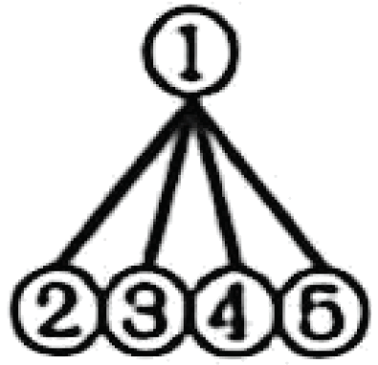 B. 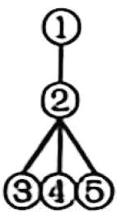 C. 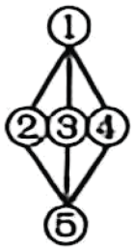
(D)
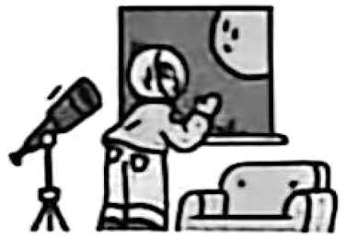
As we admire the Full Moon on the night of the Mid-Autumn Festival, have you ever thought of the relationships among the Sun, Earth and the Moon? ____16____
As Earth turns, sometimes we face the Sun. ____17____ When Earth’s spin (旋转) turns us away from the Sun, we get night. That’s when people on the opposite side of Earth face the Sun. At that time, those people have day while we have night.
____18____ Unlike the Sun, it doesn’t make its own light. It can only reflect the light from the Sun. The Sun lights up only the side of the Moon that faces the Sun. At Full Moon, the Moon is on the opposite side of Earth from the Sun. ____19____ During the Full Moon, the Moon rises around sunset (日落), and sets around sunrise.
But moonlight is so bright that you can sometimes see it during the day too. A few days before Full Moon, if you look east in the afternoon, you may see the Moon. And for a few days after Full Moon, you can find it if you look west in the morning. But the Moon is most difficult to see at New Moon, when it is between Earth and the Sun. At that time, the side of the Moon facing Earth is dark. ____20____ How amazing it is to see the changes of the Moon!
According to the changes, humans created the calendar. Remember that many humans’ achievements are based on the simplest things—glancing at the sky. Are you brave enough to join in exploring space?
根据语篇内容，从所给的选项中选出能填入空白处的最佳选项，使语篇语意连贯，选项中有一项为多余项。
A. As a result, the Moon can’t be seen at all.
B. The Moon is a different story.
C. The following is my advice for you.
D. That is when we get day.
E. Let’s take a journey to see how they move.
F. Then the side of the Moon facing Earth is all lit up.
(E)
Among the most famous Chinese paintings, there’s a very long painting of horses called One Hundred Horses. To many people’s surprise, it was painted not by a Chinese artist but an Italian named Giuseppe Castiglione. He was better known in China by his Chinese name, Lang Shining.
In 1688, he was born in Milan, Italy. When he traveled to Beijing in 1715, he was invited to work as an artist. By then, he had already made a name for himself because of his special style putting Western and Chinese painting methods together. The things in the paintings appeared lifelike.
In 1724, Emperor Yongzheng asked him to paint One Hundred Horses on silk nearly eight meters long. It was no easy task. Once the brush is placed, there is no going back. He first practised on paper over and over again. After carefully planning, he copied the best piece onto silk, little by little. It took him four years to finish the painting. The one hundred horses are in different poses. Some stand quietly, while others run, walk, drink water or even fight.
The painting’s large size alone is enough to shock the viewers. A closer look, however, may surprise you further. He skillfully painted the trees, horses and people, yet they were all painted with a Chinese brush. In One Hundred Horses, humans and nature live side by side in peace, and so do Eastern and Western aesthetics (美学). Perhaps this perfect balance is why Emperor Qianlong liked it so much.
根据语篇内容，回答问题。（1-3题答案不超过5个词，4题答案不超过10个词，5题答案不超过20个词。）
21. Who painted One Hundred Horses?
__________________________________________________
22. What was he famous for?
__________________________________________________
23. When did he finish One Hundred Horses?
__________________________________________________
24. What did he do before painting on silk?
__________________________________________________
25. What do you think of the painter? Why? (Please give one reason.)
__________________________________________________
第三部分 语言知识运用（25小题，每小题1分，共25分）
第一节 完形填空
阅读下面的语篇，理解其大意，然后从语篇后各题所给的A、B、C三个选项中，选择一个能填入空白处的最佳选项。
I stutter (口吃). I never spoke in class before. Later I found that when I had music on my headphones, I could speak ____26____ stuttering! That’s why I decided to take part in today’s speech competition.
So today is a ____27____ day for me, but it started really badly. When I was having breakfast at home, my phone rang. “Hello! Is that Tom?” It was Luke, a new boy in my class.
I tried to reply, ____28____ my throat just fully closed up and I started to stutter. And then I heard someone ____29____on the phone. It sounded like Ryan, a boy in my class who often made fun of me. I ____30____ the phone. I was sure they called me just to laugh at ____31____. OK, I wouldn’t let them make me feel bad today.
____32____, when it was my turn to give the speech in the afternoon, I was so nervous that I chose the wrong ____33____ on my phone. Instead of relaxing music, I had dance music on my headphones. The result was that it ____34____ like I was rapping (说唱). When I finished, my classmates all stood up and cheered, including Ryan.
____35____ I returned to the seat, Luke came to congratulate me. He also explained that he called to wish me luck this morning. And the laughter I heard wasn’t Ryan’s — it was actually Luke’s dog barking!
It’s really a big day for me!
26. A. against B. without C. unlike
27. A. bad B. simple C. big
28. A. but B. or C. because
29. A. crying B. shouting C. laughing
30. A. put down B. took off C. gave away
31. A. me B. them C. him
32. A. Clearly B. Unluckily C. Seriously
33. A. name B. idea C. music
34. A. sounded B. looked C. felt
35. A. Before B. After C. Until
第二节 选词填空
从方框中选择适当的词填空，使语篇意思完整。每空限填一词，每词限用一次。方框中有一个词为多余项。
proud attended good performed words popular decided excitement
“The Five-Starred Red Flag flies high…” Whenever we hear the song, we will sing along. The song is called Ode to the Motherland (《歌唱祖国》). It was written by Wang Xin.
On October 1, 1949, Wang Xin ____36____ the Founding Ceremony (开国大典) of the People’s Republic of China. He was deeply moved and ____37____ to write a song right away for New China with his love and pride. Though he had many ideas, none was ____38____ enough to him.
One day, Wang Xin walked past Tian’anmen Square. The moment he saw the Five-Starred Red Flag flying in the wind, a few ____39____ came into his mind. On his way back to Tianjin by train, when he saw the fields and mountains outside the window, the main part of the song began to take shape.
When Wang Xin got home, he said with ____40____ “I made it!” He completed the whole song at once. He ____41____ the song in different places. The song really brought people power, pride and more love for the country.
The song got ____42____ across the country. From then on, it was sung during many important national events. He said, “I’ve written many works in my life, but I believe I’ve only written ‘two songs’. One is Ode to the Motherland, a song written with musical notes, and the other is a song written for the motherland with all my heart.”
第三节 语法填空
根据语篇内容填写所缺单词或用所给单词的正确形式填空，使语篇意思完整。
The Ministry of Education (教育部) announced that class breaks and sports time for the primary and middle school students must last long enough, at least two ____43____ (hour) a day.
The more free time means to help students stay healthy. The breaking time was often cut short for years, ____44____ students almost had little time to rest or let their eyes relax. Now, the government gives students longer breaks. Schools also make sure students can enjoy ____45____ (they) by taking part in all kinds of ball games or other exercise.
“During the breaks, we do different outdoor activities. These activities help us become active. We’re full ____46____ energy after a long break.” says Wang Ming, a middle school student.
Another says, “Enough exercise helps me fall ____47____ (sleep) more easily. We believe doing more sports will play ____48____ important role in our growth.”
The government will keep a close eye on schools to push them to keep the rules. The government ____49____ (want) to end the days of “all work and no play”. We ____50____ (complete) believe that healthier and happier students will lead to a brighter future.
第四部分 口语表达（5小题，每小题1分，共5分）
根据下面的对话内容，在空白处填上一个适当的句子，使对话的意思连贯、完整。
(Two volunteers are talking about a documentary.)
A: Have you ever seen the documentary about the deep sea?
B: No, I haven’t. ________51________?
A: It’s about scientists from many countries researching the deep sea.
B: Wow, I hear that many animals live in the deep sea. Well, ________52________?
A: Er… many deep-sea animals are large and unusual. Some animals are blind, but they can “see” as well as others.
B: Cool! ________53________?
A: Some other special things are also in it. However, to our surprise, there is rubbish even at 11,000 meters deep.
B: ________54________. I think something must be done. What do you think we should do?
A: I think we should call on people to take away the rubbish when they leave the beach.
B: ________55________. Let’s protect the deep sea together.
第五部分 书面表达（共20分）
56. 交换生Jason来到中国后，在学习中华优秀传统文化时，接触到孔子 (Confucius) 的思想，他在校园论坛上发布了一则帖子。假如你是李华，请根据帖子上的内容进行回复。
要求：
1．字迹工整，段落清晰，表达清楚，语法正确，行文连贯；
2．要点必须包含所有相关信息，并适当发挥：
3．词数不少于90词，开头已给出，不计入总词数：
4．不得泄露个人信息。



