黑龙江省龙东地区2026 年初中学业水平考试
英语试题
考生须知：
1．考试时间 120 分钟；
2．全卷共五道大题，总分 110 分；
3．请将答案填写在答题卡的指定位置。
本考场试卷序号（由监考填写）____________________
第一部分 听力理解（共 20 小题，每小题 1 分，共 20 分）
第一节 听下面五段对话，根据问题从每小题所给的 A、B、C 三幅图片中，选出正确答案。听完每段对话后，你将有 5 秒钟时间作答。每段对话读两遍。
1. A. 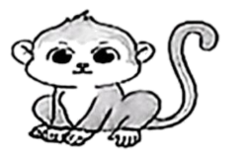 B. 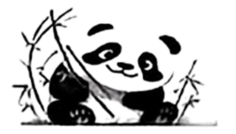 C. 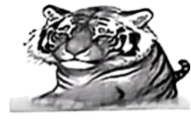
2. A. 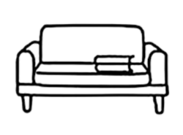 B. 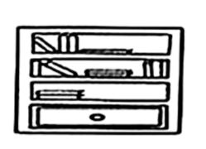 C. 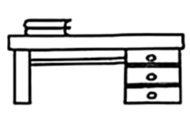
3. A. 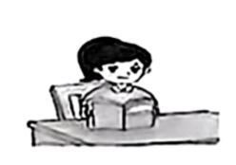 B. 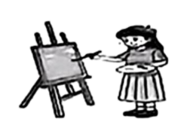 C. 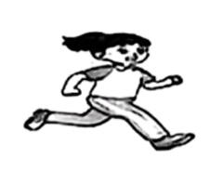
4. A. 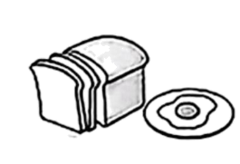 B. 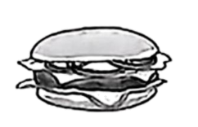 C. 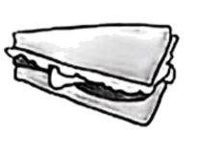
5. A.  B. 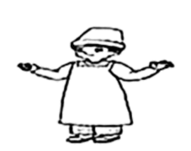 C. 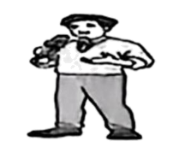
第二节 听下面四段对话或独白，请从每小题所给的 A、B、C 三个选项中选出正确答案。听每段对话或独白前，你将有 5 秒钟时间读题，听完后，你将有 5 秒钟时间作答。每段对话或独白读两遍。
听对话，回答以下各小题。
6. Who is the girl going to the museum with?
A. May. B. Tom. C. Eric.
7. How are they going to the museum?
A. By car. B. By bus. C. By bike.
听对话，回答以下各小题。
8. What’s the relationship between the two speakers?
A. Teacher and student. B. Parent and child. C. Brother and sister.
9. What are the speakers going to have tonight?
A. Potatoes. B. Carrot juice. C. Tomato and egg soup.
听对话，回答以下各小题。
10. Where did David go for a holiday?
A. Beijing. B. Xi’an. C. Harbin.
11. What was the weather like there?
A. Windy. B. Sunny. C. Rainy.
12. Which place does David like best?
A. Sun Island. B. Central Street. C. The Technology Museum.
听独白，回答以下各小题。
13. What does Peter like?
A. Drawing. B. Dancing. C. Singing.
14. Why do students love Mr. and Mrs. Green?
A. Because they are caring.
B. Because they are patient.
C. Because they are humorous.
15. How often do the Greens fly back to New York?
A. Every year. B. Twice a year. C. Three times a year.
第三节
听下面一段独白，根据内容，补全所缺信息，每空一个单词。听独白前，你将有 20 秒钟时间读题，听完后，你将有 20 秒钟时间作答。独白读两遍。
Graduation Ceremony
Time | At 8 o’clock this 16 .
Place | In our school 17 .
Activities | Mr. Li will 18 us a speech.
Activities | There is going to be a 19 .
Activities | We can enjoy a talent show.
Activities | We can also bring cameras to 20 photos.
第二部分 阅读理解（共25小题，每小题2分，共50分）
A
How would you like to spend your summer holiday? Do you want to watch TV at home or go on a trip? Well, no matter what you do, a bag of potato chips will make it more enjoyable.
You need:
☆ 2 potatoes and some oil.
☆ An oven, a baking tray (烤盘) and a knife.
How to do:
▲ First, heat the oven for 5 minutes.
▲ Second, cut the potatoes into thin pieces with a knife.
▲ Third, brush the pieces with oil and put them on a baking tray.
▲ Finally, put the baking tray into the oven and cook for 15 minutes.
Tips
It’s time for you to enjoy your delicious potato chips. You can add some salt, honey or pepper according to your likes.
根据语篇内容选择最佳答案。
1. How many steps do you need to make potato chips?
A. 2. B. 3. C. 4.
2. How long does the oven work in total?
A. For 5 minutes. B. For 15 minutes. C. For 20 minutes.
3. What’s the last step to make potato chips?
A. Heat potato chips.
B. Brush the pieces with oil.
C. Put the baking tray into the oven and cook.
4. If you like something sweet, you can add ________ to your potato chips.
A. salt B. honey C. pepper
5. When do people usually eat potato chips according to the passage?
A. When swimming.
B. When having a math class.
C. When watching TV at home.
B
There are many traditional cultures in China. All of them have a very long history. Let’s have a look at some of them.
Chinese Folk Music  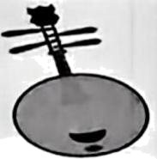  It has something to do with Chinese old stories. One of the works, Shijing, has some folk songs from 15 different areas. Pipa, erhu and xiao are traditional Chinese musical instruments. | Weiqi  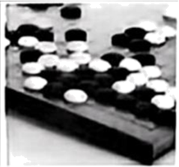  Weiqi, called “yi” in Chinese history, is a game between two players. It has a history of about 3,000 years. The game is said to be the beginning of chess games. It was introduced to Korea about 2,000 years ago.
Chinese Handwriting  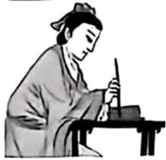  It is a special art of Asian culture. Brush handwriting is popular around the world. Wang Xizhi is famous for his handwriting. He made a great difference to the development of regular script (楷书). | Chinese Painting  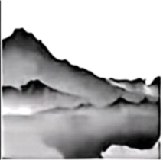  It is one of the oldest arts in the world. Most of the Chinese paintings in Chinese history were done on paper. They are mainly about mountains and water, people, flowers and birds. The most famous one is about mountains and water.
根据语篇内容选择最佳答案。
6. How many kinds of traditional Chinese cultures are mentioned?
A. 2. B. 3. C. 4.
7. When was Weiqi introduced to Korea?
A. About 1,000 years ago.
B. About 2,000 years ago.
C. About 3,000 years ago.
8. From the material, Chinese handwriting ________.
A. is the beginning of all arts
B. has a history of 3,000 years
C. is a special art of Asian culture
9. What is the most famous Chinese painting about?
A. Flowers. B. Birds. C. Mountains and water.
10. Which of the following is TRUE according to the material?
A. Chinese folk songs in Shijing came from different areas.
B. Wang Xizhi made a great difference to Chinese painting.
C. Weiqi has something to do with Chinese old stories.
C
Have you ever heard of BDS (BeiDou Navigation Satellite System 北斗卫星导航系统)? It’s a kind of navigation satellite system made by China. It has been widely used in different fields in the world.
In improving daily lives
BDS is helpful in our daily lives. When we get lost or drive in a strange city, BDS provides exact directions. Also, when children wear their smartwatches, their parents can check their position anytime and see if they are safe.
In farming
The technology of BDS is used on modern farms. Many farmers cut and collect crops with the help of automatic (自动化的) driving systems. Farmers also use BeiDou with their animals. They can sit at home and know exactly where their animals are.
▲
When there is an emergency, BDS helps. It sends short messages and information about the position. This means that help can arrive quickly at the place in need. During an earthquake, mobile phones might not work. But BDS still works. It can send short messages of 1,000 characters at a time and can also send voice and pictures.
China built the BeiDou system on its own, but it can serve the whole world. Now, more than 120 countries and areas around the world are using the system. The amazing BeiDou is not only China’s BeiDou, it is also the world’s BeiDou.
根据语篇内容选择最佳答案。
11. Choose the best title to fill in the blank “ ▲ ”.
A. In dealing with emergencies B. In sending short messages C. In receiving information
12. In which situation can we use BDS?
①When feeding animals. ②When looking for animals.
③When driving in a strange city. ④When checking children’s position.
A. ①②③ B. ②③④ C. ①②④
13. Xiaoming is not at home. His mother finds him at the park by checking her mobile phone. Look at the map, the park is to the ________ of the house.
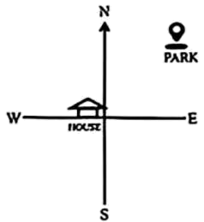
A. west B. north C. northeast
14. What does the underlined word “characters” mean in Paragraph 4?
A. 性格 B. 字符 C. 人物
15. Which is the structure of the passage?
A. 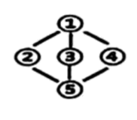 B. 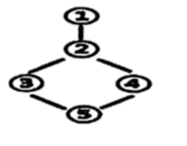 C. 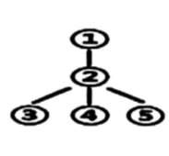
D

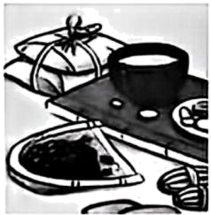
Have you ever taken Chinese medicine? What do you think of it? ___16___ However, more and more people are becoming interested in it because it’s helpful and it can treat illnesses.
Chinese people have been using traditional Chinese medicine for centuries. In ancient times, Chinese doctors always went to the mountains to pick herbs (草药) in person. ___17___ When we talk about Chinese medicine, we always think of Li Shizhen. He is one of the most famous doctors in ancient China. He travelled in the countryside with a bag of herbs and treated patients.___18___
Nowadays, traditional Chinese medicine still plays an important part in our daily lives. ___19___ If you have a cold, you can drink a cup of warm ginger (姜) tea. If you are weak, you can take Dangshen and Huangqi. Even some foreigners start to try traditional Chinese medicine. They think it is amazing.
___20___ It not only protects Chinese health but also becomes a popular way to keep healthy abroad.
根据语篇内容，从文后所给的选项中选出能填入空白处的最佳选项，使短文语意连贯。选项中有一项为多余项。
A. Maybe you don’t like it because of its taste.
B. In a word, traditional Chinese medicine is the treasure of China.
C. For example, if you have a sore throat and a cough, you can drink hot water with Gancao.
D. He spent 27 years writing a classic book called Bencao Gangmu.
E. Then they made the herbs into Chinese medicine soup to treat people.
F. They are lovers of traditional Chinese medicine.
E
Longlong is a student of Grade 7 from a middle school in Heilongjiang Province. At the start of the new school year, he tried on his free school uniform with a wish card. It’s from his elder schoolmate. That made him happy.
There is a wonderful program about recycling school uniforms in this school. The school set up a recycled uniform centre. Graduating students can give away their old uniforms there. Other kids can also give away the uniforms that are too small for them. Then the centre cleans and disinfects (为……消毒) each uniform carefully. After that, kids in need will get the uniforms. This program is very popular now. It has won growing support from parents and students. They think it saves money and helps protect the environment.
Dongdong joined in the program again last summer. He gave away his old uniform and got a bigger one for free. His mother said, “Kids grow quickly. This program helps our family save money every year.”
“Recycling school uniforms can reduce waste. Most importantly, it helps kids learn to share love and pass kindness.” said Mrs. Gao, the headmaster of the school.
根据语篇内容回答问题。（1-4题每题的答案不超过5个词，第5题不超过20个词）
21. How did Longlong feel when he tried on his free school uniform?
____________________________________________________
22. Where can students get free uniforms?
____________________________________________________
23. When did Dongdong join in the program again?
____________________________________________________
24. What did Dongdong get after he gave away his old uniform?
____________________________________________________
25. Will you give away your old school uniforms after graduation? Why?
___________________________________________________________________________________________________________________________________
第三部分 完形填空（共10小题，每小题1分，共10分）
阅读下面短文，理解其大意，然后从所给的A 、B 、C三个选项中选择一个最佳选项。
Do you like table tennis? Do you know Sun Yingsha ____26____ has won many gold medals so far? Yes, she is one of the greatest table tennis players in China. Do you want to know more about her?
When she was just 5 years old, her mother took her to a table tennis class to get more ____27____. Surprisingly, the little girl fell in love ____28____ table tennis. Sun was very hard-working. She didn’t need others to tell her to practice — she always did it ____29____. She was also smart. Once she watched someone do a new move, she ____30____ copy it right away. Because of this, she improved very fast. At the age of 10, she was ____31____ for the Hebei provincial team. This was her ____32____ step to become a professional player. Just at that time, she made up her mind to become a table tennis champion just like her favourite super hero Zhang Yining.
She achieved her dream through her love and hard work. In 2017, she won the first place in the ____33____ Singles at the Japan Open. This helped her become ____34____ around the world. At the 2021 Tokyo Olympics, she won a gold medal with her teammates. This was a big ____35____ for a young player. From then on, she has got the first place over and over again. At the 2026 World Table Tennis Championships, she won another gold medal in the team event. She is a role model for many young people.
26. A. who B. what C. which
27. A. surprise B. attention C. exercise
28. A. from B. with C. to
29. A. actively B. badly C. lazily
30. A. should B. could C. need
31. A. decided B. chosen C. told
32. A. one B. once C. first
33. A. Women’s B. Men’s C. Woman’s
34. A. tired B. famous C. helpful
35. A. success B. succeed C. successful
第四部分 语言知识运用（共15小题，每小题1分，共15分）
第一节 选词填空
从方框中选择适当的词填空，使短文意思完整。每空限填一词，每词限用一次。方框中有一个词为多余项。
environment But growth true temperature to colder build
Some scientists think that Mars might be the next place for humans to live. This idea will come ___36___ someday. To live on Mars, humans need water, food, a place to live, and a warm ___37___ with enough oxygen (氧气). ___38___ Mars is not Earth. We have to change the environment on Mars so that it is similar ___39___ Earth’s. One of the main goals is to warm it up because the average ___40___ there is about -60℃. One idea to make Mars warm is to ___41___ factories that produce greenhouse gases there. This could lead to rain and the ___42___ of plants. And it could bring us one step closer to our dream of living on Mars.
第二节 语法填空
根据内容填写所缺单词或用所给单词的正确形式填空，使语篇意思完整。
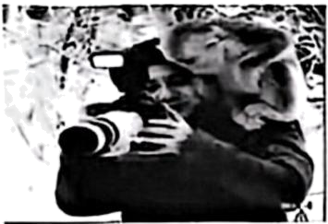
Look! Can you see the man with a camera? His name is Xiao Ge who loves taking photos of wildlife. In order to take photos of the monkeys, he has been to the Shennongjia National Park many ___43___ (time).
One winter, he had ___44___ special experience with a monkey. The monkey was the ____45____ (big) and strongest member of the group. It looked relaxed, so he ____46____ (decide) to take a close shot (拍摄). He got nearer and nearer and then sat down on the snowy ground. In fact, he was so close that he sat on ____47____ (it) tail—he didn’t realize it at all. But the monkey didn’t get ____48____ (angrily). It just pulled its tail out.
On another trip, he was busy taking photos of these lovely animals. A monkey jumped onto his shoulder ____49____ (sudden). It sat there and looked ____50____ his photos on the screen of the camera.
We share the same earth with animals. We need to repay that trust by continuing to give them our protection.
第五部分 书面表达（共15分）
51. 近年来，为培养德、智、体、美、劳全面发展的时代新人，全国各地各校积极地行动起来，深入践行“健康第一”“身心共育”的育人理念，我国学生的健康水平迈上了新台阶。如何成长为更健康的中学生？请你从饮食、运动、睡眠、心态等方面提出建议。
参考信息：
eat a balanced diet, take exercise, get enough sleep, positive, necessary
要求：
1．内容必须包括所有要点，可适当发挥，以使行文连贯；
2．文中不得出现真实的人名、校名和地名；
3．80-100词，开头已给出，不计入总词数。
There is no doubt that health is important to everyone. ________________________________________________________________________________________________________________________________________________________________________________________________________________________________________________________________________________________________________________________________________________________________________________________

