人教PEP版小学英语四年级下册期末阶段质量预测卷
姓名： 班级：
题号 | 一 | 二 | 三 | 四 | 五 | 六 | 七 | 八 | 九 | 十 | 总分
得分

听力部分
一、听音，选择听到的内容（5分）
1．听录音，选出你听到的单词。
( )1). A．cool B．cold C．coat
( ) 2). A．forty B．farm C．floor
( ) 3). A．next B．nice C．nine
( ) 4). A．sunny B．cloudy C．windy
( ) 5). A．short B．shirt C．skirt
二、听音，选择正确答案（10分）
2．听录音，选出正确的图片。
( )1). A．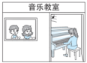 B．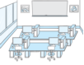 C．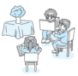
( )2). A．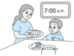 B．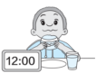 C．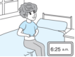
( )3). A． B．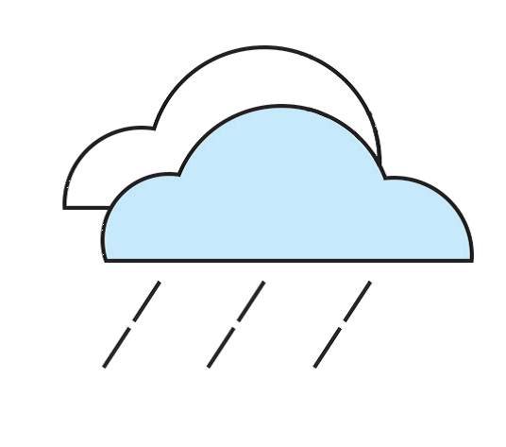 C．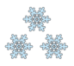
( )4). A．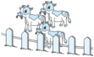 B．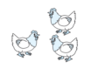 C．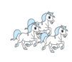
( )5). A．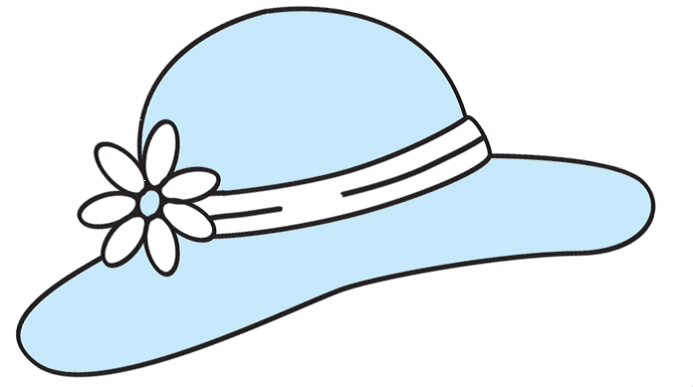 B．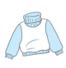 C．
3．听录音，选择正确的答语。
( ) 1). A．Yes, it does. B．No, it isn't. C．Yes, they are.
( ) 2). A．It's on the first floor. B．It's under the jacket. C．It's on the chair.
( ) 3). A．It's hot. B．It's red. C．It's expensive.
( ) 4). A．They are yellow. B．They are 80 yuan. C．They are mine.
( ) 5). A．Yes. The shoes are nice. B．Thank you. C．You're welcome.
三、听音排序（5分）
4．听录音，给下列图片排序。
A． B．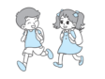 C．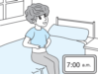 D．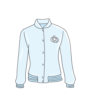 E. 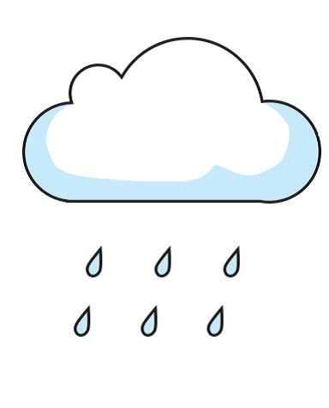
1). ________ 2). ________ 3). ________ 4). ________ 5). ________

笔试部分
四、词汇选择题（5分）
读一读，找出不同类的一项。
5．A．teacher's desk B．music room C．computer room
6．A．breakfast B．dinner C．get up
7．A．gloves B．cold C．socks
8．A．windy B．cloudy C．scarf
9．A．apples B．green beans C．potatoes
五、单选题（10分）
10．—Do you have ______ umbrella? ( )
—Yes, I do. It's a black umbrella.
A．a B．some C．an
11．—Amy, are these shoes ______? ( )
—No, they aren't. They are Chen Jie's.
A．you B．yours C．your
12．This ______ the vegetable garden. These ______ carrots. ( )
A．is; are B．are; is C．are; are
13．The gloves are nice. Can I try them ______? ( )
A．in B．on C．for
14．—How many ______ can you see? ( )
—I can see twelve.
A．tomato B．tomatos C．tomatoes
六、情景选择（10分）
15．在农场里，你想询问农民伯伯远处的那些动物是不是绵羊，你应该说：( )
A．Are these sheep here?
B．Are those sheep over there?
16．你想告诉同学山羊喜欢吃胡萝卜，你应该说：( )
A．Goats love to eat carrots.
B．Sheep love to eat carrots.
17．你正在整理衣物，想让姐姐过来帮忙，你应该说：( )
A．Let me help you.
B．Can you help me?
18．你看到床上有一条裤子，你想问这是谁的裤子，你应该说：( )
A．Whose pants are these?
B．Where are my pants?
19．你拿着一件外套，想告诉弟弟这件外套是他的，你应该说：( )
A．It’s your coat.
B．This is a coat.
七、选词/短语填空（5分）
What How Whose Where Who
20．—_______ is the computer room?
—It’s on the first floor.
21．—_______ is that woman?
—She’s my mother.
22．—_______ much are these pants?
—＄20.
23．—_______ is the weather like in New York?
—It’s snowy.
24．—_______ sunglasses are they?
—They’re mine.
八、句图匹配（10分）
A．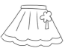 B．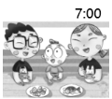 C．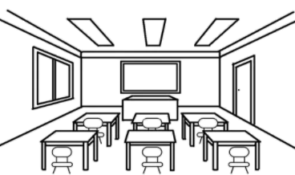 D． E.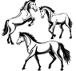
25．It's seven o'clock in the evening. It's time for dinner. ( )
26．Look at the skirt. It's pretty. It's 80 dollars. ( )
27．Those are horses. ( )
28．This is our classroom. It's nice. ( )
29．It's cloudy in Beijing today. ( )
九、连词成句（10分）
30．have lot You of a animals (.)
_____________________
31．have, get, up, breakfast, and, (.)
______________________________
32．at, the, Look, sheep, (!)
______________________________
33．to, It’s, clothes, my, time, pack, (.)
______________________________
34．umbrella, Is, too, the, expensive, (?)
______________________________
十、选内容补全对话/短文（10分）
Assistant: Welcome! ____35____
Mike: Yes. I want to buy a pretty skirt for my little daughter.
Assistant: OK. ____36____
Mike Sorry. My daughter likes orange.
Assistant: How about this orange one? ____37____
Mike: Yes, I do. ____38____
Assistant: It’s thirty yuan.
Mike: ____39____ I’ll take it.
A．It’s cheap.
B．Can I help you?
C．How much is it?
D．Do you like it?
E．How about this red skirt?
十一、阅读判断（10分）
In spring, it's warm and sunny. We can wear our jacket and shirt. In summer, it's very hot. We can wear the T-shirt, dress and hat. Sometimes, it's rainy. The umbrella is useful (有用的). In fall (秋天), it's cool. We can wear pants and jacket. In winter, it's cold. We can wear the sweater, scarf and gloves.
40．It's warm and sunny in spring. ( )
41．We can wear sweaters in summer. ( )
42．We use the umbrella on rainy days. ( )
43．We wear the scarf in winter. ( )
44．It's cold in fall. ( )
十二、阅读选择（10分）
Look! This is our school. It is so big. That is the library. It’s next to the art room. You can read books (读书) there. And the teachers’ office is on the second floor. There is also a playground. You can play football after school. And how about our class? There are forty-five students in our class. In our classroom, there is a computer. Now it’s 12 o’clock. It’s time for lunch. Let’s go!
45．The library is next to ______. ( )
A．the art room B．the teachers’ office C．the computer room
46．The teachers’ office is on the ______. ( )
A．first floor B．second floor C．playground
47．You can ______ after school. ( )
A．play football B．have lunch C．read books
48．There are ______ students in our class. ( )
A．forty B．forty-five C．forty-eight
49．What time is it now? ( )
A．10 o’clock. B．11 o’clock. C．12 o’clock.

参考答案：
1． A C B C C
【详解】
1). cool 2). floor 3). nice 4). windy 5). skirt
2． B B A C C
【详解】
1). Is that your computer room?
2). It's 12:00. It's time for lunch.
3). Today it's cloudy in Shanghai.
4). Are these horses? They're so tall.
5). I have a new shirt. It's pretty.
3． B A A C A
【详解】
1). Is it a cow?
2). Where is the library?
3). What's the weather like today?
4). Whose shorts are these?
5). Can I help you?
4． C E D B A
【详解】
I'm Leo. I get up at 7:00 today. The weather is cold and rainy. I wear my new jacket. It's very nice. I go to school at 7:40. Look! This is my school. Where is my classroom? It's on the second floor. And there is a farm near our school. We can see many green beans. They are so long.

5．A
6．C
7．B
8．C
9．A
10．C
11．B
12．A
13．B
14．C
15．B
16．A
17．B
18．A
19．A
20．Where
21．Who
22．How
23．What
24．Whose
25．B
26．A
27．E
28．C
29．D
30．You have a lot of animals.
31．Get up and have breakfast.
32．Look at the sheep!
33．It’s time to pack my clothes.
34．Is the umbrella too expensive?
35．B
36．E
37．D
38．C
39．A
40．T
41．F
42．T
43．T
44．F
45．A
46．B
47．A
48．B
49．C

