人教PEP版2025-2026学年小学六年级英语上册期中测试卷
学校:___________姓名：___________班级：___________考号：___________
听力部分
一．听录音，选出你所听到的单词或短语，将其答案的字母标号写在题前括号内。（5分）
( ) 1. A．gave B．ask C． space
( ) 2. A．follow B．slow C． down
( ) 3. A．feature B．street C． week
( ) 4. A．foot B．moon C． bookstore
( ) 5. A．see a film B．buy a word book C． take a trip
二．听音排序。听短文，根据你所听到的先后顺序给下列图片排序。(用A-E)（5分）
( )( )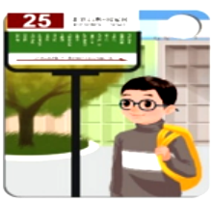( )( )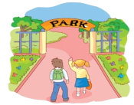( )
三．听录音，填单词，完成对话。（10分）
A: Excuse me. Where is the please?
B: It’s near the .
A: How can I get there?
B: You can take the No. 6 bus, get off at the . Then go for 5 minutes. You’ll see it.
A: Thank you.
B: You are welcome.
四．听录音，选择合适的应答句。（10分）
( ) 1. A．At six B．On foot. C． In the house
( ) 2. A．Sure. B．Thank you. C． That’s great!
( ) 3. A．By bus. B．It’s next to the cinema. C． At 7 o’clock.
( ) 4. A．Yes, it is. B．Yes, I am. C． Yes, there is.
( ) 5. A．He is going to see a film.
B．She’s going to the bookstore. C． She’s going to take a trip.
笔试部分
五、读一读，找出单词中不同类的一个。（5分）
( ) 1．A．post office B．cinema C．bookstore D．left
( ) 2．A．ship B．taxi C．train D．foot
( ) 3．A．evening B．tonight C．next week D．see a film
( ) 4．A．turn B．slow C．office D．stop
( ) 5．A．what B．when C．with D．where
六、单项选择题。（10分）
( ) 1．The post office is ______ the bookstore ______ Jianshe Street.
A．next to; on B．far; to C．near; to
( ) 2．Look! This is a ______ robot.
A．to talk B．talk C．talking
( ) 3．I have ______ comic books.
A．lot B．lot of C．lots of
( ) 4．We must pay attention _______ the traffic lights.
A．to B．with C．at
( ) 5．I am going to look _______ some beautiful flowers.
A．on B．in C．for
( ) 6．How can we get there _______ the post office?
A．from B．about C．for
( ) 7．_______ is the cinema, please?
A．Where B．Who C．When
( ) 8．There _______ some comic books on the desk.
A．is B．are C．am
( ) 9．I’m going _______ 7 o’clock.
A．on B．in C．at
( ) 10．You must ______ the traffic lights.
A．play with B．talk to C．pay attention to
七、判断划线部分发音异同，相同写“T”，不同写“F”。（5分）
1．She’s going to the fruit shop tomorrow. ( )
2．The post office is next to the hospital. You can’t miss it. ( )
3．We will get together on Mid-autumn Day. ( )
4．—How are you going to the park tomorrow? —By bike. ( )
八、用所给单词的适当形式填空。（10分）
1．You must (go) to school on time.
2．Lucy will (read) a poem.
3．Why not (buy) a new book?
4．Peter’s (aunt) hobby is singing.
5．Everybody (have) hobbies.
九、匹配题（10分）
读一读，选出合适的答语。
A．Yes, we are.
B．Because it’s half price.
C． Visit his uncle.
D．Yes, there is.
E. No, it’s very near.
1．Why do you buy books on Mondays? ( )
2．What is he going to do tonight? ( )
3．Are you going to Shanghai by plane? ( )
4．Is it far from here? ( )
5．Is there a bookstore near your home? ( )
十、句型转换（10分）
1．Sarah is reading a book in the library now. (用next Sunday 改写句子)
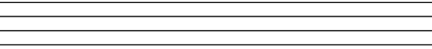
2．The park is near my home. (改为同义句)
The park is  from my home.
3．We are going there by subway. (对划线部分进行提问)
are you there?
4．We are going to make a kite tomorrow. (改变划线部分仿写新句子)
5．How can I get to the museum? (改变划线部分仿写新句子)
十一、阅读理解（10分）
Peter介绍了他了解的其他国家出行的交通工具，根据短文内容，判断下列句子是否正确，正确的写“T”，错误的写“F”。
Here are some interesting and important transportations(交通工具):
Double-decker first appeared(出现) in London in 1956. This kind of bus has two floors. People can see it on the streets of London today. We can also find the double-decker in China. Many people like it.

There are lots of yellow taxis on the streets of New York. They transport(运送) busy people to the place they want to go.
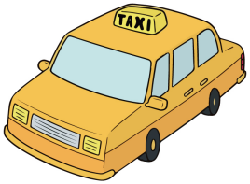
The most special way in the water city, Venice, is a small boat called “gondola” It looks like a banana. People use it every day and visitors from other countries like to travel by boat.

In Thailand, there is a kind of cute car, and its name is Tuk-tuk It is a car with two or three wheels(轮子). It is also popular in other countries of southeast Asia.
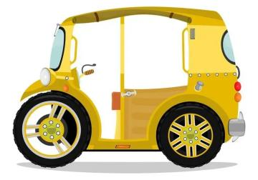
1．Double-decker is a bus with two floors. ( )
2．Double-decker first appeared in London in 1965. ( )
3．The taxis on the streets of New York are yellow. ( )
4．Gondola is a kind of big boat and it looks like a banana. ( )
5．Tuk-tuk in Thailand is a car with four wheels. ( )
十二、书面表达。（10分）
以“How to get to the science museum”为题，向大家介绍一下如何从学校到科学博物馆。不少于五句话。
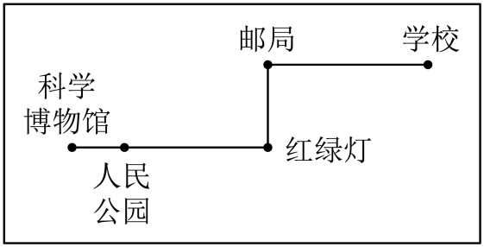
_____________________________________________________________________
_____________________________________________________________________
_____________________________________________________________________
_____________________________________________________________________

参考答案
一． B C A B B
二． B E C D A
三． museum post office cinema straight
四． B B B A C
五、DDDCC
六、ACCAC AABCC
七、TTFF
八、1．go2．read3．buy4．aunt’s5．has
九、BCAED
十、1．
2．，
3．，
4．
5．
十一、TFTFF
十二．范文：
How to get to the science museum
The science museum is not far from our school. First, go straight from our school. Next, turn left at the post office. Go straight about five minutes. Then turn right at the traffic lights. Go down the street, we can find the People’s Park on the left. Go straight, we can see the science museum.

