教科版2025学年小学六年级英语第二学期期中模拟试卷

本试卷共9页，12大题，满分100分。考试用时80分钟。

注意事项：

1. 答题前，考生务必在答题卡上用黑色字迹的钢笔或签字笔填写自己的考生号、姓名。

2. 选择题每小题选出答案后，用2B铅笔把答题卡上对应题目的答案标号涂黑；如需改动，用橡皮擦干净后，再选涂其他答案标号。答案不能答在试卷上。

3. 非选择题答案必须用黑色字迹的钢笔或签字笔写在答题卡各题目指定区域内的相应位置上；如需改动，先划掉原来的答案，然后再写上新的答案，改动后的答案也不能超出指定的区域；不准使用铅笔、涂改液和修正带。不按以上要求作答的答案无效。

4. 考生必须保持答题卡的整洁，考试结束后，将本试卷和答题卡一并交回。

一、听句子三次，判断听到的内容是否与题意相符，如相符，在括号内写“T”，否则写“F”。（共5小题，每小题1分）
1.( ) The tortoise took a nap during the race.
2. ( ) Kangaroos use their strong tails to balance when jumping.
3. ( ) We should say “excuse me” if we push in a line.
4. ( ) Dr Sun Yatsen was a famous writer in Chinese history.
5. ( ) The magic tree opened when the boy said “please”.

二、听句子三次，选出最佳的答语，将其字母编号写在括号内。（共6小题，每小题1分）
1.( ) A. It’s kangaroo.
B. It eats bamboo.
C. It has a long neck.
2.( ) A. In 1924.
B. He was a scientist.
C. He studied physics.
3.( ) A. “Thank you!”
B. “Please wait in line.”
C. “Don’t be careless.”
4.( ) A. Yes, he will.
B. Yes, he did.
C. No, he didn’t.
5.( ) A. By plane.
B. To Paris.
C. For two weeks.
6.( ) A. Because he was patient.
B. Because he was proud.
C. Because he was kind.

三、听句子三次，写出句子中所缺的单词。（共6小题，每小题1分）
1.The ______ is the king of the animals.
2.We should never ______ the oceans.
3.Dr Sun Yatsen tried to ______ the Chinese people.
4.The farmer waited for another ______ in the field.
5.The magic words are “______” and “thank you”.
6.The kangaroo has a strong ______ to jump.

四、听小对话和问题三次，选出答案相应的图片，将其字母编号写在括号内。（共6小题，每小题1分）
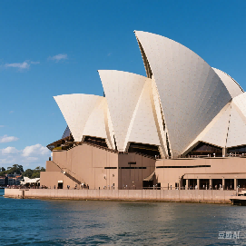 | 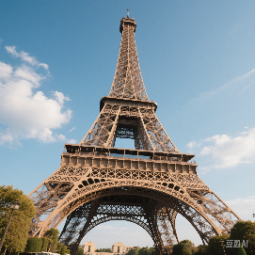 | 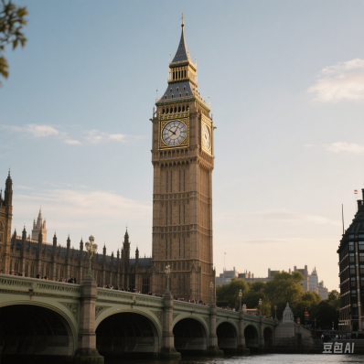
1.( ) | 2.( ) | 3.( )
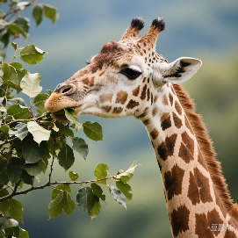 | 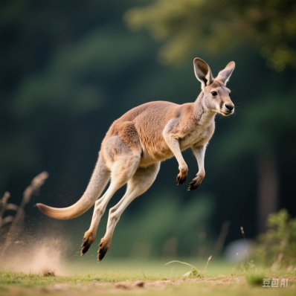 | 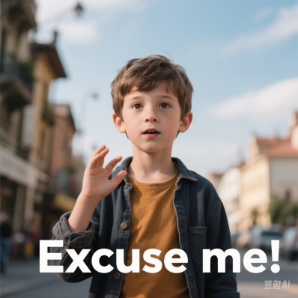
4.( ) | 5.( ) | 6.( )

五、听对话三次，判断句子是否符合对话内容，如符合，在括号内写“T”，否则写“F”。（共5小题，每小题1分）
1.( ) The hare didn’t take a rest during the race.
2.( ) The tortoise won because he was fast.
3.( ) The story teaches us to b·e patient.
4.( ) Janet thinks the hare was humble.
5.( ) Ben and Janet both like the story.

六、找出划线部分发音不同的单词，将其字母编号写在括号内。（共6小题，每小题1分）
1.( ) A. hare B. care C. share D. chair
2.( ) A. sign B. line C. dish D. polite
3.( ) A. crash B. magic C. carry D. animal
4.( ) A. ocean B. save C. face D. place
5.( ) A. choose B. school C. tooth D. book
6.( ) A. bridge B. fridge C. village D. giraffe

七、根据所给的单词，选择适当的描述，将其字母编号写在括号内。（共6小题，每小题1分）
1.( ) tortoise A. A slow animal with a hard shell.
2.( ) inventor B. A person who creates new things.
3.( ) pollute C. To make air, water, or soil dirty.
4.( ) patient D. A person who acts in movies.
5.( ) actor E. Able to wait calmly without complaining.
6.( ) magic F. Something that seems impossible but happens.

八、判断下列句子是否符合事实或错误，如符合，在括号内写“T”，否则写“F”。（共6小题，每小题1分）
1.( ) The hare won the race because he was fast.
2.( ) Kangaroos are from Australia and have strong tails.
3.( ) Dr Sun Yatsen was a famous musician in China.
4.( ) We should say “please” when asking for help.
5.( ) The Sydney Opera House is in Canada.
6.( ) Cutting down forests helps animals live better.

九、语法选择：选择正确的动词形式或句子结构。（共8小题，每小题1分）
1.The boy ______ a book when his mother came in.
A. read B. was reading C. reads
2.If it ______ tomorrow, we will stay at home.
A. rains B. rained C. will rain
3.My father ______ to New York last week.
A. go B. goes C. went
4.Look! The children ______ football in the playground.
A. play B. are playing C. played
5.She ______ her homework before dinner yesterday.
A. finish B. finished C. finishing
6.The teacher told us ______ late for class.
A. don’t be B. not to be C. to not be
7.This is the book ______ I borrowed from the library.
A. who B. which C. what
8.“______ you ever been to London?”
A. Have B. Has C. Had

十、根据首字母提示，填写单词完成句子（每空一词）。（共4小题，每小题2分）
1.The k______ lives in Australia and carries its baby in a pouch.
2.The t______ ran too fast and crashed into a tree.
3.We should p______ trees to save the animals’ homes.
4.“The Boy Who Cried Wolf” teaches us to always tell the t______.

十一、阅读理解
I. 读短文，判断句子正误（T/F）。（共5小题，每小题1分）
The Fox and the Crow
One sunny afternoon, a crow flew over a village and found a juicy piece of meat on a windowsill. She quickly grabbed it with her beak and flew to a tall tree nearby. Just as she settled on a branch, a sly fox passing by noticed the crow’s treasure. The fox, known for his clever tricks, decided to get the meat for himself.
“Oh, beautiful crow!” the fox called out. “Your feathers are so shiny, and your voice must be as lovely as your appearance. Would you sing a song for me?” The crow, flattered by the fox’s words, puffed up her chest proudly. She opened her beak wide to sing, but the moment she did, the meat fell straight down. The fox snatched it up and grinned. “Thank you for the meal,” he said. “Your voice is sweet, but your judgment is not!”
The crow realized her mistake too late. She learned that flattery can hide selfish intentions, and trust should be given wisely.
( ) 1. The crow found the meat in a forest.
( ) 2. The fox wanted the crow to sing because he admired her voice.
( ) 3. The crow dropped the meat when she tried to fly away.
( ) 4. The fox thanked the crow sincerely.
( ) 5. The story warns against trusting flattery.
II. 读短文，选择正确答案。（共5小题，每小题2分）
The Life of Leonardo da Vinci
Leonardo da Vinci, born in 1452 in Italy, was one of the greatest minds in history. He was not only a painter but also an inventor, scientist, and engineer. His famous painting, the Mona Lisa, is admired worldwide for her mysterious smile.
As a child, Leonardo showed a talent for drawing. At 14, he became an apprentice to a famous artist. He spent years studying human anatomy, even dissecting bodies to understand muscles and bones. His notebooks were filled with sketches of flying machines, submarines, and bridges—ideas far ahead of his time.
Despite his genius, Leonardo struggled to finish many projects. He often moved from city to city, working for wealthy patrons. In his later years, he settled in France, where he died in 1519. Today, his works remind us that curiosity and creativity can change the world.
1.Leonardo da Vinci was born in ______.
A. France B. Italy C. Spain
2.What is the Mona Lisa famous for?
A. Her colorful dress.
B. Her mysterious smile.
C. Her detailed background.
3.Leonardo studied human anatomy by ______.
A. reading books B. dissecting bodies C. painting portraits
4.Why did Leonardo move frequently?
A. He disliked his patrons.
B. He sought new challenges.
C. He wanted to escape wars.
5.The main purpose of the passage is to ______.
A. list Leonardo’s inventions
B. describe his artistic techniques
C. introduce his life and achievements
III. 读故事，按顺序排列图片（A-D）。（共4小题，每小题1分）
A. The hare takes a nap under a tree.
B. The tortoise steadily moves toward the finish line.
C. The hare challenges the tortoise to a race.
D. The tortoise wins while the hare sleeps.
正确顺序：______ → ______ → ______ → ______

十二、写作
根据提示，写一篇关于“保护动物”的短文（不少于50词）。
提示：
1.Why are animals in danger?
2.What can we do to help them?
3.Your hope for the future.

听力材料与答案
一、听句子三次，判断听到的内容是否与题意相符，如相符，在括号内写“T”，否则写“F”。
1.The tortoise won the race because he was patient.
2.Kangaroos have strong tails to help them jump.
3.We should say “thank you” when others help us.
4.Dr Sun Yatsen was a great leader in China.
5.The magic tree opened when the boy said “please”.
答案： 1. F 2. T 3. F 4. F 5. T
二、听句子三次，选出最佳的答语，将其字母编号写在括号内。
1.What animal is from Australia and carries its baby in a pouch?
2.When was Deng Jiaxian born?
3.What should you say if someone pushes in the line?
4.Did the farmer wait for another hare?
5.How will you travel to London?
6.Why did the tortoise win the race?
答案： 1. A 2. A 3. B 4. B 5. A 6. A
三、听句子三次，写出句子中所缺的单词。
1.The lion is the king of the animals.
2.We should never pollute the oceans.
3.Dr Sun Yatsen tried to free the Chinese people.
4.The farmer waited for another hare in the field.
5.The magic words are “please” and “thank you”.
6.The kangaroo has a strong tail to jump.
答案： 1. lion 2. pollute 3. free 4. hare 5. please 6. tail
四、听小对话和问题三次，选出答案相应的图片，将其字母编号写在括号内。
1.对话：
M: Where is the Sydney Opera House?
W: It’s in Australia, near the harbour.
question：Which picture shows the Sydney Opera House?
2.对话：
W: Look at that animal! It has a very long neck.
M: Yes, it’s eating leaves from the tree.
question：What animal are they talking about?
3.对话：
M: What should I say if I need to pass someone in a line?
W: You should say “Excuse me” politely.
question：Which picture shows the right action?
4.对话：
W: Which tower is famous in Paris?
M: The Eiffel Tower. It’s very tall!
question：Which picture matches the Eiffel Tower?
5.对话：
M: What animal jumps with strong back legs?
W: The kangaroo! It carries its baby in a pouch.
question：Which animal is described?
6.对话：
W: Big Ben is a famous clock tower. Where is it?
M: It’s in London, the capital of Britain.
question：Which picture is Big Ben?

答案
1.A 2. D 3. F 4. B 5. E 6. C
五、听对话三次，判断句子是否符合对话内容，如符合，在括号内写“T”，否则写“F”。
Ben: Did you read the story “The Hare and the Tortoise”?
Janet: Yes! The hare was too proud and took a rest.
Ben: But the tortoise kept moving slowly, right?
Janet: Exactly. In the end, the tortoise won the race.
Ben: So the story tells us to be patient and never give up.
答案： 1. F 2. F 3. T 4. F 5. T

笔试部分答案
六、 1. A 2. C 3. D 4. B 5. D 6. D
七、 1. A 2. B 3. C 4. E 5. D 6. F
八、 1. F 2. T 3. F 4. T 5. F 6. F
九、 1. B 2. A 3. C 4. B 5. B 6. B 7. B 8. A
十、 1. kangaroo 2. hare 3. plant 4. truth
十一、
I. 1. F 2. F 3. F 4. F 5. T
II. 1. B 2. B 3. B 4. B 5. C
III. C → A → B → D
十二、 （参考范文）
Many animals are in danger because people cut down forests and pollute the environment. We can help them by planting trees and not buying things made from animals. I hope everyone will work together to protect animals, so they can live happily on Earth.

