人教版2025学年五年级英语第二学期期中模拟测试卷
听力部分（40分）
一、听录音，选出你所听到句子中所包含的单词。(5分)
( ) 1. A. plate B. play C.player
( ) 2. A. trip B. sheep C. cheap
( ) 3. A. three B.there C. tree
( ) 4. A. shirt B.shorts C.short
( ) 5. A. 3:40 B. 3:13 C. 3:30

二、听句子，判断图片与录音是否相符，用√或×表示。（5分）
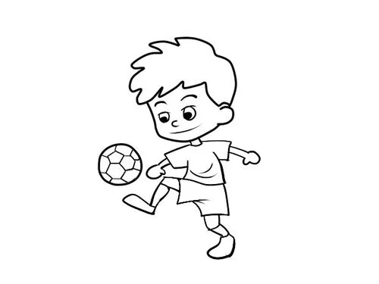
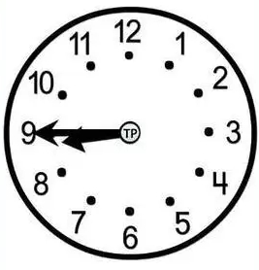
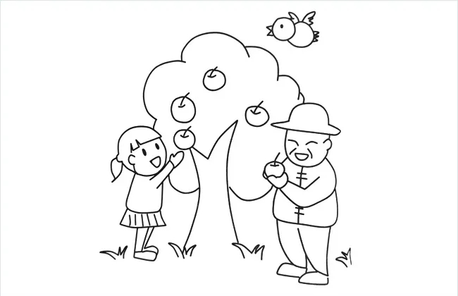
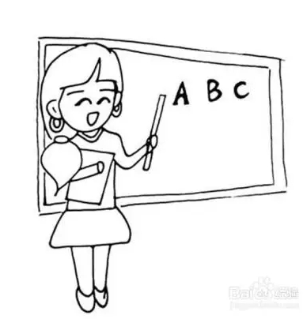

( ) ( ) ( ) ( ) ( )
三、仔细听，从方框中选出每小题你所听到句子的最佳答语。（10分）
A. It’s sunny and warm. B.No,it isn’t.
C. I often play sports. D. No,I don’t. E. It’s in May.
1.( ) 2. ( ) 3. ( ) 4. ( ) 5. ( )
四、听录音，补全句子。（10分）
1. When do you do _____________ ______________?
2. I have two _____________ ______________on Mondays.
3. It often rains in__________.You can take an _______________.
4. _____________ Day is in _______________.
5.Americans often eat_____________ in ________________ .
五、听短文，判断句子正（T）误（F）。（10分）
( )1. Jack's favourite month is April.
( )2. There is a sports meet in May.
( )3. Jack is good at playing basketball.
( )4. Mike likes January best.
( )5. Mike likes swimming in winter vacation.
笔试部分（60分）
- 选出每组单词中划线部分发音不相同的一项。（5分）
( ) 1. A. lunch B. school C. March
( ) 2. A. island B. isn’t C. win
( ) 3. A. green B. great C. brown
( ) 4. A. clever B. please C. plate
( ) 5. A. season B. clean C. great
二、按要求写词语（10分）
1. story(复数) ________ 2. teachers(名词所有格) __________
3. Dec.(完全形式)____________ 4. leaves(单数) ___________
5. China(形容词) ___________6.I’ll (完全形式) ___________
7. late(反义词)________ 8.shop(现在分词) ___________
9. she(宾格) __________ 10.cool(对应词) _____________
三、选择题。（10分）
( ) 1. When do you go back school?
A. for B.to C. on
( ) 2. I often read books 8:00 night.
A. at ; at B. at ; in C. in ; at
( ) 3. Fall comes after .
A. autumn B. summer C. winter
( ) 4.I eat lunch at home.
A. like B. am C. usually
( ) 5. is the second mouth of a year.
A. February B. January C. March
( ) 6. We’ll the pipa my mother.
A. play; to B. plays ; for C. play; for
( ) 7.There are days in February in 2016.
A.28 B. 29 C. 30
( ) 8. The days are in summer.
A. long B. short C. big
( ) 9.Children’s Day is June.
A. on B. at C. in
( ) 10.—Do you like summer?--
A. Yes, I am. B. Yes, we do. C. No, we aren’t.
四、选出各句中有错误的一项，并在后面横线上改正。（10分）
( ) 1.The days is hot in summer. __________
A B C D
( ) 2. I can go swimming everyday. __________
A B C D
( ) 3. We finish class on the morning. __________
A B C D
( ) 4. Mother’s Day is in June. __________
A B C D
( ) 5. I’ll cook to my mother. __________
A B C D
五、按要求完成句子。(10分)
1. My friends go swimming in summer. (就划线部分提问)
_____________________________________________
2. The school trip is in March this year. (就划线部分提问)
_____________________________________________
3. I like winter best. (写出同义句)
_____________________________________________
4. The leaves fall in fall.(翻译成中文)
_____________________________________________
5. My mother’s birthday is in April.(改为一般疑问句并作否定回答)

六、阅读短文，判断对错，用√或×表示。（10 分）
Dear Sarah,
It is autumn in April here in Sydney. I like autumn best. It is warm in the day and cool at night. Many people visit us in autumn because they like the weather. What is the weather like in April in your city? I play sports every day. On weekends, I often help my mother go shopping, and sometimes help my father wash his car. I take an art class on Saturday afternoon. What do you often do? Please tell me.
All the best,
Mike
( ) 1. It is cool in the day and warm at night in April in Sydney.
( ) 2. Many people visit Sydney because of the good weather.
( ) 3. It’s autumn in April in Beijing, too.
( ) 4. Mike often helps his father wash the car on weekends.
( ) 5. Mike takes an art class on Saturday afternoon .
七、作文。（5分）
请你以My favourite month为题，写一篇小作文，来介绍自己最喜欢的月份，并写出喜欢的理由。不少于5句话。

_______________________________________________________
_______________________________________________________
_______________________________________________________

听力材料
一、听录音，选出你所听到句子中所包含的单词。每小题听一遍。
1.There are many eggs on the plate.
2 This shirt is very cheap.
3.There are four seasons in a year.
4 .My brother is short and thin.
5.I often play sports at 3:40 p.m.
二、听录音，判断图片与录音是否相符，用√或×表示。
1. I often take a dancing class on Fridays.
2. I can pick apples in autumn.
3. I have PE class at 9:45.
4. I like playing football on the weekend.
5.We will go to the Great Wall in July.
三、仔细听，从方框中选出每小题你所听到句子的最佳答语。
1. When is May Day?
2. Is Teachers’ Day in May?
3. What’s the weather like in spring?
4. What do you do on the weekend?
5. Do you often play sports on the weekend?
四、听录音，补全句子。
1. When do you do morning exercises?
2. I have two dancing classes on Mondays.
3. It often rains in spring.You can take an umbrella.
4. Children’s Day is in June.
5.Americans often eat chicken in November .
五、听短文，判断句子正（T）误（F）。
（现在请同学们先快速浏览题目，10秒钟后，将会播放短文听力内容。）
Hello, my name is Jack. My favourite month is April. We have a sports meet and an art show in April. I'm good at playing football. Mike is my best friend. His favourite month is January. He likes New Year's Day. And he likes skating in winter vacation.

参考答案

听力部分：
- ACBCA
- ×√×√×
三、EBACD
四、1. morning exercises
2.dancing classes
3.spring umbrella.
4. Children’s June.
5. chicken November .
五、TFFTF

笔试部分：
- BACAC
二、1. stories 2. teachers’
3. December 4. leaf
5. Chinese 6. I will
7. early 8. shopping
9. her 10. warm
三、BABCA CBACB
四、1. B are
- D every day
- C in
- D May
- B for
五、1. What do your friends do in summer?
2. When is the school trip this year?
3. My favourite season is winter.
4. 树叶在秋天落下。
5. Is your mother’s birthday in April? No, it isn’t.
六、×√××√
七、略

