外研版2022—2023学年度第一学期
五年级英语期中检测题
时间：40分钟 满分：100分 得分
第一部分 听力（共四大题，满分40分）
Ⅰ．听录音，从A、B、C中选出你所听到的单词。每个单词读两遍。（每小题2分，共0分）
（ ）1. A. along B. above C. arrive
（ ）2. A. matter B. met C. mountain
（ ）3. A. first B. fourteen C. fifteen
（ ）4. A. lost B. list C. lose
（ ）5. A. wear B. with C. wait

Ⅱ．看图听句子，选出与句子意思一致的图画。每个句子读两遍。（每小题2分，共10分）
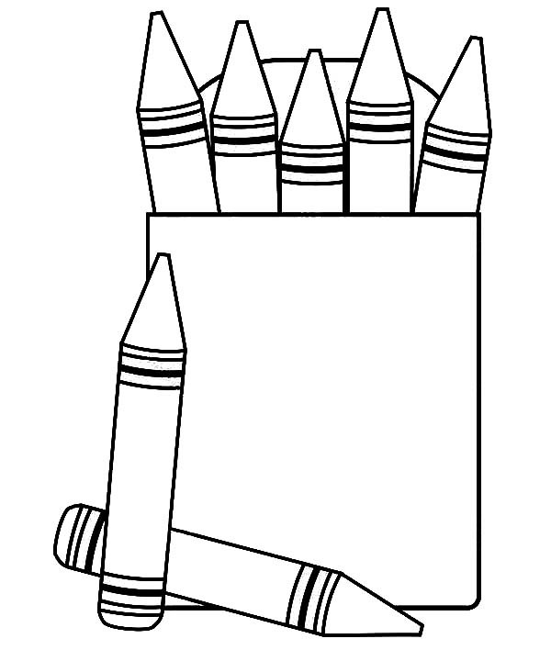
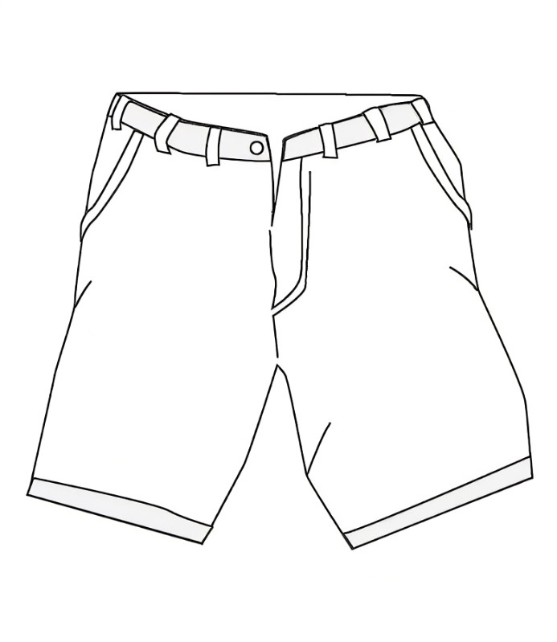

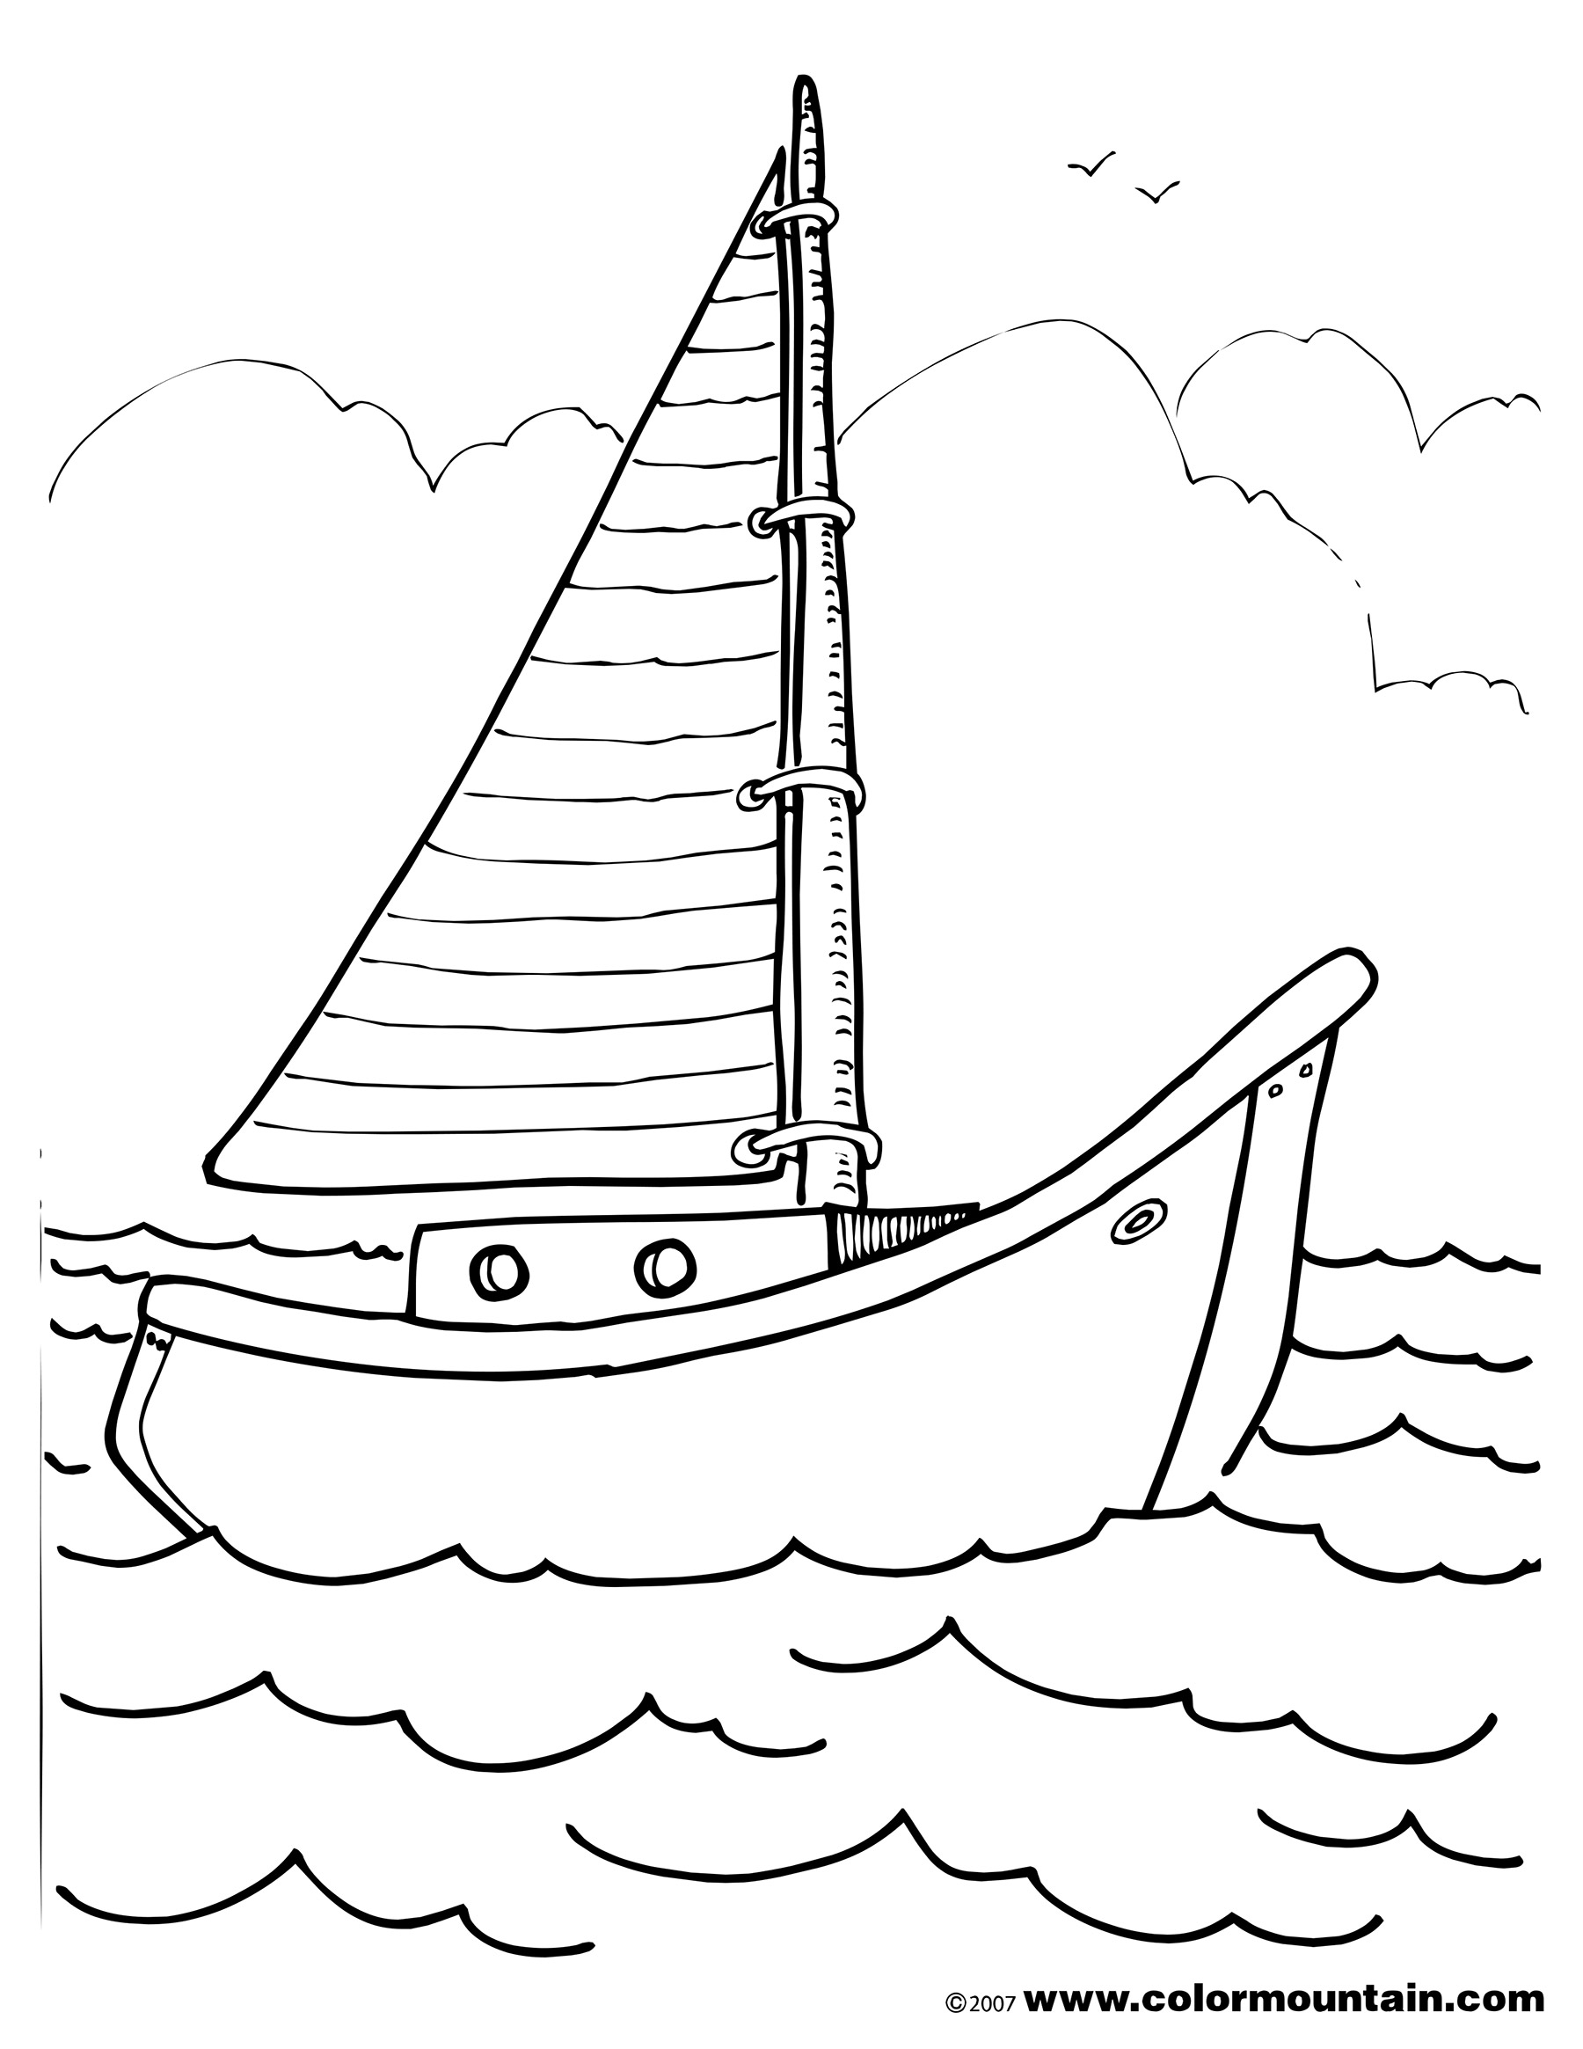

A B C D E
6. _________ 7. _________ 8. _________ 9. _________ 10. _________
Ⅲ．听录音，根据你所听到的句子，选择恰当的答语。每个句子读两遍。（每小题2分，共10分）
( ) 11. A. No, she isn’t. B. No, she doesn’t. C. Yes, she did.
( ) 12. A. Half a kilo. B. I ate it all. C. Nineteen.
( ) 13. A. By plane. B. I went there with Dan. C. I went to London.
( ) 14. A. Thank you. B. I don’t know. C. That’s OK.
( ) 15. A. He had a nice trip. B.He lost his T-shirt. C. I bought a new plant.
Ⅳ．听下面小短文，判断句子是否与短文一致，相符的填“√”，不相符的填“×”。
短文读两遍。(每小题2分，共10分)
（ ）16. Lucy went to the park with her mother.
（ ）17. Tom went to the park by bike.
（ ）18. Lucy and Tom drank juice there.
（ ）19. Tom took photos at the park.
（ ）20. Lucy and Tom went home at eleven.

- 笔试（共七大题，满分60分）
V.选出每组单词中不属于同一类别的词。（每小题2分，共10分）
（ ）21. A. email B. above C. postcard
（ ）22. A. need B.took C. found
（ ）23. A. hour B. minute C. mountain
（ ）24. A. number B. how C. when
（ ）25. A. send B. best C. use
VI．单项选择。请将正确答案的标号写在题前的括号中。（每小题1分，共10分）
( ) 26. Look at those _________. Let’s eat some.
A. eggs B. chocolate C. pear
( ) 27. Jane went to the supermarket and ________ sweets.
A. buys B. bought C. will buy
( ) 28. —______ rice did you buy? —Half a kilo.
A. How many B. How much C. Many
( ) 29. Tony didn’t buy ___________ meat last night.
A. a B. some C.any
( ) 30. Lily was back ________ Harbin last week.
A. for B.from C. of
( ) 31. There is only one bottle of juice here, ____ there are twenty pupils.
A. but B. and C. so
( ) 32. —___________? —She lost her bag.
A. Who took her bag B. What’s in her bag C. What’s the matter with her
( ) 33. Mum washed clothes for the little boy _______.
- now B. tomorrow C. last Sunday
( ) 34. —How did you get to the Great Wall?
—_________.
A. I like the Great Wall B. By bus C. Amy got there
( ) 35. —Have a good day. —_______.
- Thank you B. All right C. Sorry
VII.选择方框内的单词或词组完成下列句子，每个限用一次。(每小题1分，共5分)
A. kilo | B. hurry up | C. place | D. fifty | E. arrived
- John, ___________. The bus is coming.
- We ___________ there at nine o’clock at night.
38. There are ___________crayons in the bag.
39. They visited a famous ___________ in London.
40. —How many pears did you need? —A ___________.
VIII.从右栏中找出适合左栏的答语，并将其标号填入题前的括号内。(每小题1分，共5分)
( ) 41. Did Jack live in Tianjin? A. I lost my list.
( ) 42. How many bananas did you buy? B. All right.
( ) 43. Where did you go yesterday? C. To the museum.
( ) 44. Please give out the crayons. D. Two.
( ) 45. What’s the matter? E. No, he didn’t.
A. Let’s make a shopping list.
B. Great!
C. How many apples do we need?
D. Three kilos.
E. We can buy some.
IX.情景交际。根据对话内容，选择方框内句子完成下列对话。每个句子只能使用一次。(每小题2分，共10分）
A: We need food for our picnic.
B: ______46______
A: All right!
B: ______47______
A: Fifteen.
B: How much chocolate do we need?
A: ______48______
B: And we can need some juice, too.
A: I like apple juice and orange juice.
B: OK. ______49______
A: Let’s go to the supermarket now.
B: ______50______
46.________ 47.________ 48.________ 49.________ 50.________
X.阅读理解。阅读下面材料，根据其内容选择正确答案，并将答案的标号写在题前的括号内。(每小题2分，共10分）
Hello, I’m Sally. It is Wednesday today. I went to Beijing by plane with my family last night. We arrived in Beijing at ten o’clock in the morning. We visited the Great Wall. We all liked it. And we ate lots of food. I liked Tang Hu Lu and Dou Zi best. My parents liked the Beijing Roast Duck best. Tomorrow we are going to Qingdao. We’re going there by train. We’re going to swim in the sea. The seafood is delicious. The fruit is fresh. And we will buy some seafood and fruit for our friends. Then we will go back home on Sunday.
( ) 51. Sally’s family went to Beijing by _________.
A. car B. plane C. train
( ) 52. —What’s Sally’s mother’s favourite food ? —____________.
- Seafood B. Tang Hu Lu C. Beijing Roast Duck
( ) 53. They will go to Qingdao on ________
- Wednesday B. Tuesday C. Thursday
( ) 54. —What are they going to buy for their friends? —________.
A. fruit B. Dou Zi C. duck
( ) 55. John will be in Qingdao for ______ days.
A. one B. three C. seven
XI. 写作。昨天为周一，Ken度过了忙碌的一天，请你根据下表格中的信息提示，写一写Ken昨天的活动。（共10分）
In the morning | have classes
In the afternoon | do some sports  clean the classroom
In the evening | eat some delicious food  watch TV

It was Monday yesterday. Ken had a very busy day. In the morning

听力材料

Ⅰ.听录音，从A、B、C中选出你所听到的单词。每个单词读两遍。
1. along 2. met 3. fifteen 4. list 5. wear
Ⅱ.看图听句子，选出与句子意思一致的图画。每个句子读两遍。
6. —Did you take a boat trip yesterday? —Yes, I did.
- —What did you buy at the supermarket?
—I bought an ice cream.
8. Mum bought a pair of shorts for John.
9. There are crayons.
10. Dad went to a museum.
III.听录音，根据你所听到的句子，选择恰当的答语。每个句子读两遍。
11. Did Amy come back from Shanghai yesterday?
- How much cheese do you want?
- How did you go to London?
14. Oh, I’m sorry.
15. What’s the matter with Sam?
Ⅳ．听下面小短文，判断句子是否与短文一致，相符的填“√”，不相符的填“×”。
短文读两遍。
Last week, Lucy went to the park with Tom. They went there by bike. They arrived there at 8 o’clock in the morning. They bought ice creams and ate them. Lucy drank a bottle of water and Tom drank some juice. Lucy took some photos there. Tom played football. Then they went home at ten o’clock.

参考答案
Ⅰ、1-5 ABCBA
Ⅱ、6-10 DCEBA
Ⅲ、11-15 CAACB
Ⅳ、16-20 ×√××√
V、21-25 BACAB 26-30 ABBCB
VI、31-35 ACCBA
VII、36-40 BEDCA
VIII、41-45 EDCBA
IX、46-50 ACDEB
X、51-55 BCCAB
XI、 Ken had classes. In the afternoon, he did some sports and cleaned the classroom. In the evening, he ate some delicious food and watched TV.

