
深圳市2022-2023学年五年级英语下册期末模拟测试
本试卷分为听力与笔试两部分。考试时间 60 分钟。
答卷前， 请务必将自己的姓名、考生号、考点校、考场号、座位号填写在指定的位置上。答题时， 务必仔细审题，认真作答，保持卷面整洁。
祝考试顺利！
第一部分 听力部分
一、听录音，选出与所听内容相符的图片。
( )1. A. 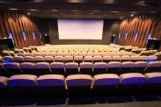 B.  C. 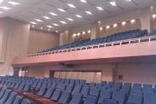
( )2. A. 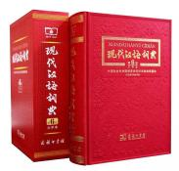 B. 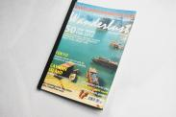 C.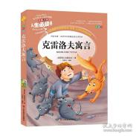
( )3. A.  B.  C. 
( )4. A. 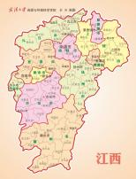 B. 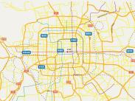 C. 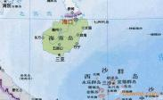
( )5. A.  B.  C. 
- 听录音，选择正确的答语。
( )1. A. Yes，they’re hers B. They’re hers. C.They’re English books.
( )2. A. Because the study is quiet. B. Because I like reading. C.Because it’s fun.
( )3. A. I’m going to stay at home. B. I don’t like holidays. C. I go to Beijing every year.
( )4. A.I have a toothache. B.He has a fever. C.Peter is right.
( )5. A.I like pears. B.I like the small one. C.I’d like some pears.
- 听录音，判断图片与所听内容是（T）否（F）相符。

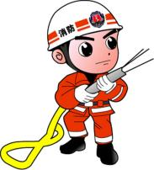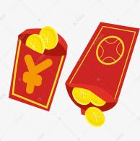
1. ( ) 2.( ) 3.( ) 4.( ) 5.( )
四、听录音，将信息填充完整。
Have a1.
Should  Take a2.  Have a3.  - 5.  Drink a lot of water | Shouldn’t  Go to bed late  Eat too much meal

第二部分 笔试部分
五、根据图意，填上适当的单词完成句子。
1.Linda is going to see a ________. 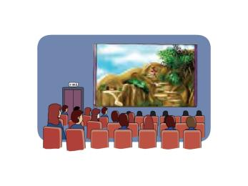
2. Amy has a ________. He feels bad. 
3. Watch is a great ________. It can tell us time. 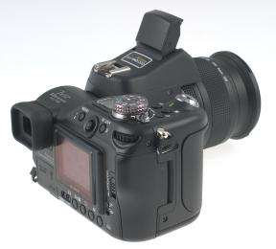
4. There is a beautiful ________ in the sea. 
5. My grandfather reads a ________ every morning. 

- 根据英文解释或者提示，选出对应的单词或者短语，将字母表号填入括号内（10 分）
A.tidy up | B.dining room | C.dictionary | D.Spring Festival | E.weak in

( )1. a room in the house for eating meals
( )2.a book with words and phrases are listed
( )3. not good at
( )4. to keep things clean
( )5. a very important and traditional Chinese Festival
七、从方框中选择正确的答语，并将答案编号在答题卡上相对应的位置用铅
笔涂黑。（10 分）
( ) 1. Will you help me?
( ) 2. Where are you going?
( )3.Where are the books about animals?
( ) 4.What did she have for breakfast?
( ) 5.What time does your father go to work?
- She had sandwiches for breakfast. B. He goes to work at six o’clock.
C. They are on the shelf B. D. I’m going to Sanya.
E. Of course, I will.

八、读一读，选择合适的句子完成对话。
A. Blue is my favourite colour. B. Where is the T-shirt shop?
C. Oh, it’s my size. D. Mum, it’s too big.
E. Mine is very old.
Peter is going to Sanya with his family tomorrow. They’re in a shopping centre now. Peter needs a new T-shirt.
Peter: Oh, it is so big here. (1) ________
Mum: It’s on the third floor. Let’s go upstairs (上楼).
Peter: Oh, there are so many T-shirts!
Mum: So, which one do you like, the blue one or the green one?
Peter: I like the blue one, Mum. (2) ________
Mum: Try on this blue T-shirt, please.
Peter: OK, Mum.
Peter: (3) ________
Mum: So try on this one, please. It’s your size.
Peter: Let me try it on. (4) ________
Mum: I should buy a T-shirt too. (5) ________
Peter: How about this red one, Mum?
Mum: Oh, it’s very beautiful. Let me try it on.
Peter: Mum, you look very young!
Mum: Ha, thank you, Peter.

九、阅读
My parents and I are going to visit Chengdu next week. And we’re going to visit my uncle in Chengdu. My uncle’s name is Tom. He works in Chengdu now. Chengdu is in the southwest of China. We are going to stay there for two weeks. Dad is going to call him tomorrow. He is going to tell Uncle Tom about our trip. Mum is going to buy some presents for Uncle Tom. I'm going to the library this Saturday. I want to borrow some books about Chengdu. And I’m going to ask him some questions.
( ) 1. We're going to visit Uncle Tom ______
A. next month B. next week C. last week
( ) 2. We're going to stay there for ______days.
A. 2 B. 3 C. 14
( ) 3. ______is going to go shopping this Sunday.
A. Mum B. Dad C. Bob
( )4. I'm going to the _____this Saturday.
A. cinema B. library C.museum
( ) 5. I want to borrow some books about______
A. Beijing B. big cities C. Chengdu
十、写作
最近淄博烧烤爆火起来，你将和谁一起去呢？请做一份旅游计划与我们分享。
参考词汇：
Where to go: Zibo
When: summer holiday
Go there by: train/plane
How long: three days
Stay in: a hotel
What to do：enjoy barbecue（烧烤），eat seafood...

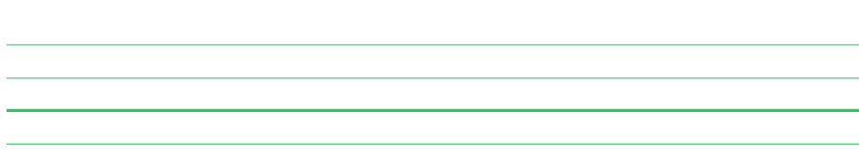


深圳市2022-2023学年五年级英语下册期末模拟测试答案
听力答案
一、
1-5 BACAB
二、
1-5 BCAAB
三、
1-5 TFFTF
四、
(1)cold (2) medicine (3) good rest (4) keep l (5) exercising
笔试部分
五、
1. film 2. toothache 3. invention 4. island 5. newspaper

六、
1-5 BCEAD
七、
1-5 EDCAB
八、
(1)-(5) BADCE
九、
1-5 BCABC
十、略。
注意一般将来时态。


深圳市2022-2023学年五年级英语下册期末模拟测试听力材料
本试卷分为听力与笔试两部分。满分 70 分。考试时间 60 分钟。
答卷前， 请务必将自己的姓名、考生号、考点校、考场号、座位号填写在指定的位置上。答题时， 务必仔细审题，认真作答，保持卷面整洁。
祝考生考试顺利！
- 听录音，选出与所听内容相符的图片。
1. Do you want to row a boat in the lake?
2. I need some money to buy a dictionary, Mum.
3. We’ll go to the village to see our relatives this weekend.
4.Xinjiang is in the west of China.
5.The Mid-Autumn Festival is in September or October.
- 听录音，选择正确的答语。
- Whose books are those?
- Why do you like reading?
- What’s your plan for the holiday?
- What’s wrong with you,Peter?
- Which pear do you like the big one or the small one?
- 听录音，判断图片与所听内容是（T）否（F）相符。
- I like helping people. I’ll be a fireman in the future.
- The Open day is coming.Miss Fang will meet our parents in the hall.
- Those shoes are too big.They are not my size.
- I think the watch is a great invention.
- At the Spring Festival ,people watch fireworks at night.
- 听录音，将信息填充完整。
Peter have a cold.He goes to a hospital to see the doctor.
Doctor:What’s wrong with you?
Peter:I have a cold.
Doctor:Let me have a look. You have a cold . You should take a medicine.You should also keep exercising. You shouldn’t go to bed late.You shouldn’t eat too much meal.Have a good rest and you’ll get well soon.
Peter:Thank you,doctor.
Doctor:You’re welcome.

