译林版2025学年小学五年级英语下学期期中提高测试卷
一、听录音，选出你所听到的内容。
( ) 1. A．they B．them C． time
( ) 2. A．near B．need C． here
( ) 3. A．sing B．swimming C． see
( ) 4. A．metro B．moon C． mouse
( ) 5. A．take off B．take on C． take out
( ) 6. A．try B．tree C． train
( ) 7. A．before B．because C． beside
( ) 8. A．bathrooms B．mushrooms C． bedrooms
( ) 9. A．get on B．get to C． put on
( ) 10. A．turn right B．traffic light C． on your right
二、听录音，判断图片与所听内容是否相符，相符的写“T”，不相符的写“F”，听两遍。
1. 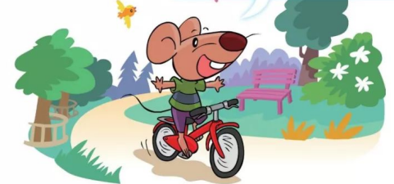 ( )
2. 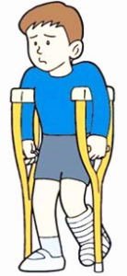 ( )
3. 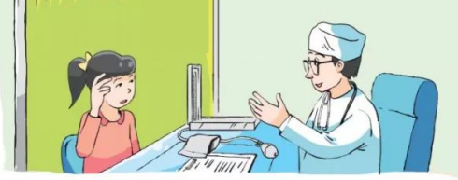 ( )
4. 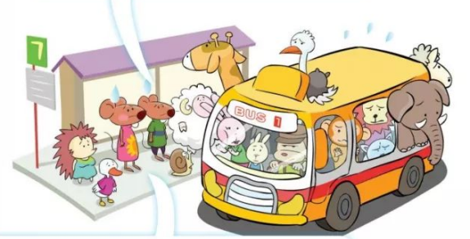 ( )
5. 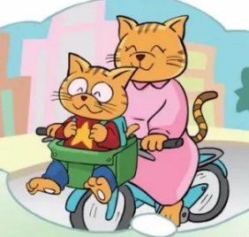( )
三、听问句，选择合适的答句，听两遍。
( ) 1. A．No, she doesn’t. B．No, she can’t. C． No, she isn’t.
( ) 2. A．I feel cold. B．I am eleven. C． I have a cold.
( ) 3. A．Yes, I live far from my school. B．No, I live near my school. C． No, I don’t.
( ) 4. A．He’s in the hospital. B．He has a fever. C． He feels good.
( ) 5. A．Because I’m fine today. B．Because I feel happy. C． Because I am ill today.
四、听对话及问句，选择正确的答句，听两遍。
( ) 1. A．No, it isn’t. B．Yes, it is. C． We don’t know.
( ) 2. A．His foot hurts. B．He has a fever. C． His head hurts.
( ) 3. A．No, she doesn’t. B．Yes, she does. C． No, she likes dancing.
( ) 4. A．Behind the museum. B．In front of the museum C． On Red Apple Street.
( ) 5. A．No. He takes the metro. B．Yes, he does. C． Yes, he takes the metro.
五、听录音，根据所听内容完成短文，听两遍。
Hello, this is my friend Andy. He on Park Street, our school. So he comes to school on . He likes sweets. So sometimes he has a . When his teeth hurt, he cannot eat rice or fruit. He can only drink some . He eat too many sweets. He his teeth in the morning and before bedtime.
六、选出每组单词中画线部分的音标不同的一项。
1．A．draw B．drive C．through D．drink
2．A．Monday B．honey C．some D．parrot
3．A．shop B．shout C．sweet D．wish
4．A．chair B．headache C．teach D．lunch
5．A．there B．both C．third D．thing
七、填空题
1．The skirt f her very well.
2．It’s so hot. Mary has to t o her jacket.
3．—Do you go to Beijing by p ?
—No, I often go there by t .
4．Walk a this street and you can see the zoo.
5．My grandma has a t . Her teeth hurt.
6． (be) there (some) juice in the glass?
7．Helen, (come) and (help) me.
8．My uncle always travels to many (city) by car.
9．May is our new friend. She wants (chat) with us.
10．Who (want) to show Nancy the way to the library every day?
八、选择题
1．Cinderella is _____________ because she _____________ go home before 12 o’clock. ( )
A．happy; has to B．sad; cannot C．sad; has to
2．—__________ beautiful Cinderella is! But she cannot go to the party. ( )
—__________ a pity!
A．What; What B．What; How C．How; What
3．She wants ________, and she wants ________ the bike to school. ( )
A．bike; to ride B．a bike; ride C．a bike; to ride
4．Excuse me, can you tell me how _________ there? ( )
A．get to B．to get to C．to get
5．My cousin lives far from school. He ________ to school every day. ( )
A．ride a bike B．rides a bike C．by bike
6．Bus No. 8 is coming. Let’s _______ the bus. ( )
A．get on B．get in C．get off
7．—How can I __________ Mike’s home? ( )
—You can __________ there by bus.
A．get; get B．get to; get C．get to; get to
8．—What’s wrong with ______? ( )
—He ______ a fever.
A．he; have B．his; has C．him; has
9．—Why _________ Liu Tao so sad? ( )
—_________ he doesn’t feel well.
A．does; Because B．is; Because C．can; So
10．—My ears and nose hurt. ( )
—________
A．Thank you. B．Let me help you. C．That’s a good idea.
九、匹配题
匹配句子。
A．Sure.
B．Thank you.
C． Yes, I do.
D．I’m sorry to hear that.
E. I’ve got a headache.
F. I can’t eat well now.
G. By bike.
H. Yes, I am.
I. She should drink some water.
J. Because I still feel ill.

1．What’s wrong with you? ( )
2．Mary is ill. ( )
3．Why are you not at school today? ( )
4．What should she do? ( )
5．How do you feel now? ( )
6．Do you drink a lot of water? ( )
7．Are you taking any medicine? ( )
8．I can take some fruit for you. ( )
9．How does Jim come to school today? ( )
10．Can you help me? ( )
十、句型转换
1．Jill has a good time at her birthday party. (改为一般疑问句)
Jill a good time at her birthday party?
2．I often ride a bike to the park. (改为同义句)
I often to the park .
3．John comes to school by car. (对画线部分提问)
John to school?
4．There is a park next to the supermarket. (对画线部分提问)
the park?
5．The students should listen to the teacher carefully in class. (对画线部分提问)
the students in class?
十一、补全短文
根据上下文和首字母提示，完成短文。
“Would you like to have lunch w 1 me at weekends?” asks Susan. “Yes. But I don’t know your house. ” says Molly. “It is easy to get to my house.” You can t 2 The No. 3 bus. Then, get o 3 at Hexin S 4 . Walk for five minutes. You will see a big tree on your r 5 . After the tree. You can see a hospital. Go past it and you can see a yellow-and-white house near some bushes (灌木丛). That is my house.
十二、阅读理解
（1）阅读图文并选择正确答案。
Li Hua is ten years old. She is 150 cm tall. She lives in Sunshine Town. She wants to take the metro to City Library with her parents today.
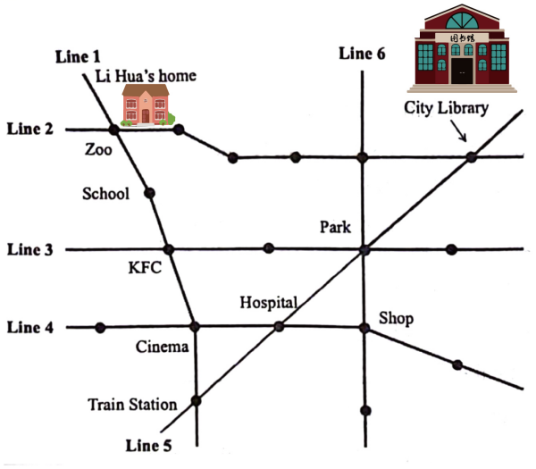
Ticket price(票价):
Adults(成人): 2 yuan (≤4 km); 3 yuan (4.1-9 km)
Children: Free-below 130 cm (身高1.3米以下免费)
Half-above 130 cm (身高1.3米以上半价)
Tips: ①Don’t shout.
②Don’t eat or drink.
1．How many lines(线路) are there in the picture? ( )
A．Five. B．Six. C．Seven. D．Eight.
2．Li Hua and her parents are at home. They want to go to City Library. Which line should they take? ( )
A．Line 1. B．Line 2. C．Line 3. D．Line 4.
3．It’s 3.8 km from Li Hua’s home to City Library. How much should they pay for(支付) the tickets? ( )
A．3 yuan. B．5 yuan. C．7.5 yuan. D．9 yuan.
4．What can people do on the metro? ( )
A．They can read books. B．They can shout. C．They can eat hamburgers. D．They can drink juice.
5．From City Library to Cinema, which is the best(最佳) way? ( )
A．City Library—Zoo—School—Cinema B．City Library—Park—Shop—Cinema
C．City LibraryPark—KFC—Cinema D．City Library—Park—Hospital—Cinema
（2）阅读短文，判断短文后句子是(T)否(F)与短文内容相符。
Americans with a small family have a small car or a large one. If both parents are working, they usually have two cars. When the family is large, they will have a van.
A van can hold(容纳) seven people. So a family with three children can ask their grandparents to go on a holiday together.
You can think a van is motor home(房车). It is good for holidays. When a family goes to the mountains or the beach, they can live in their motor home for some days. In America, there are many parks(停车处) for motor homes. That’s why motor homes are very popular.
6．In America, all the people take a van to work. ( )
7．Ben’s family has a van and two children. They can ask their grandparents to go on a holiday together. ( )
8．A van is smaller than a car. ( )
9．American people can live in the van when they go for a holiday. ( )
10．Vans are not very popular because people can’t park the vans. ( )
（3）阅读对话，回答下列问题。
Mrs Black: Get up, David. It’s time to have breakfast.
David: I can’t go to school today, Mum.
Mrs Black: What’s wrong with you?
David: I have a bad headache and a cough?
Mrs Black: Oh, dear. You have a cold. I’ll call Miss Li after breakfast.
After breakfast...
Mrs Black: Hello. May I speak to Miss Li?
Miss Li: This is Miss Li speaking.
Mrs Black: This is David’s mother. David has a cold today. He can’t go to school. What lessons do you have today?
Miss Li: Let me see. Oh, it’s Tuesday today. We have Chinese, English, Science, Art and Computer Studies.
Mrs Black: Thanks, Miss Li. David’s sister Nancy will help him with his lessons.
Miss Li: Don’t worry. He must have a good rest. Bye.
Mrs Black: Buy, Miss Li.
11．What day is it today?

12．What’s wrong with David?

13．When does Mrs Black call Miss Li?

1．What lessons do they have today?

15．Who will help David with his lessons?

十三、书面表达
(要求：根据提示，看图完成留言条。注意大小写，保持语句通顺，无语法错误。)
班主任孙老师要到你家家访，为了告诉孙老师如何到达你家，你画了一张路线图，并写了留言。
请根据地图内容，将留言补充完整。
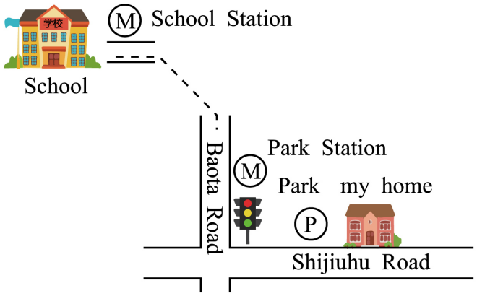
Dear Miss ________,
Here is the way to my home. I live on ____________________________________.
It’s ___________________________.You can
_____________________________________.
Next, get off at Park Station, then go along
_____________________________________.
_____________________________________.
Welcome _________________!
Yours,
________

参考答案

一． B A B A A C B B A C
【详解】1. I want to show them my new bike.
2. Bobby’s house is near the zoo.
3. I don’t like swimming.
4. Tina goes to school by metro.
5. Take off that small coat.
6. I really visit my aunt by train.
7. Cinderella is sad because she can’t go to the party.
8. We can’t eat these nice mushrooms.
9. You can get on the metro at park station.
10. You can see the hospital on your right.
二． T F F T T
【详解】1. Bobby likes riding a bike in the park.
2. Jack has a fever. So he should have a rest at home.
3. My uncle has a toothache. He goes to the dentist.
4. They can’t get on the bus because the bus is full.
5. Sam goes to school by bike. He sits in the basket.
三． B A C B C
【详解】1. Can Cinderella come back after 12:00?
2. How do you feel?
3. Do you live near your school?
4. What’s wrong with Sam?
5. Why don’t you come to school today?
四． B C A B A
【详解】1. A: Mike, is your home on Sun Street?
B: No, it isn’t. My home is on Moon Street, near my school.
Q: Is Mike’s home on Moon Street?
2. A: What’s wrong with you, Tom?
B: My head hurts.
Q: What’s wrong with Tom?
3. A: What do you like doing, Lily?
B: I like dancing. What about you, Nancy?
A: I don’t like dancing. I like drawing.
Q: Does Nancy like dancing?
4. A: Where’s the museum?
B: It’s on Green Apple Street, behind City Library.
Q: Where is City Library?
5. A: How do you come to school, Tom?
B: Guess.
A: By bus?
B: No, by metro.
Q: Does Tom take a bus to school?
五． lives near foot eating toothache warm water shouldn’t should brush
【详解】听力材料：
Hello, this is my friend Andy. He lives on Park Street, near our school. So he comes to school on foot. He likes eating sweets. So sometimes he has a toothache. When his teeth hurt, he cannot eat rice or fruit. He can only drink some warm water. He shouldn’t eat too many sweets. He should brush his teeth in the morning and before bedtime.
六1．C 2．D 3．C 4．B 5．A
【解析】1．选项ABD画线部分的发音为/dr/，选项C画线不分的发音为/θr/，所以C不同，故选C。
2．选项ABC画线部分的发音为/ʌ/，选项D画线不分的发音为/ə/，所以D不同，故选D。
3．选项ABD画线部分的发音为/ʃ/，选项C画线不分的发音为/s/，所以C不同，故选C。
4．选项ACD画线部分的发音为/tʃ/，选项B画线不分的发音为/k/，所以B不同，故选B。
5．选项BCD画线部分的发音为/θ/，选项A画线不分的发音为/ð/，所以A不同，故选A。
七1．fits
【详解】句意：这条短裙很适合她。本题考查动词的形式。根据句意及首字母，可知单词为fit适合，句子可用一般现在时，主语The skirt是第三人称单数，fit用第三人称单数形式fits，故答案为fits。
2． take/ake off/ff
【详解】句意：天气太热了。玛丽不得不脱下她的夹克。本题考查动词短语和动词的形式。has to不得不，后跟动词原形，根据首字母提示，take off脱下，符合句意，故答案为take；off。
3． plane/lane train/rain
【详解】句意：—你乘坐飞机去北京吗？—不，我经常乘坐火车去的。本题考查介词的固定搭配。根据首字母和句意可知第一个空考查单词plane，by plane乘飞机；第二个空考查单词train，by train乘火车。故答案为plane；train。
4．along/long
【详解】句意：沿着这条街走就能看到动物园。本题考查动词短语。根据句意及首字母，可知短语为walk along沿着……走，故答案为along。
5．toothache/oothache
【详解】句意：我的奶奶牙痛。她的牙受伤了。本题考查动词短语。根据句意和首字母可知考查单词toothache牙疼，has a toothache牙疼，故答案为toothache。
6． Is any
【详解】句意：瓶子里有果汁吗？本题考查there be句型和不定代词。juice是不可数名词，句子可用一般现在时，be用is，位于句首，首字母大写，some一般用在肯定句中，any一般用在否定句和疑问句中，故答案为Is，any。
7． come help
【详解】句意：海伦，来帮我。本题考查动词的形式。句子是祈使句，动词用原形，and连接的动词形式要一致，故答案为come，help。
8．cities
【详解】句意：我叔叔总是开车去许多城市。本题考查可数名词及其单复数。many修饰可数名词复数，city的复数是cities，故答案为cities。
9．to chat
【详解】句意：梅是我们的新朋友。她想和我们聊天。本题考查动词的形式，want to do sth想做某事，故答案为to chat。
10．wants
【详解】句意：谁每天想要给南希指明去图书馆的路？本题考查动词的形式。由every day每天可知句子时态是一般现在时，主语who是第三人称单数，动词want要用第三人称单数形式wants，故答案为wants。
八1．C
【详解】句意：灰姑娘很伤心，因为她必须12点前回家。本题考查形容词辨析和动词短语。happy高兴的，sad伤心的，has to必须，cannot不能，根据所学可知灰姑娘很伤心，因为她必须12点前回家，故选C。
2．C
【详解】句意：—灰姑娘多美丽啊！但是她不能参加派对。—多可惜啊！本题考查感叹句。What引导的感叹句结构为：What (+ a/an)+ 形容词 + 名词(+ 主语 + 谓语)！How引导的感叹句结构为：How+ 形容词 (+ 主语 + 谓语)！选项C符合题意，故选C。
3．C
【详解】句意：她想要自行车，她想骑自行车去学校。本题考查不定冠词和动词不定式。“want sth”表示 “想要某物”，“bike” 是可数名词，前面需要加不定冠词“a”；“want to do sth.” 表示 “想要做某事”，故选 C。
4．C
【详解】句意：打扰一下，你能告诉我怎么去那里吗？本题考查动词短语和动词的形式。get there到达那里，how to do sth怎样做某事。故选C。
5．B
【详解】句意：我的表弟(表哥/堂哥/堂弟)住得离学校远。她每天骑自行车去上学。本题考查动词短语和动词的第三人称单数。A骑自行车，动词原形；B骑自行车，动词的第三人称单数；C骑自行车，介词固定搭配。句子缺少谓语动词，排除C，时态是一般现在时态，主语是he，谓语动词用第三人称单数形式，排除A。故选B。
6．A
【详解】句意：8路公交车来了。让我们上公交车吧。本题考查动词短语。A上车(公交车、火车等较高的交通工具)，B上车(一般指小汽车)，C下车。选项A符合句意，故选A。
7．B
【详解】句意：—我怎么去迈克家？—你可以乘公共汽车去那里。本题考查动词短语。get获得，得到；get to到达；第一空，get to+地点名词，表示到达某地；第二空，get there到达那里，there是副词， get后省略to；故选B。
8．C
【详解】句意：—他怎么了？—他发烧了。本题考查人称代词和动词的形式。with是介词，后面的人称代词用宾格做宾语，him人称代词宾格；主语he是第三人称单数，后面的动词用第三人称单数形式has。故选C。
9．B
【详解】句意：—刘韬为什么如此悲伤？—因为他身体不太好。本题考查be动词和连词辨析，does做，是助动词；is是；can能够。形容词sad前用be动词is，Because因为，选项B符合题意，故选B。
10．B
【详解】句意：我的耳朵和鼻子受伤了。本题考查祈使句。A谢谢。B让我帮助你。C这是个好主意。选项B符合题意，故选B。

九1．E 2．D 3．J 4．I 5．F 6．C 7．H 8．B 9．G 10．A
十1． Does have
【详解】原句句意：吉尔在她的生日聚会玩得很开心。本题考查句型转换。原句谓语动词has是第三人称单数，改为一般疑问句，助动词用does，has变原形have，故答案为Does，have。
2． go by bike
【详解】句意：我经常骑自行车去公园。本题考查句型转换。ride a bike to the park动词短语，骑自行车去公园，可以和go to the park by bike替换，go to the park动词短语，去公园，by bike介词固定搭配，骑自行车，故答案为go；by；bike。
3． How does come
【详解】原句句意：约翰坐车上学。本题考查句型转换。题目要求对划线部分提问。划线部分是by car，用how提问，后跟一般疑问句，时态为一般现在时，主语John是第三人称单数，变一般疑问句要借助助动词does，后跟动词原形，comes要变成come，故答案为How，does，come。
4． Where is
【详解】原句句意：超市旁边有一个公园。本题考查句型转换。画线部分是地点，用where提问，后跟is引导的一般疑问句，故答案为Where，is。
5． What should do
【详解】原句句意：学生们在课堂上应该认真听老师讲课。本题考查句型转换。画线部分是应该做的事情，用what提问，后跟should引导的一般疑问句，问句为：学生们在课堂上应该做什么？故答案为What，should，do。
十一1．with/ith 2．take/ake 3．off/ff 4．Station/tation 5．right/ight
【导语】本文主语介绍怎么样去苏珊的家。
1．句意：周末你要和我一起吃午饭吗。和with，符合句意，故答案为with。
2．句意：你可以乘坐3路公共汽车。乘坐take，符合句意，故答案为take。
3．句意：然后，在和新站下车。下车get off，符合句意，故答案为off。
4．句意：然后，在和新站下车。车站Station，符合句意，故答案为Station。
5．句意：你会在你的右边看见一棵大树。右边right，符合句意，故答案为right。
十二1．B 2．B 3．B 4．A 5．D
【导语】本文讲了地铁的路线。
1．句意：图中有几条线路？A五条。B六条。C七条。D八条。根据图片可知有6条线路，故选B。
2．句意：李华和她的父母在家。他们想去城市图书馆。他们应该走哪条线路？根据图片可知他们应该走线路2，故选B。
3．句意：从李华家到市图书馆有3.8公里。他们应该付多少钱买票？根据“She is 150 cm tall. She wants to take the metro to City Library with her parents today.”及票价，可知他么应该付5元钱，故选B。
4．句意：人们在地铁上可以做什么？A他们可以看书。B他们可以大喊大叫。C他们可以吃汉堡包。D他们可以喝果汁。根据“Tips: ①Don’t shout. ②Don’t eat or drink.”，可知他们可以看书，故选A。
5．句意：从城市图书馆到电影院，哪条是最好的路？根据图片可知最好的路是City Library—Park—Hospital—Cinema，故选D。
6．F 7．T 8．F 9．T 10．F
【导语】本文讲的是美国家庭与家用车的关系。
6．句意：在美国，所有的人都乘面包车去工作。根据文中“If both parents are working, they usually have two cars.”可知人们通常开轿车去工作，题干描述错误，故答案为F。
7．句意：本一家有一辆面包车和俩孩子。他们可以叫上他们的祖父母一起去度假。根据文中“A van can hold seven people. So a family with three children can ask their grandparents to go on a holiday together.”可知题干描述少于最大容量的七个人，故答案为T。
8．句意：面包车比轿车小。根据文中“When the family is large, they will have a van.”和常识可知题干描述错误，故答案为F。
9．句意：当美国人度假的时候，他们可以住在面包车里。根据文中“You can think a van is motor home. It is good for holidays.”可知题干描述正确，故答案为T。
10．句意：面包车不流行是因为面包车不好停车。根据文中“In America, there are many parks for motor homes.”可知题干描述错误，故答案为F。
11．It is Tuesday. 12．He has a bad headache and a cough. 13．Mrs Black calls Miss Li after breakfast. 14．They have Chinese, English, Science, Art and Computer Studies. 15．Nancy will help David with his lessons.
十三．例文：
Dear Miss Sun,
Here is the way to my home. I live on Shijiuhu Road. It’s far from school. You can take a metro to my home. You can get on at School Station. Next, get off at Park Station, then go along Shijiuhu Road. Go straight and you can find my home near the park.
Welcome to my home!
Yours,
Lily

