2022-2023学年译林版小学英语三年级上册期中综合质量调研卷

★听力部分
一、听音，选择正确答案(共15分)
1．听录音，选出你所听到的字母或单词。
( ) 1). A．G B．J C．K
( ) 2). A．B B．D C．E
( ) 3). A．C B．N C．A
( ) 4). A．E B．D C．F
( ) 5). A．father B．family C．friend
( ) 6). A．hi B．he C．she
( ) 7). A．brother B．sister C．mother
( ) 8). A．good B．goodbye C．grandpa
( ) 9). A．you B．my C．I
( ) 10). A．class B．Miss C．sister
2．听录音，选出正确的答句。
( ) 1). A．I’m Mike. B．Yes, I am.
( ) 2). A．Goodbye, Miss Li. B．Good afternoon, Miss Li.
( ) 3). A．Yes, I’m Helen. B．No, I’m Helen.
( ) 4). A．He’s my friend too. B．Hello, Yang Ling.
( ) 5). A．Hello, Liu Tao. B．Hello, I’m Liu Tao.

二、听音，选择听到的内容(共5分)
3．听录音，选出你所听到的句子。
( ) 1). A．Hello, I’m Liu Tao. B．Hi, Liu Tao. C．Hi, I’m Liu Tao.
( ) 2). A．Good morning. B．Good afternoon. C．Good evening.
( ) 3). A．He’s my brother. B．She is my sister. C．This is my brother.
( ) 4). A．This is Mike. B．This is me. C．This is Tim.
( ) 5). A．Are you Bobby? B．He is Sam. C．I’m John.
三、听音排序(共5分)
4．听录音，用数字给所听句子排序。
( )This is my father.
( )Hello, she’s my sister.
( )Goodbye, Miss Li.
( )Are you Su Hai?
( )Good afternoon, class.

★笔试部分
四、词汇选择题(共5分)
选出每组中不同类的选项。
5．A．hello B．goodbye C．hi
6．A．mother B．family C．father
7．A．he B．this C．she
8．A．morning B．afternoon C．sister
9．A．yes B．no C．am
五、单选题(共10分)
10．She’s _________ mother. ( )
A．I B．me C．my
11．—Are you Liu Tao? ( )
—_________, I am .
A．Yes B．No C．yes
12．—_________, mum . ( )
—Good night, my dear.
A．Good night B．Goodbye C．Good afternoon
13．______Mike. _____my friend. ( )
A．He's; She's B．He; She C．He's; He's
六、情景选择(共10分)
14．你向别人介绍自己的家庭，应该说：( )
A．This is my family. B．This is my father.
15．晚上6 点见到山姆，如何打招呼? ( )
A．Good evening, Sam. B．Good morning, Sam.
16．当你想问别人她是谁时，你可以说：( )
A．Who is he? B．Who is she?
17．下课了，老师会对大家说：( )
A．Goodbye, class. B．Good morning, class.
18．你想向别人介绍你的妹妹，可以这样说：( )
A．This is my brother. B．This is my sister.
19．I Nancy. She my friend Yang Ling. ( )
A．are; is B．is; am C．am; is
七、字母题(共10分)
写出下列字母的左邻右舍。
20．________ Cc ________
21．________ Hh ________
22．________ Nn ________
23．________ Ee ________
24．________ Kk ________
八、句子匹配(共10分)
A．See you.
B．Yes, I am Yang Ling.
C．No, I’m not. I’m Bobby.
D．Good evening.
E. Goodbye, Miss Li.
F. Hello, Bobby.
25．Are you Mike? ( )
26．This is my brother Bobby. ( )
27．See you next time. ( )
28．Goodbye, class. ( )
29．Good evening. ( )
九、连词成句(共10分)
30．my, is, family, This (.)
____________________________________________________________________
31．my, friend, Goodbye (, .)
______________________
32．my, sister, is, Tina, (.)
____________________________________________________________________
33．not, Liu, Tao, I’m, (.)
____________________________________________________________________
34．Are, Miss, Yang, you (?)
____________________________________________________________________
十、阅读选择(共10分)
Hello. I’m Tim. I’m 10. There are (有) four people (人) in my family. They are my father, my mother, my sister and me. Mary is my sister. She’s two. I love my family. I have (有) some friends at school. They are Tom, Paul and Alice. They are ten.
35．_________ is Tim’s sister. ( )
A．Tom B．Alice C．Mary
36．Tim is _________. ( )
A．8 B．9 C．10
37．_________ are my friends. ( )
A．Tom, Mary and Alice
B．Tom, Alice and Paul
C．Alice, Tim and Paul
38．How many (多少) people are there in Tim’s family?. ( )
A．4 B．3 C．2
39．下面哪个句子是正确的？( )
A．Mary is Tim’s friend.
B．Paul is Tim’s friend.
C．Alice is Tim’s sister.
十一、阅读判断(共10分)
根据人物关系图来判断正误，正确的写T，错误的写F。
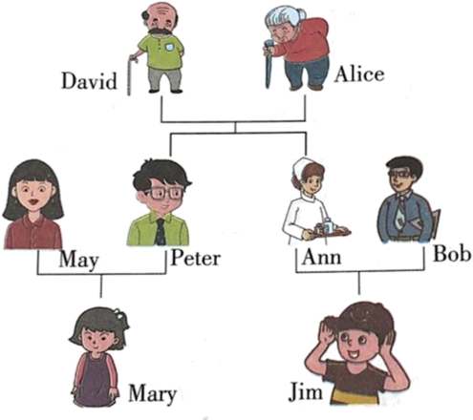
40．Peter is David ’s father. ( )
41．Mary is Jim’s cousin. ( )
42．Alice is Ann’s grandma. ( )
43．Jim is Bob’s son. ( )
44．Peter is Ann’s brother. ( )

参考答案：
1． B C B B C B
A B B A
【详解】1). J
2). E
3). N
4). D
5). friend
6). he
7). brother
8). goodbye
9). my
10). class
【点睛】
2． B B A A A
【详解】1). Are you Mike?
2). Good afternoon, class.
3). Are you Helen?
4). Wang Bing is my friend.
5). Hello, Miss Li.
【点睛】
3． C C A B C
【详解】1). Hi, I’m Liu Tao.
2). Good evening.
3). He’s my brother.
4). This is me.
5). I’m John.
【点睛】
4． 4 2 5 1 3
【详解】1). Are you Su Hai?
2). Hello, she’s my sister.
3). Good afternoon, class.
4). This is my father.
5). Goodbye, Miss Li.
【点睛】
5．B 6．B 7．B 8．C 9．C
10．C
11．A
12．A
13．C
14．A
15．A
16．B
17．A
18．B
19．C
20． Bb Dd 21． Gg Ii 22． Mm Oo 23． Dd Ff 24． Jj Ll
25．C 26．F 27．A 28．E 29．D
30．This is my family.
31．Goodbye, my friend.
32．Tina is my sister.
33．I’m not Liu Tao.
34．Are you Miss Yang?
35．C 36．C 37．B 38．A 39．B
40．F 41．T 42．F 43．T 44．T

