2022-2023学年鲁教版小学三年级英语上册期末测试卷
班级：__________ 姓名：__________
（时间：40分钟，满分97分+3分卷面分）
题号 | 一 | 二 | 三 | 四 | 五 | 六 | 七 | 八 | 书写 | 总分
得分
听力部分（共57分）
一、听录音，圈出你所听到的字母，每个小题听两遍。（每个小题1分，共10分）

1. P p B b
2. R r I i
3. U u V v
4. Z z K k
5. T t D d
6. G g J j
7. Q q U u
8. I i L l
9. M m N n
10. H h Y y

二、听录音，圈出你所听到的单词，每个小题听两遍。（每个小题1分，共10分）

1. you your
2. this that
3. nice nose
4. are arm
5. black blue
6. farmer father
7. nine fine
8. meet Mr
9. have head
10. good foot
三、听录音，判断所听内容是否与图片一致，一致的打“√”，不一致的打“×”。每个小题听两遍。（每个小题1分，共7分）

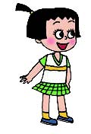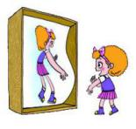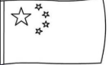

( ) ( ) ( ) ( )
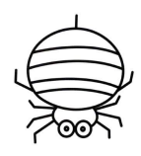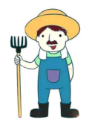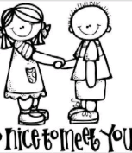
( ) ( ) ( )
四、听录音，将物品与正确的颜色和数量相连，每个小题听两遍。（每个小题4分，共20分）
1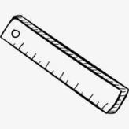
seven
yellow
2. 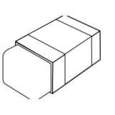
eight
green
3. 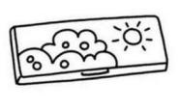
three
red
4. 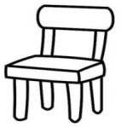
ten
blue
5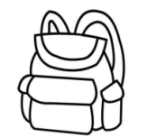
four
orange
五、听录音，选出你所听到的句子。每个小题听两遍。（每个小题2分，共10分）
( ) 1. A. Nice to meet you. B. Nice to meet you, too.
( ) 2. A. How are you? B. How old are you?
( ) 3. A. What’s that? B. What’s this?
( ) 4. A. Mr Wood is our teacher.
B. Miss Wood is our teacher.
( ) 5. A. What colour do you like?
B. How many colours do you see?
笔试部分（共40分）
六、情景选择。（每小题1分，共10分）
( ) 1. 今天是你的生日，Jenny送你礼物时，你应该说：
A. This is for you. B. Thank you!
( ) 2. 当你指着离自己比较远的东西问那是什么时，应该说：
A. What's this? B. What's that?
( ) 3. 当你把自己的妈妈介绍给Danny时，应该说
A. This is my mother. B. This is my farmer.
( ) 4. 当你想向Peter介绍你的嘴巴时，应该说：
A. This is your mouth. B. This is my mouth.
( ) 5. 你在路上遇到了很久没见的外教，应该说：
A. How are you? B. What’s your name?
( ) 6. Tom说：“I like orange.”如果你也喜欢，可以说：
A. Me, too. B. Great!
( ) 7. 当你想知道交换生Tom的年龄时，你会问：
A. What’s that? B. How old are you?
( ) 8. 当你问Jenny带了几支铅笔时，你可以说：
A. How many pens do you have?
B. How many pencils do you have?
( ) 9. 当你向别人介绍你的朋友Amy时，你应该说：
A. This is my friend, Amy.
B. Nice to meet you, Amy.
( ) 10. 当Tom问你QQ号时，你告诉他：
A. one one nine B. two one three five six
七、单项选择。（每小题1分，共10分）
( ) 1. ─How old ________ you? ─I ________ eight.
A. is; are B. are; am C. /; am
( ) 2. How many ________ do you have?
A. books B. ruler C. pen
( ) 3. I have ten ________.
A. pen B. book C.pencils
( ) 4.─This eraser is ________ you. ─Thank you.
A. for B. / C. like
( ) 5. ─I am seven. ─I am seven, ________.
A. for B. years C. too
( ) 6. ─What ________ is it? ─It's red.
A. colour B. name C. like
( ) 7. ─What colour do you like? ─I ________ yellow.
A. am B. is C. like
( ) 8. What colour ________ you like?
A. are B. do C. is
( ) 9.--This is for you. --______________
- No. B. Thank you. C. OK.
( ) 10.Look! ________my brother.
A. He’s B. He C. She’s
八、选出与句子相对应的图片（每个小题2分，共10分。）
( ) 1.-How many colours? --Red, orange, yellow
...Seven.
A.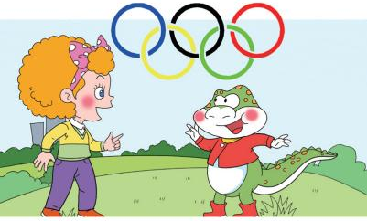 | B.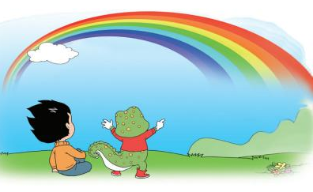

( ) 2.--What colour is it? --It’s red and yellow.
A.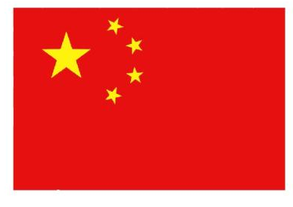 | B.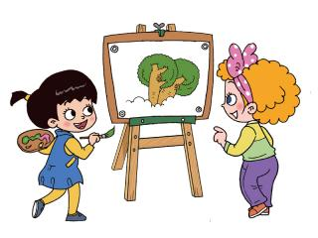

( ) 3. -What’s this?--It’s a ruler.
A.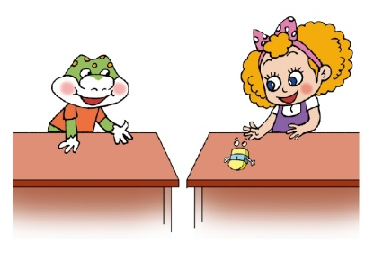 | B.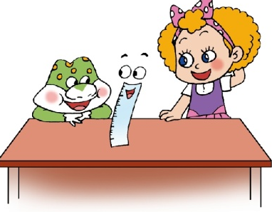

( )4.This is my father. He’s a teacher.

A.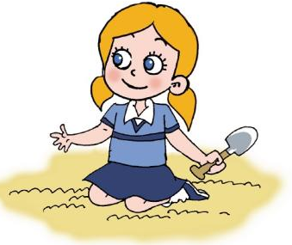 | B.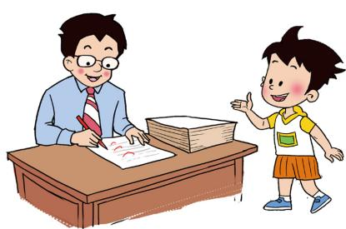

( )5. I lave two legs.
A.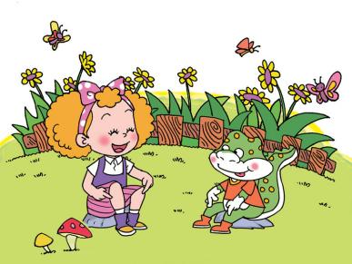 | B.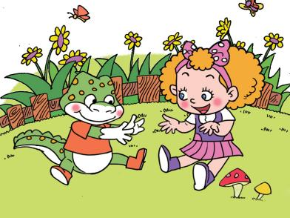

九、根据问句选择合适的答语填在题前的括号里（10分）
( )1. Good afternoon. A. It's white.
( )2. What’s your name? B.I'm Jenny.
( )3. How old are you? C. Nice to meet you.
( )4. What colour is it? D. I'm six.
( )5. This is my friend, Peter. E. Good afternoon.

参考答案

一、1.B 2.R 3.V 4.Z 5.T 6.J 7.Q 8.L 9.M 10.Y
二、1.you 2.that 3.nice 4.arm 5.black 6.father 7.nine 8.meet 9.head 10.foot
三、×√×√×√×
四、1. three blue rulers; 2. ten red erasers; 3. four orange pencil-cases
4. eight yellow chairs; 5. seven green schoolbags
五、AABBA 六、ABABA ABBB 七、BACAC ACBBA
八、BABBA 九.EBDAC

听力部分文本

一、听录音，圈出你所听到的字母，每个小题听两遍。
- B 2.R 3.V 4.Z 5.T 6.J 7.Q 8.L 9.M 10.Y
二、听录音，圈出你所听到的单词，每个小题听两遍。
1.you 2.that 3.nice 4.arm 5.black
6.father 7.nine 8.meet 9.head 10.foot
三、听录音，判断所听内容是否与图片一致。每个小题听两遍。
1.This is my head. 2.This is my arm. 3.She’s a doctor.
4.It’s red and yellow. 5.I have two legs. 6.My grandpa is a farmer.
7. She is my friend.
四、听录音，将物品与正确的颜色和数量相连，每个小题听两遍。
1. three blue rulers 2. ten red erasers 3. four orange pencil-cases
4. eight yellow chairs 5. seven green schoolbags
五、听录音，选出你所听到的句子。每个小题听两遍。
1.Nice to meet you. 2.How are you? 3.What’s this?
4.Miss Wood is our teacher. 5.What colour do you like?

