2024-2025译林版三年级英语上学期期末测试卷
听力部分（30分）
一、听录音，给下列图片标序号。（5分）



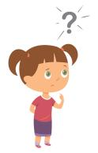
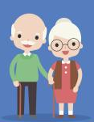

( ) ( ) ( ) ( ) ( )

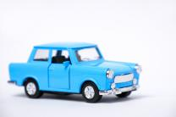
二、听对话，给下列图片排序。（5分）
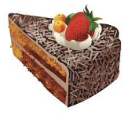
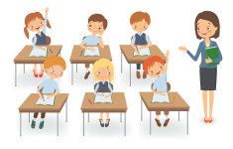


( ) ( ) ( ) ( ) ( )
三、听录音，选出正确答语。（10分）
( )1.A.Yellow. B.Yes. It’s yellow.
( )2.A.Yes. You’re right. B.Hello, Tina.
( )3.A. No, I’m not B.I’m ten
( )4.A.No, thank you. B.Look at me!
( )5.A.OK. Thank you. B.It’s me.
( )6.A.Yes, I am. B.No, thanks.
( )7.A.It’s a toy car. B.They are books.
( )8.A.See you. B.Good night.
( )9.A.Good afternoon, Miss Li. B.Good morning, Mr Green.
( )10.A.I’m ten. B.I’m Tom.
- 听录音，将相关图片连线。（5分）
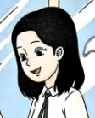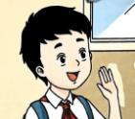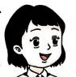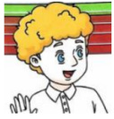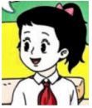







- 听录音根据所听内容在横线上填入相应单词。（5分）
Hello, I'm Toe. I'm . Look! Tommy. And her is Alice. We are all in the same . And this is my little . He's Jeff. Jeff and I like robots.
笔试部分（70分）
六、单项选择。(10分)
( )1.— Look at _____ cap.— How nice!
A.me B. my C. I
( )2. This is Helen. She is my_____ .
A. sister B. brother C. father

( )3. Orange _____ red?
A. and B. or C. at
( )4.—I don't like bread.— What about _____ egg?
A. a B. an C./
( )5. This red ball is _____ you.
A. in B. with C. for

七、按要求默写字母。(10 分)
1.按字母表顺序默写字母Cc—Gg的大小写形式。

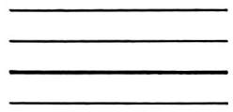
2.按字母表顺序默写字母Jj—Nn的大小写形式。

3.按字母表顺序默写字母Vv—Zz的大小写形式。

4.按字母表顺序默写5个元音字母的大小写形式。

八、情景选择。(10 分)
( )1.想让别人看你的新T恤衫时，你可以说：
A. Look at my new cap.
B. Look at my new T-shirt.
C. Look at my new jacket.
( )2.当你将礼物送给对方时，你可以说：
A. This is for me. B. This is for you. C. It's for me.
( )3.当同学将自己的朋友介绍给你认识时，你应该说：
A. This is my friend. B. This is my family. C. Nice to meet you.
( )4.想问对方自己的裙子是什么颜色的，你可以说：
A. What colour is your skirt?
B. What colour is my shirt?
C. What colour is my skirt?
( )5.想向别人展示自己时，你可以说：
A. Look at me! B. See you. C. No, I'm not.

九、将下列各组句子分别排成一段通顺的对话，将序号写在小火车上。(10分)
A. Yes, please.
B. Happy Birthday, Sam! This is for you.
C. Wow, how nice! Would you like a sweet?
D. It's a robot.
E. Thank you, Bobby. What's this?

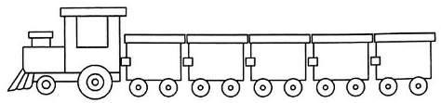

十、选词填空（10分）
A. white B. you C. doll D. What colour E. This F. What

Joe: Hello, Helen. 1. is for you.
Helen: Thank 2. , Joe. 3. is this?
Joe: It's a 4. .
Helen: 5. is it?
Joe: It's pink(粉红色的) and 6. .
Helen: How nice!
十一、根据所给图片或中文提示补全句子。(10分)
1. She is my 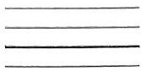(妹妹) Helen.
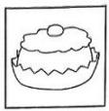
2. The nice is for Tim.

3. My (橙色的) skirt is great.

- Happy New 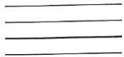二, Uncle John!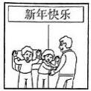
十二、阅读对话，判断下列句子正(T)误(F)。 (10分)
Tom, Linda & Amy: Happy New Year, Grandpa and Grandma!
Grandpa: Happy New Year! Here are some presents(礼物). This is for you, Tom.
Tom: Thank you. It is a blue ball. I like it.
Grandma: This new skirt is for you, Linda.
Linda: Thank you. It's yellow. I like it very much.
Grandparents: Here's a packet(一袋) of sweets for you, Amy.
Amy: Oh,I like sweets. Thank you, Grandpa and Grandma.

( )1. It is Grandpa's birthday today.

( )2. Tom's ball is yellow.

( )3. Linda's new skirt is blue.

( )4. The sweets are for Amy.

( )5. Tom, Linda and Amy like their presents.

听力材料
- 听录音，给下列图片标序号。(听两遍)
1. a black and white ball
2.grandfather and grandmother
3. What's that?
4. I love my family.
5. It's great.

二、听对话，给下列图片排序。(听两遍)
1. A: Look at my toy car. B: It's nice.
2. A: This is my friend. B: Nice to see you.
3. A: Happy New Year! B: Happy New Year!
4.A: Good morning, class. B: Good morning, Miss Li.
5. A: Would you like a cake? B: Yes, please.

三、听录音，选出正确的答语。(听两遍)
1.Is it yellow or green?
2.Are you Tina?
3.How old are you?
4.Would you like an egg?
5.This is for you.
6.Would you like a sweet?
7.What's that?
8.See you next time.
9.Good morning, boys and girls.
10.What’s your name?

四、听录音，将相关图片连线。(听两遍)
1.It's a book. It's for Yang Ling.
2. This ball is for you, Liu Tao.
3. Look at the toy car. It's for Mike.
4. That's a cake for Su Hai.
5. Look at this dress. It's for Miss Li.
五、听录音，根据所听内容在横线上填入相应单词。
Hello, I'm Toe. I'm ten. Look! He’s Tommy. And her name is Alice. We are all in the same class. And this is my little brother. He's Jeff. Jeff and I like robots.

听力答案：
一 、23154

二 、24135

三、 AABAA BAABB

四、
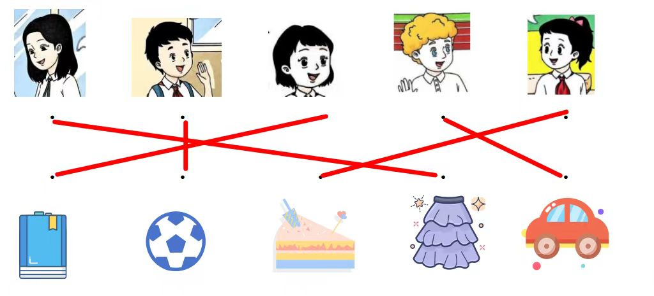
五、 ten He’s name class brother
六、1.B 2. A 3 B 4.B 5.C
七、1. Cc Dd Ee Ff Gg 2. Jj Kk Ll Mm Nn
- Vv Ww Xx Yy Zz 4. Aa Ee Ii Oo Uu
八、1. B 2. B 3. C 4. C 5. A
- B E D C A
十、 1. E 2. B 3. F 4. C 5. D 6. A
十一、1. sister 2. cake 3. orange 4. Year
十二、FFFTT

