湘少版2024-2025三年级英语上学期期末复习测试卷
班级_______姓名________得分________
听力部分（40分）
一、听录音，选出你所听到的字母或单词。（10分）
( )1.A.DF B.BH C.GR
( )2.A.five B. nine C. three
( )3.A.mother B. sister C. father
( )4.A. blue B. pink C.red
( )5.A. ruler B. schoolbag C. pencil case
二、听录音，选出你所听到的句子。（10分）
( )1. A. I'm eight. B. He's eight.
( )2.A. Stand up,please. B. Sit down,please.
( )3.A.Hi,Peter. B. Hello, I'm Peter.
( )4. A.Is this your book? B. Is this a ruler?
( )5. A.It's green and orange. B. It's blue and purple.
三、听录音，根据你所听到的内容选择正确的答语。（10分）
( )1.A. Goodbye. B. Good morning.
( )2. A.I'm four. B. My name is Lulu.
( )3.A.Thank you. B. That's great.
( )4.A.My name is Lily. B. I'm ten.
( )5. A.He's my brother. B. She's my aunt.
四、听录音，判断下列句子与你所听内容是(T)否(F)相符。（10分）

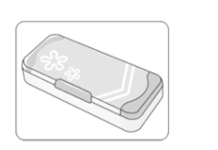 | 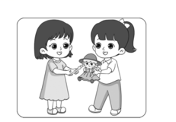 | 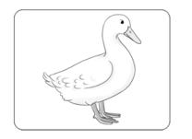 | 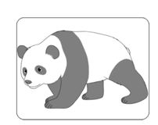 | 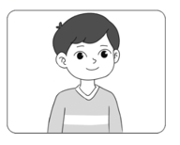
1.( ) | 2.( ) | 3.( ) | 4.( ) | 5.( )

笔试部分（60分）
五、字母与句子书写。
A.写出下列字母的左邻右舍。大小写形式都要写。(5分）
1. | Bb | 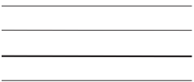 | Dd | 2. | Ff |  | Hh
3. | Oo | 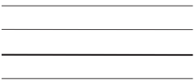 | Qq | 4. | Ll |  | Nn
5. | Xx | 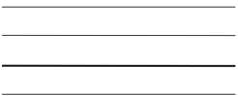 | Zz
- 在四线三格中正确书写下列句子。（5分）
Happy birthday! Here is a gift for you.
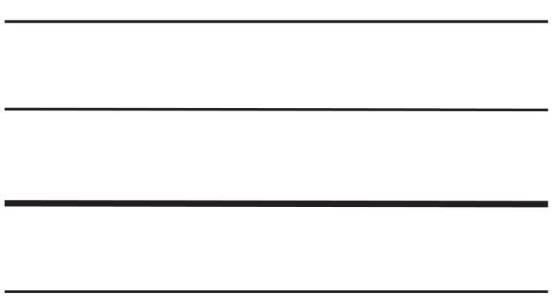
- 选出下列每组单词中不同类的一项。（10分）
( )1.A. pig B. goose C. pear
( )2. A. five B. seven C. picture
( )3.A. ruler B. head C. pencil
( )4.A. pink B. gift C. green
( )5.A.class B. father C. mother
七．单项选择题。（10分）
( )1.It's____ apple. It's not___ pear.
A.an; an B. a; an C.an; a
( )2.I____eight. How old____you?
A. am; are B.is; are C.are; is
( )3. This is Miss Li._____is my English teacher(英语老师).
A. I B. He C.She
( )4.I_______like lemons.
A. not B. isn't C. don't
( )5.---________is the tree?
---It's green and brown.
- What B. What colour C. How old
八、情景交际。（10分）
( )1.当你在下午遇到好朋友Peter时,你应该说:
- Good morning,Peter.
B.Good afternoon,Peter.
( )2.第一次见到对方打招呼时，你应该说:
- Nice to meet you.
B.Goodbye
( )3.当你向Mr Zhang介绍你的好朋友Mingming时，你会说:
- Hi,Mr Zhang, this is Mingming.
- Hi,Mr Zhang, I’m Mingming
( )4.你送给朋友一个玩具猫，你可以说:
- Here is a toy cat for you.
- I like the toy cat.
( )5.当你想表达你不喜欢柠檬时，你可以说:
- I like lemons
B. I don’t like lemons
九、给下列句子选择正确的应答语。（10分）
( )1. How old are you?
( )2. What’s her name?
( )3. Hello, Anne.
( )4. Good afternoon,class.
( )5. Who's he?
A. He's my uncle.
B. Good afternoon, Miss Li.
C.Her name is Lulu.
D.I’m nine.
E. Hi, Peter.
十、阅读短文,判断正（T）误（F）。(10分)
Hello,I'm Lisa. I'm six. Look at my school things. This is my schoolbag. It's red. That is my pencil case. It's white and blue. And you can see three pencils,two erasers and a ruler in my pencil case.What colour is the ruler? It's pink. I like pink. I will go to school tomorrow(明天我将要去上学).I'm very happy now!
( )1. Lisa is 6.
( )2.Lisa's(丽莎的)schoolbag is white and blue.
( )3. You can see two pencils in Lisa's pencil case.
( )4. Lisa likes pink.
( )5. Lisa is happy now.

听力材料
一、1.BH 2.three 3.mother 4.red 5.schoolbag
二、1.I'm eight.
- Sit down,please.
- Hello, I'm Peter.
- Is this your book?
- It's green and orange.
三、1.Good morning.
2.How old are you?
3.Here is gift for you.
4.What’s your name?
5. Who is she?
四、1. This is a schoolbag.
- Here is a doll for you.
- Quack, quack.It’s a duck.
- It’s black and white.
- She is my sister.

参考答案
一、B A A C B
二、A B B A A
三、B A A A B
四、F T T T F
五、A
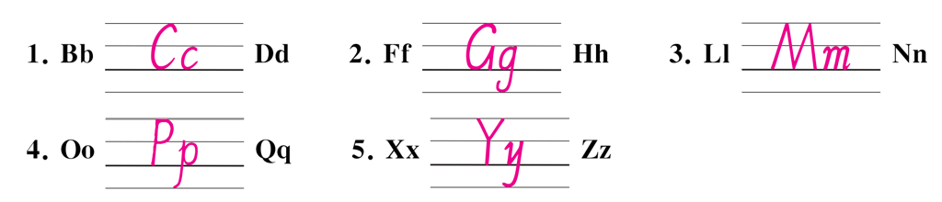
B.略
六、C C B B A
七、C A C C B
八、B A A A B
九、D C E B A
十、T F F T T

